Kunden:ZHAW:2015:00067.03-Titelblatt-Bachelorbuch:Versionen:Institute:wmf:2015-04-27-ZHAW-Titelblatt-Bachelorbuch-IDP.wmf

**Bachelor thesis (Computer Science)**

Analysis of online review and restaurant revenue data

|  |  |  |
| --- | --- | --- |
| **Authors** |  | Manu Paul Kunnumpurathu  Muhammed Fatih Solmaz |
| **Supervisor** |  | Dr. Martin Frey |
| **Secondary supervisor** |  | Dr. Reto Bürgin |
| **Industrial partner** |  | Prognolite |
| **External supervisor** |  | Marco Wirthlin |
| **Date** |  | 10.06.2022 |

**Erklärung betreffend das selbstständige Verfassen einer Bachelorarbeit an der School of Engineering**

**Erklärung betreffend das selbstständige Verfassen einer Bachelorarbeit an der School of Engineering**

Mit der Abgabe dieser Bachelorarbeit versichert der/die Studierende, dass er/sie die Arbeit selbständig und ohne fremde Hilfe verfasst hat. (Bei Gruppenarbeiten gelten die Leistungen der übrigen Gruppenmitglieder nicht als fremde Hilfe.)

Der/die unterzeichnende Studierende erklärt, dass alle zitierten Quellen (auch Internetseiten) im Text oder Anhang korrekt nachgewiesen sind, d.h. dass die Bachelorarbeit keine Plagiate enthält, also keine Teile, die teilweise oder vollständig aus einem fremden Text oder einer fremden Arbeit unter Vorgabe der eigenen Urheberschaft bzw. ohne Quellenangabe übernommen worden sind.

Bei Verfehlungen aller Art treten die Paragraphen 39 und 40 (Unredlichkeit und Verfahren bei Unredlichkeit) der ZHAW Prüfungsordnung sowie die Bestimmungen der Disziplinarmassnahmen der Hochschulordnung in Kraft.

**Ort, Datum:** **Name Studierende:**

**Zusammenfassung**

Die Entwicklung des Internets ermöglichte das freie Teilen von Erfahrungsberichten auf dedizierten Social-Media-Plattformen. Solche unter anderem auf Plattformen wie Google oder Tripadvisor aufzufindende Berichte können potentielle Kunden bei der Wahl einer Gastwirtschaft beeinflussen. Diese Arbeit untersucht die Korrelation zwischen Erfahrungsberichten auf den obig genannten Webseiten und dem Umsatz von Restaurants. Des Weiteren wird überprüft, ob die Berichte auf diesen beiden Plattformen eine positive Korrelation aufweisen.

Die Erfahrungsberichte wurden automatisiert mittels Web Scraping von den jeweiligen Webseiten gewonnen. Die für diese Arbeit relevanten Umsatzzahlen wurde von Prognolite zur Verfügung gestellt. Um möglichst genaue Ergebnisse zu erzielen, wurden die Datensätze auf solche vor der COVID-19-Pandemie limitiert und diese in die verschiedenen Saisons aufgeteilt. Die Evaluation der Resultate wurde anhand der Pearson- und Spearman-Korrelationskoeffizienten vorgenommen.

Die Untersuchung der Daten kommt zum Schluss, dass die Erfahrungsberichte der Plattformen Google und Tripadvisor nicht korrelieren. überdies scheinen die Google-Berichte oftmals gar keinen Zusammenhang mit den Umsatzzahlen der jeweiligen Gastbetriebe aufzuweisen. Die Tripadvisor-Berichte hingegen zeigen im Vergleich öfters positive Korrelationen mit dem Umsatzdaten auf. Die könnte so interpretiert werden, dass Erfahrungsberichte auf Tripadvisor einen grösseren Einfluss auf Gastronomie-Umsatzzahlen haben als die auf Google zu findenden. Jedoch gibt es noch zu viele Unklarheiten, um eine klare Aussage treffen zu können.

**Abstract**

Advances in computer technology instigated the creation of social platforms which offer familiar ways of sharing past experiences, like word of mouth, in the form of online reviews. Online user ratings can influence the decision-making of potential restaurant customers using review platforms like Google or Tripadvisor, which in turn could have an impact on the revenue of said restaurant. Based on this hypothesis, this thesis explores the correlation between these two factors. Following, it begs the question of whether reviews on both online platforms, Google and Tripadvisor, show positive correlations.

User ratings were gathered through web scraping, while restaurant revenue data was received from the industry partner Prognolite. Methodologies such as reconstructing the computation of the overall rating, limiting the data to the time before the global pandemic and seasonal decomposition were applied to the ratings and the revenue data accordingly in hopes of improving the results. The evaluation was based on Pearson and Spearman correlation coefficients.

Contrary to what has been assumed, the conducted research indicates that Google and Tripadvisor ratings do not correlate. Furthermore, it suggests that Google ratings often do not show any positive correlations with revenue data. Meanwhile, Tripadvisor ratings show more positive correlations with revenue data than anticipated. This implies that Tripadvisor ratings have a bigger influence on restaurant revenue than Google ratings, but the reliability of these findings could be impacted by many variables like the difference in the number of ratings, limited restaurant revenue data and many more.

**Preface**

During the course of our bachelor studies in computer science at ZHAW School of Engineering, various concepts and methods were introduced, and applied in diverse software projects – ranging from Java software applications to machine learning projects.

One of the domains, which intrigued us, were machine learning and data science. By going through the advertised bachelor theses, we came across a project proposed by Dr. Martin Frey – in cooperation with the industry partner, Prognolite – which met our interests. The notion to work with an industry partner on a machine learning and data science project was the determining factor for our decision on conducting this research.

First and foremost, we would like to express our sincere gratitude to our supervisors Dr. Martin Frey and Dr. Reto Bürgin, for giving us the opportunity to conduct this research, for their valuable guidance and patience throughout the entire project, and for their profound knowledge and insights in the field of statistical data analysis. They have taught us the tools and methods to perform and present research of this kind.

Beside our supervisors, we would like to thank Marco Wirthlin from Prognolite, for his participation, assistance, and for his availability. He provided us with the data required for the research. We are very grateful for his support, without which the completion of this thesis would not have been possible.

Last, but not least, we would like to thank our families and friends for providing us with love and support, and for accompanying us throughout our journeys so far.

Contents

1 Introduction 1

1.1 Goal and scope of the thesis 2

2 Theoretical principles 4

2.1 Correlation coefficients 4

2.1.1 Peason product-moment correlation 4

2.1.2 Spearman rank correlation 5

2.1.3 Interpretation of the correlation coefficients 5

2.2 Time series decomposition 6

2.2.1 Example on a real-world dataset 6

3 Methodology 9

3.1 Hardware 9

3.2 Software 9

3.3 Data 9

3.3.1 Restaurant revenue data: Prognolite 9

3.3.2 Restaurant review data: Tripadvisor and Google 10

3.4 Data acquisition: Web scraping 11

3.4.1 Tripadvisor 11

3.4.2 Google 13

3.5 Data processing 15

4 Results 17

4.1 Analysis of the overall rating 17

4.1.1 Tripadvisor overall rating 17

4.1.2 Google overall rating 18

4.2 Prerequisites for the correlation analyses 20

4.2.1 Running average rating and overall rating 20

4.2.2 Data before, and data before and during the COVID-19 pandemic 20

4.2.3 Delayed impact of rating on revenue 22

4.2.4 Seasonality and trend 22

4.2.5 Time period 24

4.3 Correlation between Tripadvisor and Google restaurant rating 24

4.4 Correlation between Google restaurant rating and Prognolite turnover data 27

4.5 Correlation between Tripadvisor restaurant rating and Prognolite turnover data 30

5 Conclusion 34

6 Lists 35

6.1 Bibliography 35

6.2 List of figures 36

6.3 List of tables 37

7 Appendix 38

7.1 JSON schema of the restaurant review data for a restaurant 38

7.2 Comparison between Google review as JSON and the actual Google review 39

# Introduction

The technological advances over the past few decades have introduced new, more efficient, and effective opportunities of interactions between customers and restaurants. On online review platforms, such as Yelp, Tripadvisor and Google, restaurant visitors can post and share their experiences and opinions in form of online reviews – known as electronic-word-of-mouth (eWOM) – about the meals and services they have purchased or consumed. With a simple mouse click, one can produce information about a restaurant – ranging from food quality and variety to service, hygiene, and atmosphere – or acquire them from a myriad of other diners.

The vast amount of information provided by the online review platforms have enabled customers to learn from each other’s experiences and have helped them to make better decisions on visiting a particular restaurant. Restaurateurs, on the other hand, can utilise eWOM to improve customer needs and maximize their revenues. Hence, it is important to understand how these platforms affect the economy in the restaurant sector [1].

Extant studies conducted on food service, adopting online reviews and sale performances data, have found, that the number of online reviews and overall rating can increase the popularity of a restaurant, resulting in having a positive effect on restaurant revenue – especially of restaurants with an excellence certificate [2] [3].

A Harvard business study by Michael Luca (2016) supports these findings. Luca explored the influence of online review platform Yelp on the restaurant data from the Washington State Department of Revenue. The study arrived at the following conclusions: First, a one-star increase in customer rating on Yelp leads to an increase of 5-9 % in revenue. Second, the ratings have a greater impact on restaurant revenues than the reviews, on the basis that consumers do not use all information available to them, since many restaurants on Yelp receive hundreds of reviews, making it time-consuming to read them all. Third, a greater number of restaurant reviews translates into a greater causal impact on that restaurant’s revenues [4].

Another study by Limin Fang concluded that doubling consumers’ exposure to Yelp increases the revenue of a high-quality new independent restaurant by 8-20 % and decreases that of a low-quality one by a similar amount. Other platforms have shown similar effects but in smaller magnitude. In contrast, online review platforms do not aﬀect the revenues of chains and old independent restaurants [1].

Studies not related to the gastronomy sector also verified a positive correlation between eWOM and firm performances. Xie et al. (2014) found that customer ratings are positively associated with revenues of hotels listed on Tripadvisor. Torres et al. (2015) observed that the number of online reviews has a positive effect on hotel booking on Tripadvisor [2] [5]. The paper written by a Finnish research group also highlights the effects of eWOM on the sales of mobile applications in Google Play. The results show that higher values of overall rating correlate statistically with higher sales, and the number of ratings correlates positively with sales in the long term but negatively in the short term [6].

## Goal and scope of the thesis

The primary goal of the thesis is to investigate, whether there is any statistical relationship between the online review data and the revenue data for a selected set of restaurants in Switzerland. The revenue data is provided by the industry partner [Prognolite](https://prognolite.com)[1], a firm, which helps restaurants, bakeries, and businesses in the food sector to optimize their processes and resource management based on their past data e.g., revenue, weather, events, and holidays. The review data are obtained from Tripadvisor and Google, because these two platforms have become one of the dominant sources of consumer reviews [1]. The secondary aim is to examine the correlation between the ratings across platforms where revenue data exists. The review data consists of customer ratings and reviews: a customer rating refers to the numerical star value given by a customer to express their satisfaction, while the costumer review is a verbally written message by a customer. The focus is on the customer rating. The verbal dimension is not within the scope of the thesis.

Based on the objectives and the reviewed literature, three research questions are formulated:

1. Is there any statistical relationship between Google and Tripadvisor restaurant review data?

Although restaurants are rated differently across platforms, the correlation results between Google and Tripadvisor presented by Limin Fang show moderate correlation, which indicates that the two platforms are different. Tripadvisor targets primarily travellers or tourists whose rating standards for restaurants may systematically differ from those for Google, which is widely used by locals and tourists [1]. On the basis of the study undertaken by Fang, we hypothesize that there is a moderate correlation between Google and Tripadvisor restaurant review data, i.e., customer satisfaction.

1. Is there a correlation between Google restaurant review data and Prognolite restaurant revenue data?

Based on the finding from the literature research, we believe, there is a positive correlation between the Google restaurant review data and the Prognolite restaurant revenue data. We expect that higher ratings will result in attracting both regular and new costumers which in turn promotes the increases in turnover of those restaurants.

1. Does a correlation exist between Tripadvisor restaurant review data and Prognolite restaurant revenue data?

We assume that Tripadvisor – like Google – has a similar impact on revenues, but in smaller magnitude, since Tripadvisor is not widely used by the majority of the population.

On the basis of the above-mentioned objectives, research questions, and hypotheses, which have been formulated and discussed with Prognolite, the scope can be divided into three main parts:

1. Data acquisition:
   * The Google and Tripadvisor review data needed for the data analysis shall be fetched from an API, if possible. Otherwise, a scrapping tool shall be developed for the review data extraction.
2. Data processing:
   * In order to perform data analysis, the gathered review dataset and the Prognolite restaurant revenue data have to be processed and organised – a clean implementation which facilitates this process needs to be thought through.
3. Data analysis:
   * By applying statistical or machine learning methods, the correlation between the datasets ought to be investigated.

The outline of the subsequent chapters is as follows: Chapter 2 provides the theoretical background in statistics needed to interpret the data analysis performed in the latter chapters. In the following chapter 3, the methodology is described. This chapter contains the technical approach how the data was acquired and processed. Chapter 4 describes the results of our study. Finally, in chapter 5, a conclusion about the entire work as well as an outlook is discussed.

# Theoretical principles

This chapter introduces the basic knowledge of the two most commonly used correlation coefficients – the Pearson coefficient and the Spearman coefficient – required to comprehend the correlation analysis performed in chapter 4. We focus on how they should and should not be used and interpreted. Section 2.2 covers the fundamentals of seasonal decomposition, a concept we used to decompose the restaurant revenue time series.

## Correlation coefficients

Correlation is a measure of a monotonic relationship between two variables in a correlated data, where the increase of the value of one variable tend to result in either an increase (positive correlation) or a decrease (negative correlation) of the value of the other one, and vice versa [7].

### Peason product-moment correlation

A special case of a monotonic association is a linear relationship between two variables. Most often, the term correlation is used in conjunction with such a linear relationship, known as Pearson product-moment correlation, commonly abbreviated as *r*. This coefficient is a dimensionless measure and ranges from -1 to 1 [7].

The Figure below depicts scatterplots of sample data with different Pearson correlation coefficients.

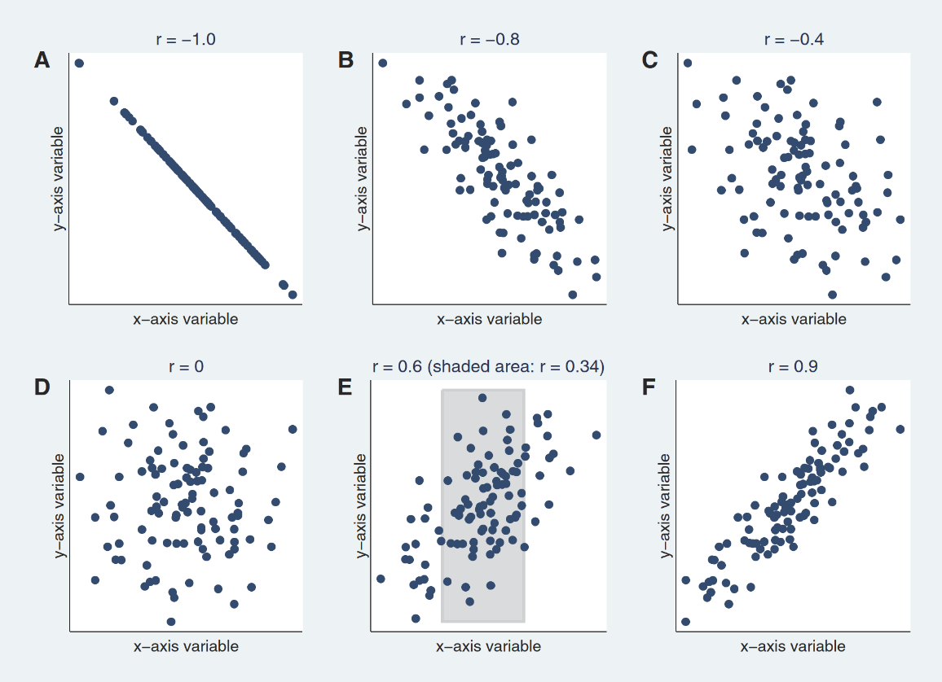

Figure 1: Scatterplots of sample data with different Pearson correlation coefficients [7]

Figure 1 A illustrates a perfect correlation of -1. A perfect correlation of -1 or 1 implies that all the data points lie exactly on a straight line. In Figure 1 B and F, the scatterplot approaches a straight line as the coefficient tends towards -1 or 1, whereas in Figure 1 D there is no linear relationship, as the coefficient is 0. Figure 1 E displays that the correlation depends on the range of the assessed value, a wider range leans towards higher correlation than the smaller range in the shaded area [7].

### Spearman rank correlation

In contrast to a Pearson correlation, a Spearman correlation – generally abbreviated as *ρ* (rho) or *rs* – can be used to analyse nonlinear monotonic relationships. Furthermore, it is relatively robust against outliers. The Spearman correlation also ranges from -1 to 1, whereas *ρ* = 0 implies that there is no association, while *ρ* = -1 or 1 implicate a perfect correlation [7].

### Interpretation of the correlation coefficients

The scatterplots in the following Figure 2 illustrate the two correlation methods – Pearson and Spearman – on a sample dataset. Note, that the correlation coefficient should always be assessed by a visual representation of the data. For example, in Figure 2 A, both coefficients are close to 0, which connotes that there is no association between the x-axis and y-axis variables, when in fact, the plot suggests a strong quadratic relationship. Another interesting observation is, that despite the same Pearson correlation coefficient values *r* in Figure 2 B through D, the data is quite different in each of the panels. Figure 2 Breveals, on the one hand, the robustness of the Spearman coefficient against outliers and on the other hand, its notable influence on the Pearson coefficient. In Figure 2 C, a sinusoid relationship – neither linear nor monotonic – is depicted, both correlation methods are unable to capture it. This can be further observed in Figure 2 D [7].

Over the course of years, several threshold values to translate a correlation coefficient into descriptors such as “weak”, “moderate” or “strong” relationship – which are arbitrary and inconsistent – have been proposed. While most researchers would agree that a correlation less than 0.1 indicates a negligible and one greater than 0.9 a strong relationship, values in between are disputable and therefore should be interpreted within the context of the posed research question [7].

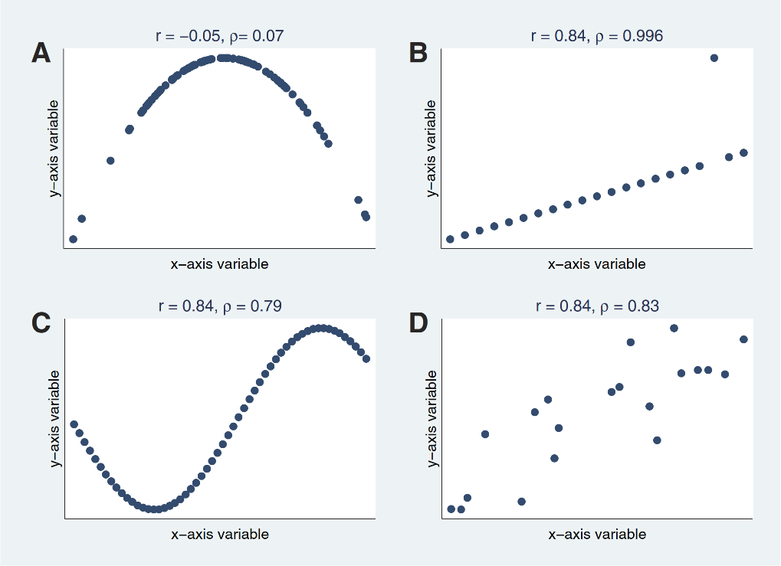

Figure 2: Scatterplots of sample data with both correlation coefficients [7]

## Time series decomposition

Time series decomposition is a method that splits a time series, which may exhibit a variety of patterns into several components, each representing an underlying pattern category, “trend”, “seasonality”, and “residual” [8] [9]. This is often employed to help improve understanding of the time series or to improve forecast accuracy [8].

The decomposed pattern components are defined as follows:

* **Trend** describes whether the time series is decreasing, increasing or constant over time [9]. It does not have to be linear. Sometimes we refer to a trend as a “change of direction”, e.g., when it might go from an increasing to a decreasing trend [10].
* **Seasonality** describes the periodic signal in the time series [9]. This pattern occurs when a time series is affected by seasonal factors such as the time of the year or the day of the week. Seasonality has always a fixed and known frequency [10].
* **Residual** is what remains behind the separation of seasonality and trend from the time series. It is the variability in the data that cannot be explained [9].

A time series can be considered as a combination of these components, either additively or multiplicatively [11].

An additive decomposition model is defined as

$y\left(t\right)=S\left(t\right)+T\left(t\right)+R\left(t\right)$,

where $y(t)$ is the data; $S(t)$, the seasonal component; $T(t)$, the trend component; and $R(t)$, the residual component, at period $t$. Alternatively, a multiplicative decomposition is formulated as

$y\left(t\right)=S\left(t\right)×T(t)×R(t)$ [12].

To identify whether the problem is additive or multiplicative, a review of a plot of the time series can be regarded as a good starting point [11]. A rule of thumb for selecting the right model is to see if the trend and seasonal variation are relatively constant over time, i.e., linear. When this is the case, an additive model can be chosen. Otherwise, if the trend and seasonal variation increase or decrease over time, a multiplicative decomposition shall be used [9].

### Example on a real-world dataset

For better understanding, let us look at a real-world dataset (see Figure 3), which describes the total number of airline passengers from 1949 to 1960. The horizontal axis represents the number of monthly observations during that period, the vertical axis, the number of airline passengers in thousands [11].

The line plot may suggest a linear trend. A seasonality can also be observed; however, the amplitude appears to be increasing, indicating a multiplicative problem. Hence, a multiplicative decomposition is applied as shown in Figure 4 [11].

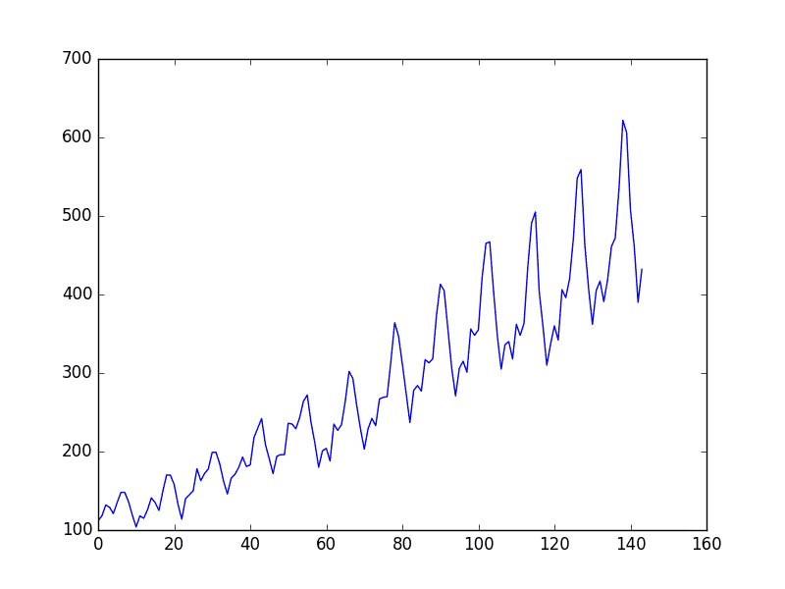

Figure 3: Airline passengers dataset [11]

There are also datasets for which a naive or classical decomposition fails, as illustrated in Figure 5, where it was not able to separate the noise from the linear trend. For such scenarios, caution and scepticism is required [11].

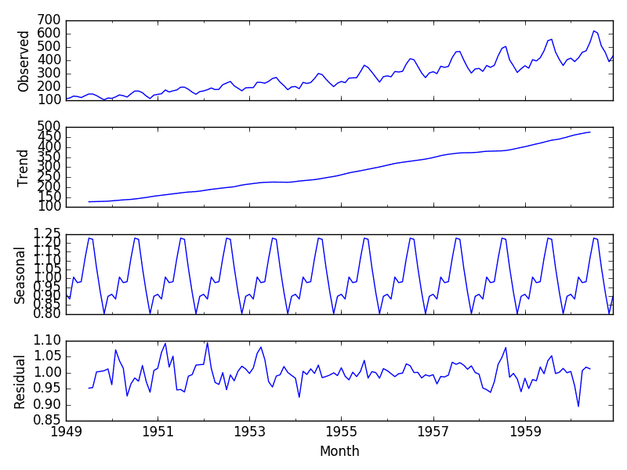

Figure 4: Multiplicative decomposition of airline passengers dataset [11]

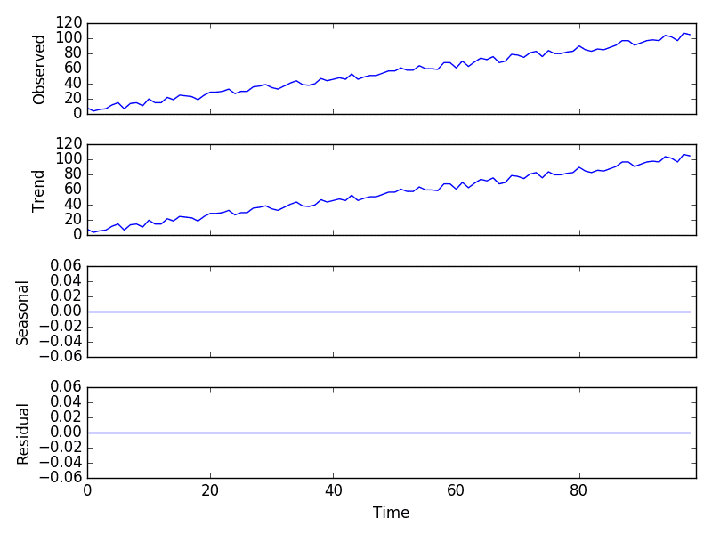

Figure 5: Additive decomposition of linearly increasing trend with random noise [11]

# Methodology

In this chapter, we discuss the components needed for the analysis in chapter 4 – beginning with a brief overview of the hardware and software setup, followed by an outline of the three datasets: the restaurant review data from Tripadvisor and Google, and the restaurant revenue data from Prognolite. The chapter concludes with an in-detail description of the web scraping process – a technique, we applied to extract and store the restaurant review data from websites – followed by a section about data processing.

## Hardware

The web scraping, depending on the amount of review data, is a time-consuming procedure, which can take several days to complete. Hence, it was conducted on a ZHAW server with Intel Core processor (Broadwell- microarchitecture) with 2.5 GHz, 16 cores and 128 GB main memory (RAM). The server runs the Linux kernel 4.15. All the other tasks could be performed without the application of the server.

## Software

This thesis mainly involves data science tasks. The two common programming languages suited for such tasks are R and Python. Despite the popularity of R among data scientists and the broad variety of libraries it provides for statistical analysis and visualisation, we decided to use Python, because, firstly, we didn’t have any prior knowledge of R and secondly, over the course of our bachelor studies, we were exposed to several Python projects and were therefore already familiar with this language. Like R, Python also offers several libraries for data science, such as NumPy and SciPy for scientific computing, Pandas for data analysis and manipulation, Matplotlib and Seaborn for creating data visualizations [13]. Besides the data science libraries, packages like Requests and Selenium are used for review data acquisition, which will be discussed in-depth in section 3.4.

The project, which can be found [here](https://github.com/fatihsolmaz22/Bachelorarbeit_FS22)[2], is set up with Poetry, a tool for dependency management and packaging in Python. As a development environment, PyCharm is used.

## Data

In the following subchapters, the data required for the correlation analysis are presented individually.

### Restaurant revenue data: Prognolite

The restaurant revenue data obtained from our industry partner Prognolite, is a large CSV file comprising information on 15 restaurants in Switzerland, some of which are chain affiliated. The information includes details such as date with timestamp, turnover in CHF, local (school) holidays, local temperature in degree Celsius, etc. In this work, we use only the date with timestamp and the corresponding turnover information for each restaurant.

### Restaurant review data: Tripadvisor and Google

To study the effectiveness of eWOM on restaurant revenues, review data needs to be collected. Our first consideration was to acquire the restaurant review data effortlessly and efficiently, if possible, from an API, provided by popular online review platforms. An important criterion was, that the review data for each restaurant where revenue data exists, should contain sufficient ratings. After comprehensive research by consulting extant literature, the three platforms Yelp, Tripadvisor, and Google emerged. Yelp was ineligible, since there was no review data for some of the restaurants we wanted to investigate. The other two platforms, however, provided the relevant information we needed, although, it had to be extracted through web scraping (see section 3.4), as neither platform offer APIs. As a result, we decided to scrape the restaurant review data from Tripadvisor first and then from Google, because the latter proved to be more complex and arduous.

The Table 1 below gives an overview of the gathered review data in numbers. Just by observing the numbers, we can tell that, in general, more reviews are written on Google than on Tripadvisor. This can be justified by the fact that Tripadvisor targets primarily travellers or tourists, while Google is widely known and used by the majority, including locals and tourists.

|  |  |  |
| --- | --- | --- |
| **Restaurant** | **Number of reviews** | |
| *Tripadvisor* | *Google* |
| The Butcher |  |  |
| Uster | 13 | 368 |
| Aarbergergasse | 146 | 1233 |
| Zug, Metalli | 152 | 960 |
| Zürich West | 63 | 906 |
| Missu Miu |  |  |
| Europaallee | 120 | 1272 |
| Negishi |  |  |
| Zug, Metalli | 395 | 910 |
| Pilatusstrasse | 140 | 1379 |
| Steinen | 137 | 644 |
| Nooch |  |  |
| Aarbergergasse | 368 | 930 |
| Basel, Barfi | 188 | 646 |
| Mall of Switzerland | 57 | 772 |
| Mattenhof | 50 | 448 |
| Richti, Wallisellen | 195 | 951 |
| Uster | 28 | 369 |
| Outback |  |  |
| Stadelhofen | 403 | 1627 |

Table 1: The scraped review data in numbers

The review data come from two different sources; hence it had to be processed and organised and brought to the same format. For this purpose, we use the schema defined in Appendix 7.1, which is derived from the review information presented on the Tripadvisor website for one restaurant. Note, that not all the available information on the website were scraped and therefore presented. The important ones for the analysis are the overall rating (from 1 to 5), the number of reviews and the review data, which includes e.g., the individual user ratings with the corresponding dates when they were published. This schema is also applicable to Google restaurant reviews, as it shares certain similarities to the ones on Tripadvisor.

Many restaurants on online review platforms receive up to hundreds of customer reviews, making it time-consuming to read them all. In such cases, we assume, that the first thing a person may do to learn about the quality of a restaurant, is to look at the overall rating, which might take into account several factors, for instance the author data – information about a costumer, who composed the review – or the number of likes, a review received from other customers. This additional information was also extracted, with the goal of finding how the overall rating is calculated. The results of this analysis are stated in chapter 4, section 4.1.

## Data acquisition: Web scraping

### Tripadvisor

Initially, we contacted Tripadvisor via email, asking if they could provide us the review data through an API. Unfortunately, they did not respond to our request – a creative solution had to be devised. We decided to scrape the data off the webpage (see Figure 6), which is publicly accessible.

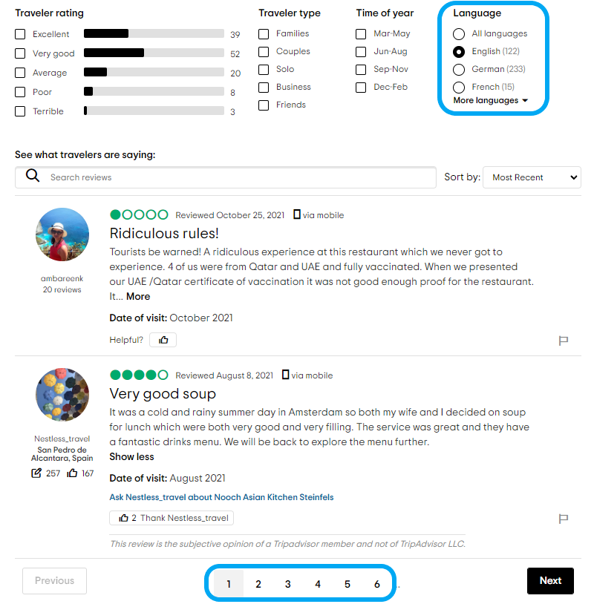

Figure 6: Tripadvisor webpage with restaurant reviews. Note that for purpose of presentation, only two reviews are listed.

This is the part of the webpage where the reviews for a single restaurant are shown. First, we tried scraping the review data using two Python packages called Requests and BeautifulSoup. These packages are only capable of loading the static HTML page; interactions – framed in blue, in Figure 6 – such as button clicking, are not possible. However, these interactions are very much needed to scrape all the reviews.

Since Tripadvisor has designed its pages in a manner, that only 10 to 15 reviews are displayed per site, many page switches are necessary to gather all the data. Furthermore, the website initially loads reviews only in the web browser's default language, which also has to be changed by clicking the option “All languages”; a lot of reviews are filtered out if this option is not selected.

We needed a technology to perform these tasks successfully. We found Selenium to be a great tool to overcome these challenges. Using this framework, one can fetch a page, select specific elements, and perform the preferred actions, such as clicking on a button on the chosen element, using JavaScript commands. In addition, it can also preserve the state it is in after performing an action, e.g., after switching to another page, it stays on that page, available for further actions.

Using this technology as a baseline, we developed a “ScrapingTool”, which can be found in our GitHub repository[3]. This tool simplified the data extraction from Tripadvisor.

**Tripadvisor review container**

The customer reviews are bundled in HTML elements with HTML tag “div” and attribute name “review-container”, as depicted in Figure 7. Accordingly, we collected all the review elements for each page and extracted the required information from them, for instance, the individual ratings, stored inside the “review-container” with HTML tag “span” and attribute name “ui_bubble_rating.bubble_40“; and the dates within the element tag “span” and attribute name "ratingDate".

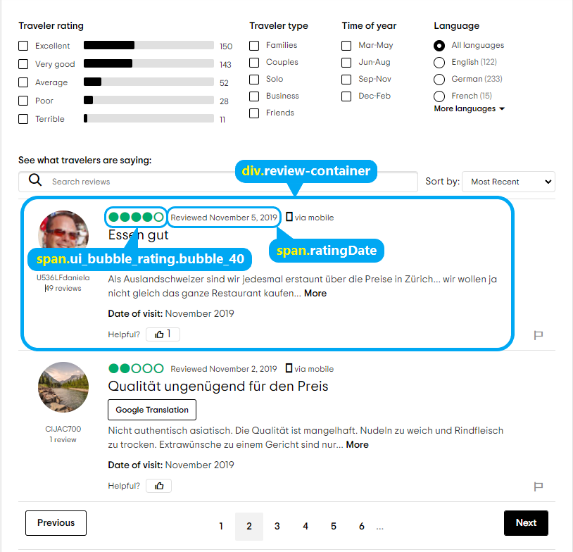

Figure 7: Review container, which comprises the review data of an individual customer.

### Google

While scraping Tripadvisor, it occurred to us that there was not sufficient review data for the correlation analysis. For this reason, we decided to scrape Google reviews as well. The following Figure illustrates a restaurant review section on Google Maps.

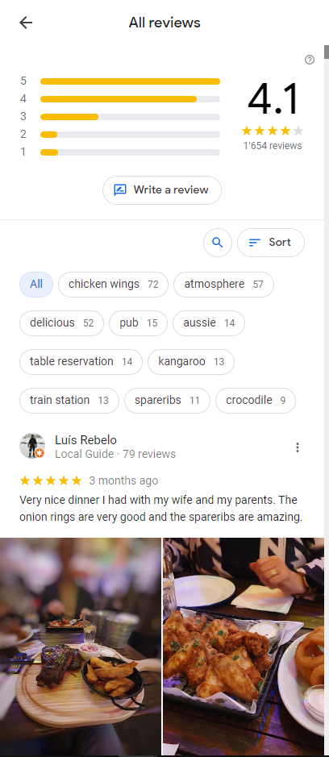  
This is the initial page when visiting a restaurant's review section on Google Maps; only the first 10 reviews are visible to the user. To view further reviews, one would have to scroll down to the bottom of the page. There is no issue in acquiring the first few reviews but after loading a set amount of reviews, the webpage becomes unresponsive and shows an error (see Figure 9).

Figure 8: Example of a restaurant review section on Google Maps.

We started to think, it is impossible to extract the review data from Google. But then, another idea occurred. Usually, when data is dynamically requested, it has to be separately downloaded by the browser and injected into the webpage. Based on this realisation, we started observing the network traffic in the browser, as shown below.

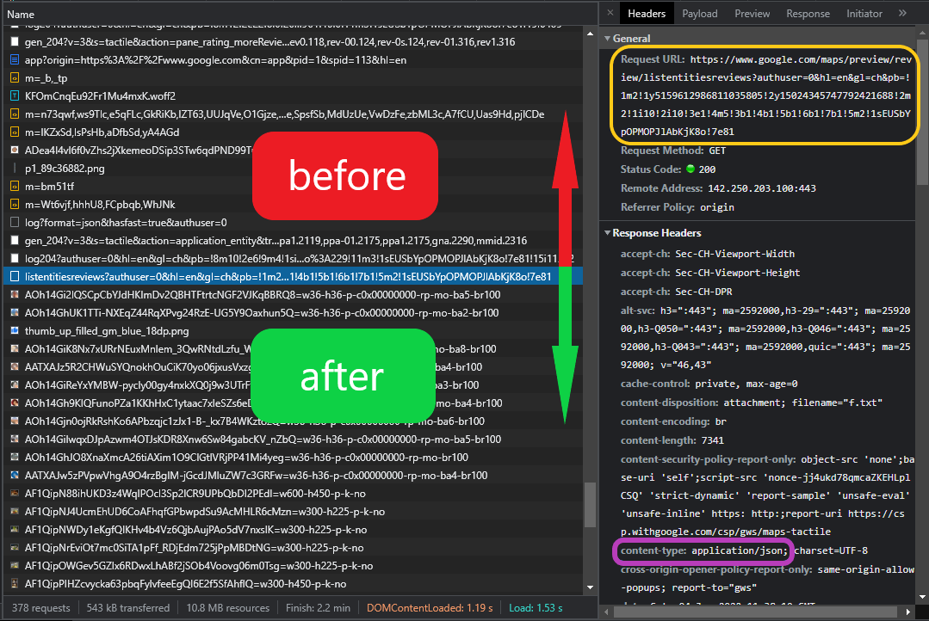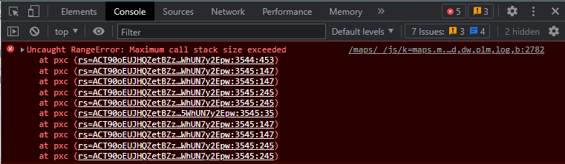After scrolling down to the bottom of the page for the first time, to load the next set of reviews, the browser shows inside the network traffic section, a new list of files or information, which is highlighted in green and labelled with “after” in Figure 10. By inspecting the first link, which is emphasised in blue, one can see on the right side, the entire request link – framed in yellow; more notably, the “content-type” of the response to that request, which is a JSON file – highlighted in purple. Consequently, we decided to take a look at this file, since it might contain the information, we require.

Figure : Error message in the browser after attempting to load too many reviews

Figure : Network traffic before and after scrolling to the bottom of the review section

The JSON file only provided restaurant review data of 10 reviewers. Therefore, we decided to scroll down one more time and compare both request links that granted us access to the review data Figure 11.

Figure 11: Comparison of the request links before scrolling down (left) with the one after scrolling down (right).

Note, that both links only differ in one digit as emphasised in blue. The left link provides reviews with the indices 10 to 19, whereas the right one, the reviews with the indices 20 to 29. In order to request all the review data, one would only have to replace the highlighted digit with 0, 10, 20, 30 etc.

However, this approach leads to sending a lot of requests to the Google server, which in turn asks us to complete a CAPTCHA – a type of challenge-response test used in computing to determine whether the user is human [14]. The tricky part was to realise that after completing the CAPTCHA manually, the browser will store the interaction between the Google server and the user as a cookie, which then again can be saved and later used to prevent Google servers from blocking the execution of further requests.

## Data processing

After performing the data acquisition, the extracted restaurant review and revenue data have to be processed, in order to provide the required variables needed for the correlation analysis, namely:

* **Running average rating per time period** of a restaurant, which describes the average customer satisfaction and is computed by adding up the individual costumer ratings per time period and then dividing by the number of ratings per time period. Note, that time period is a placeholder for month, quarter or year.
* **Overall rating development over time period**, which characterizes how the overall rating of a restaurant has developed over the course of months, quarters or years since the first rating, the restaurant received, till the recent rating. This measure is calculated by adding up the values from the first rating to the latest rating, divided by the number of ratings during that period.
* **Average turnover per time period** of a restaurant, a measure, which is the sum of turnover over days during a time period, divided by the number of days on which revenue was generated during that same period. Again, time period refers to month, quarter or year.

For time series data, that originate from a restaurant which has strong recurring seasonal fluctuations and rising or falling trends, the decomposition of these patterns is crucial. For example, a restaurant is more likely to have a high revenue during summer due to better weather conditions or on holidays such as Christmas. However, these circumstances probably do not influence user ratings, nor are they related to the restaurant rating. As a result, there will be an upwards trend in revenue in the summer or on holidays, but no visible upwards trend in the costumer ratings. Therefore, we certainly need to normalize the revenue data to make it comparable to the ratings of the restaurant. This is achieved through decomposing the time series with Python into several components: trend, seasonal and residual. For the correlation analysis between the restaurant review and revenue data, the original time series, and the decomposed results: trend and residual, are used.

# Results

In this chapter we present the results to answer the initially formulated research questions and to verify the hypotheses. First, we discuss our findings of how the overall rating is calculated for restaurants on Tripadvisor and Google. The subsequent sections are devoted to the correlation analyses – the primary goal of our thesis – where we utilize different tools, e.g., line and scatter plots; the correlation coefficients, Pearson and Spearman; and time series decomposition.

## Analysis of the overall rating

The notion behind this analysis is that nowadays, popular online review platforms provide an enormous amount of information. We assume that the first thing a person might do to learn about a restaurant on such platforms, is to look at the overall rating, often displayed at the beginning of the website. We believe that a good overall rating can increase the popularity of a restaurant, which in turn can have a positive effect on restaurant revenue. Furthermore, we hypothesize that the reckoning of the overall rating varies from platform to platform, since each platform is built differently.

### Tripadvisor overall rating

Tripadvisor states that the overall bubble rating takes into account the quality, quantity and age of individual tourists’ ratings and reviews. The “bubble” rating ranges from one to five – one meaning “terrible” and five meaning “excellent”. The overall rating can be broken down by distribution of ratings; type of travel, such as business or family; or aspects of the business, such as service or cleanliness [15].

Since the formula, Tripadvisor use to calculate the overall rating, is not publicly accessible, an alternative solution approach had to be devised. Initially, the plan was to employ multiple linear regression. We therefore scraped additional restaurant review information (see section 3.3.2), we thought, were necessary to build and train a model to predict the overall rating. Before deciding for this approach, we had also considered – contrary to Tripadvisor's statement – whether the overall rating might just be the average of the individual costumer ratings.

Thus, we scraped the review data from 1720 restaurants in canton Zurich. We then computed the average rating for each restaurant and compared it with the overall rating. The below scatterplot in Figure 12 depicts that the computed and rounded average of the individual costumer ratings is equivalent to the overall rating. For all the 1720 restaurants, the data points lie on a straight line. The scatterplot above in Figure 12 showcases the link between the overall rating and the computed overall rating. Notice, that despite all the data points being scattered in a horizontal direction, they remain within the bounds specified by the vertical dashed red lines.

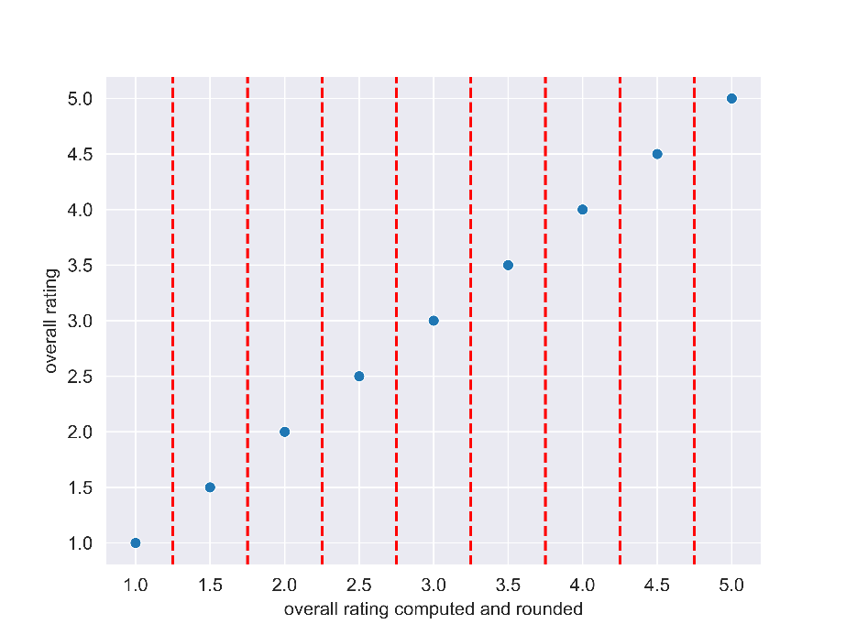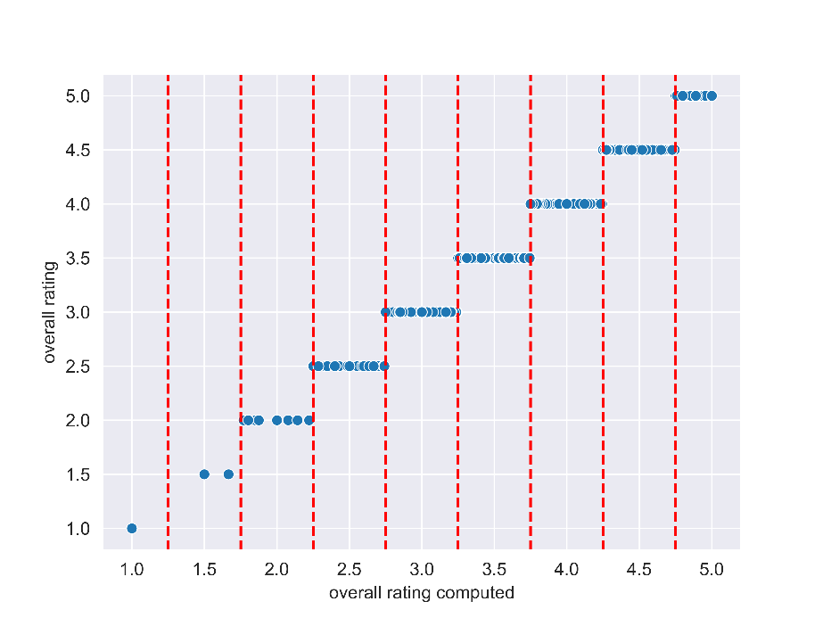

Figure 12: Scatterplots which describe the relationship between Tripadvisor overall rating and the computed overall rating. The vertical red dashed lines represent the bounds.

### Google overall rating

The restaurant overall rating on Google is calculated from user ratings and a variety of other factors [16]. Nevertheless, we tried the same approach as previously described, with the only difference, we did not use a large dataset, but rather the review data of the 15 restaurants, where we had the revenue data, because the scraping of a large Google review dataset is sophisticated. In addition, we did not have time to investigate this further. The scatterplots in Figure 13 demonstrate that for the 15 restaurants, the computed and rounded average of the individual user ratings is equivalent to the overall rating and the data points remain within the bounds.

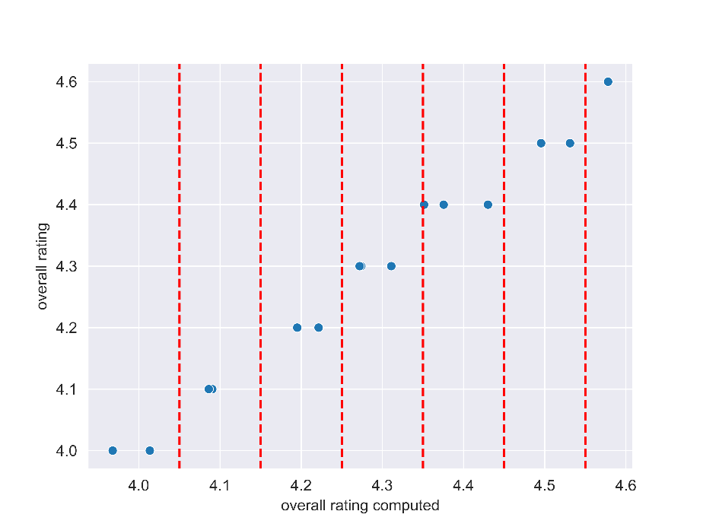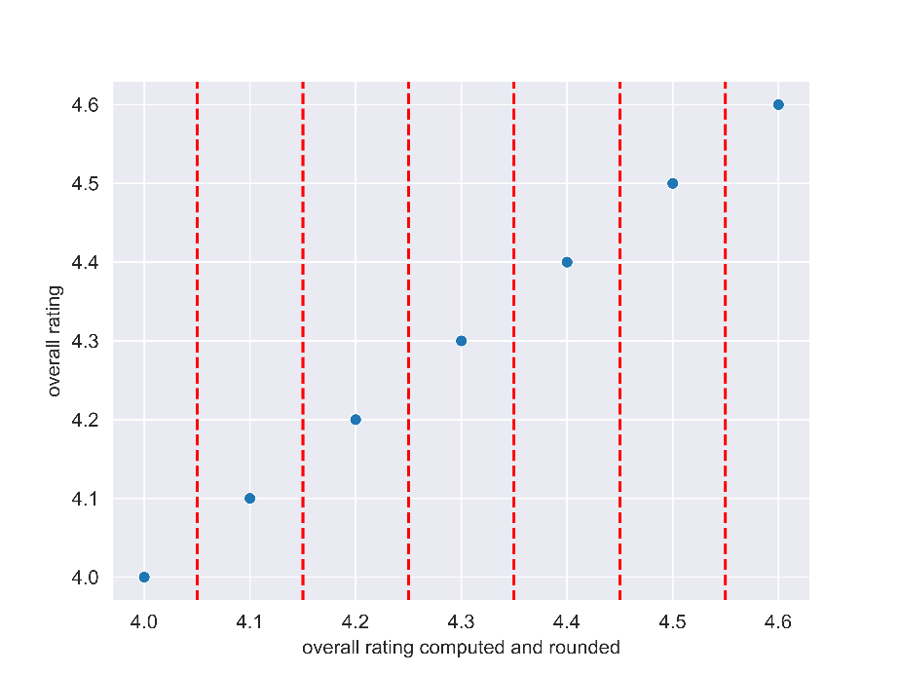

Figure 13: Scatterplots which describe the relationship between Google overall rating and the computed overall rating. The vertical red dashed lines represent the bounds.

## Prerequisites for the correlation analyses

### Running average rating and overall rating

In this subchapter we discuss whether the calculated overall rating or the running average rating described in section 3.5 is better suited for the correlation assessments. The Table below shows a comparison between these two ratings for two restaurants.

|  |  |
| --- | --- |
| **Running average rating** | **Overall rating** |
|  |  |
|  |  |

Table 2: Running average rating versus Overall rating

When comparing running average rating to overall rating, there are big differences to be seen. These contrasts mainly derive from the fact that the calculated overall rating tends to stabilize around a fixed point with minor peaks and lows. So, if the revenue data is rather stable, it would correlate. Otherwise, if it fluctuates a lot, it will not correlate. This seems counterproductive to the research questions we try to answer. For this reason, we are using the running average rating as our baseline for the correlation analysis.

### Data before, and data before and during the COVID-19 pandemic

Towards the end of 2019, a global pandemic heavily impacted the world, prompting many countries to take appropriate measures, which also had a great influence on restaurants around the globe. For this reason, we are looking closer into how to handle the data correctly to prevent faulty interpretation of our findings (see Table 3).

|  |  |
| --- | --- |
| **Before COVID-19** | **Before and during COVID-19** |
|  |  |
|  |  |
| r = 0.29, ρ = 0.12 | r = 0.45, ρ = 0.37 |

Table 3: Data before COVID-19 versus data before and during COVID-19

The example above shows the rating and turnover data for the restaurant Nooch Aarbergergasse. Note, that on the left side, only data until the end of 2019 is considered. There are significant differences to be seen. Visibly, the column labelled “Before and during COVID-19” shows more notable fluctuations than the column on the left. It is hard to conclude why the correlation coefficients differ this much, but we think that in some cases it might have to do with the fact that there are more data points with low revenue and low rating in the dataset “Before and during COVID-19”, highlighted by a yellow circle. Hence, in this case, the correlation coefficients show better results, since the outliers, circled in green, are less out of the picture compared to the ones on the left side. There is no denying that it still correlates somehow, but it is hard to assess how representative the correlation measurement value of the data is, which includes the time period after the global pandemic hit.

After extensive evaluation of the correlation plots, we have determined that differentiating data periods before the impact of the global pandemic is necessary. If not, our data analysis could be corrupted by several influential variables such as shutdown, hygiene protocols, mask mandates, etc. impacting everyday interactions during and after that time period. As a consequence, for our evaluations in sections 4.3 to 4.5, we will only be including the data before the year 2020. The intention of this, is to support a distinctive evaluation of the acquired data.

### Delayed impact of rating on revenue

We assume that the impact of ratings on review portals like Google or Tripadvisor has a delay, since it takes some time for ratings to be seen by users and create an upward or downward trend in revenue income. After some investigation of the data, we have decided to build in a delay of one month, which means that the rating value of the chosen restaurant at the start of the month is matched to the accumulated revenue by the end of the month. In the case of comparing the running average rating to the average revenue, the running average rating of the previous month is matched to the average turnover of the current month. When comparing Google and Tripadvisor ratings for a restaurant, the implementation of a delay is not needed, since these ratings do not have any impact on each other.

### Seasonality and trend

Following the theory described in section 2.2, we investigate whether seasonality and trend possibly have an impact on the revenue data. The Figure 14 below depicts some of the restaurants, we were able to extract the seasonal and trend components from.

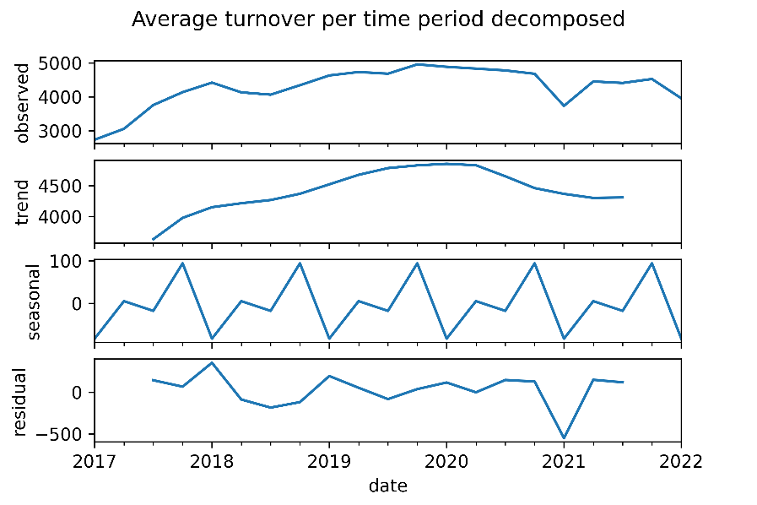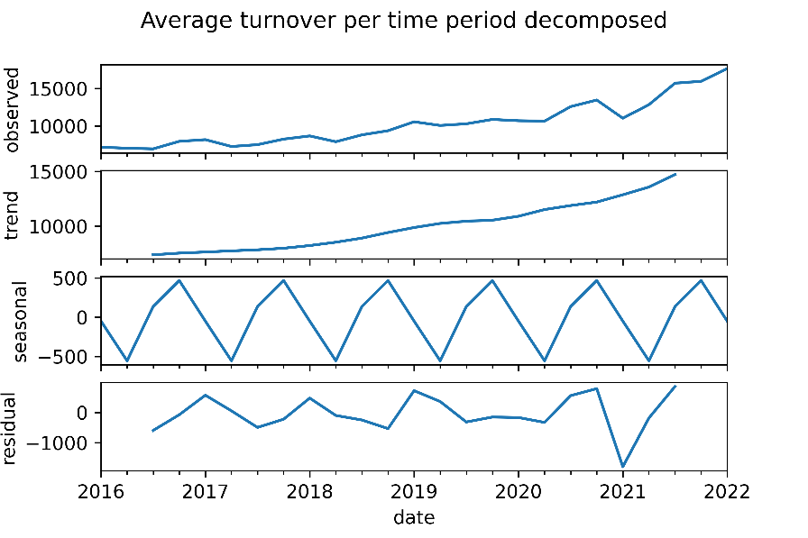

Figure 14: Time series decomposition of average turnover for the restaurants Butcher Metalli (top) and Nooch Richti (bottom)

We were able to perform a decomposition on 13 of 15 restaurant revenue data; the decomposition exhibited similar patterns, as shown above. For two of the restaurants, the decomposition failed due to the small number of data points. The decomposed component seasonality illustrates that there are seasonal effects in the revenue data. It shows a falling tendency in seasonality at the start of the year and a rising tendency towards the end of the year. We assume that the rise in revenue is caused by good weather conditions in the summer or holidays like Christmas. In addition, it is important to notice that the amplitude for our findings of the seasonality data is not as high, compared to its original value. Therefore, even if we exclude these patterns, it does not affect our data significantly. Similarly, there is a visible trend in these plots, but since we assume that reviews trigger a rising or falling trend, we are incorporating that part of the composition into our evaluation. Accordingly, we are taking into consideration using the combination of the residual and trend components, and leaving out seasonality, whenever it seems to have a positive impact on the calculated correlation coefficients. The used methodology is denoted in the title of the plot, as “(residual + trend)”, when seasonal decomposition is applied, otherwise as “(observed)”, as outlined in the following Table 4.

|  |  |
| --- | --- |
| **Observed** | **Residual + Trend** |
|  |  |
|  |  |
| r = 0.36, ρ = 0.15 | r = 0.69, ρ = 0.54 |

Table 4: Original average turnover time series versus the decomposed time series

Clearly, there is an improvement both in the visual plots of the revenue data and the correlation measurement values. Unfortunately, the decomposition is not always possible for the available time period of the dataset as a whole, as shown above; thus, we have to be careful about how representative it is. For this reason, we will only consider the decomposed data if it consists of sufficient data points, which was always the case throughout the analysis.

### Time period

There is one more variable that we had to decide on, the time period, which defines how many days we accumulate the data for the next averaged data point. We used three different options: “Monthly”, “Quarterly” and “Yearly”. As the names suggest, “Monthly” is a 1-month period, “Quarterly” represents a 3-month period and “Yearly” a yearly time period. After many experiments, we realized that “Monthly” resulted in not having enough data points to perform seasonal decomposition; It could only decompose the average turnover of 6 out of 15 restaurants. “Yearly” did not make much sense either, since the timespan of the data we work with, is not long enough. Using the option “Quarterly”, we were able to decompose up to 13 out of 15 restaurant revenue data and it provided sufficient data points for computing the correlation coefficients. For this reason, we are using data accumulated in quarter-year periods for the correlation analyses.

## Correlation between Tripadvisor and Google restaurant rating

As described in our research questions, we have reasons to believe that Google and Tripadvisor ratings show rather moderate correlations. Therefore, we used both datasets and tried to find similarities by analysing plots and employing correlation coefficients. Below are the correlation plots (see Table 5) of the given restaurants with more than 4 common data points.

|  |  |
| --- | --- |
| **A** | **B** |
| r = 0.33, ρ = 0.71 | r = 0.58, ρ = 0.38 |

|  |  |
| --- | --- |
| **C** | **D** |
| r = 0.44, ρ = 0.53 | r = 0.42, ρ = 0.29 |
| **E** | **F** |
| r = 0.21, ρ = 0.27 | r = 0.24, ρ = 0.24 |
| **G** | **H** |
| r = 0.09, ρ = 0.02 | r = -0.13, ρ = -0.19 |

|  |  |
| --- | --- |
| **I** | **J** |
| r = -0.17, ρ = -0.40 | r = -0.38, ρ = -0.25 |
| **K** |  |
| r = -0.55, ρ = -0.50 |  |

Table 5: Scatterplots of running average ratings of Google and Tripadvisor

Contrary to our expectations, the scatterplot A shows a promising correlation with minor outliers. The restaurants labelled B to D show a moderate correlation, as expected. Surprisingly, the rest shows weak to no positive correlations, either in any of the measurement values. Due to not achieving the anticipated results and our curiosity, we decided to investigate some datasets on a deeper level (see Figure 15 and Figure 16).

Here we are looking closer into the data of the scatterplots labelled E and F. The green circles indicate that there are several instances where a correlation can be observed, but it is not conclusive in any way or form. We suspect that it is quite impossible to derive definite correlations because Google data provides more data points for the calculation of running average ratings than Tripadvisor does, which will be discussed in detail in section 4.5. This leads to fewer fluctuations of running average rating values for Google data than for Tripadvisor data. As a result, we are unable to capture changes more distinctively for Google ratings. We believe that Google has a different audience than Tripadvisor, which makes the comparison difficult; Tripadvisor is primarily used by tourists or customers who are heavily invested in writing online reviews, whereas Google by the whole population, with great diversity. These differences can lead to systematic distinctions in restaurant ratings.

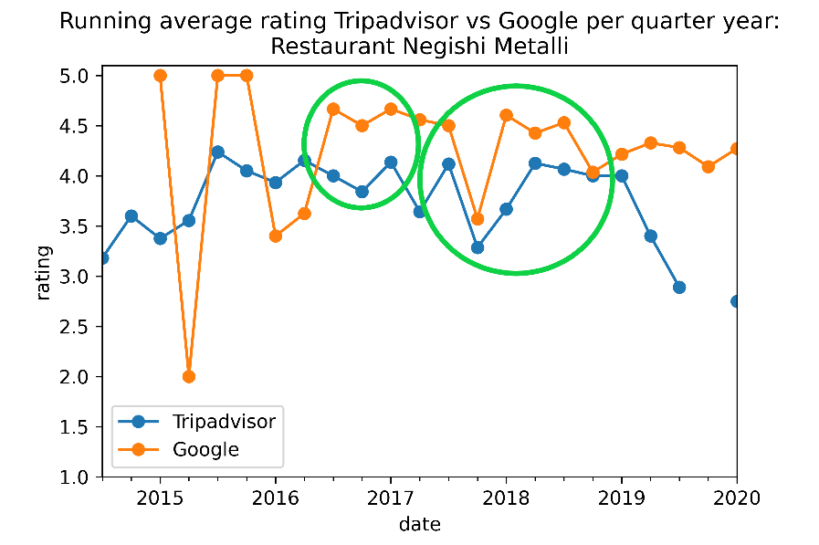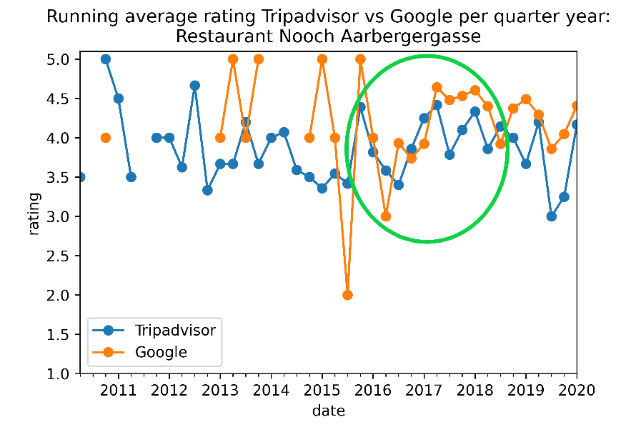

Figure 15: Line plot of the scatterplot with label **E**

Figure 16: Line plot of the scatterplot with label **F**

## Correlation between Google restaurant rating and Prognolite turnover data

Based on our formulated hypothesis, we believe that there is a positive relationship between Google restaurant ratings and Prognolite restaurant revenues. The following Table 6 depicts the scatterplots of the restaurants, containing more than 3 data points, with their correlation coefficients. Some of the revenue data have been seasonally decomposed and are labelled accordingly.

|  |  |
| --- | --- |
| **A** | **B** |
| r = 0.29, ρ = 0.12 | r = 0.22, ρ = 0.24 |
| **C** | **D** |
| r = 0.14, ρ = -0.09 | r = 0.07, ρ = 0.06 |
| **E** | **F** |
| r = -0.14, ρ = -0.08 | r = -0.18, ρ = -0.25 |

|  |  |
| --- | --- |
| **G** | **H** |
| r = -0.38, ρ = -0.22 | r = -0.27, ρ = -0.31 |
| **I** | **J** |
| r = -0.29, ρ = -0.57 | r = -0.39, ρ = -0.51 |
| **K** |  |
| r = -0.51, ρ = -0.43 |  |

Table 6: Scatterplots of running average rating Google versus average turnover

As expected, scatterplots of the restaurants labelled as A to D show weak positive correlations. But contrary to our expectations, most of them show no positive correlations in any of the measurement values. Due to not achieving the anticipated results, we decided to investigate some datasets on a deeper level (see Figure 17 and Figure 18).

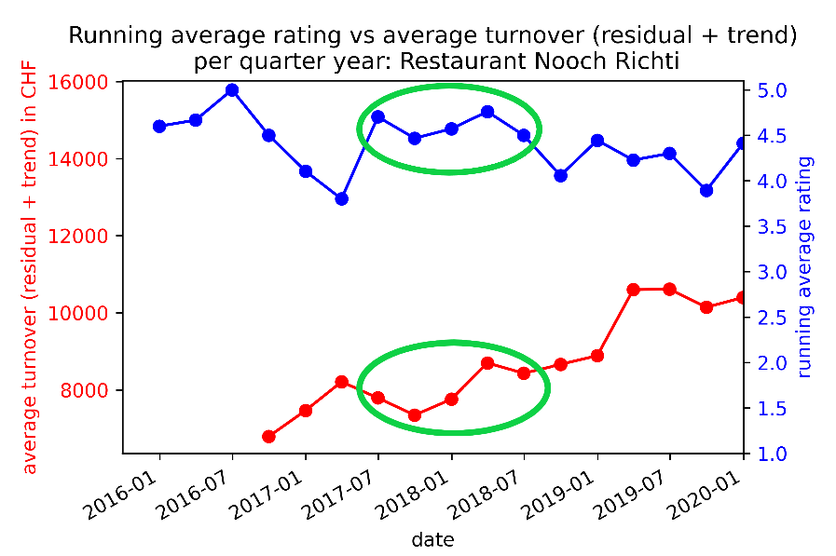

Figure : Line plot of the scatterplot with label **H**

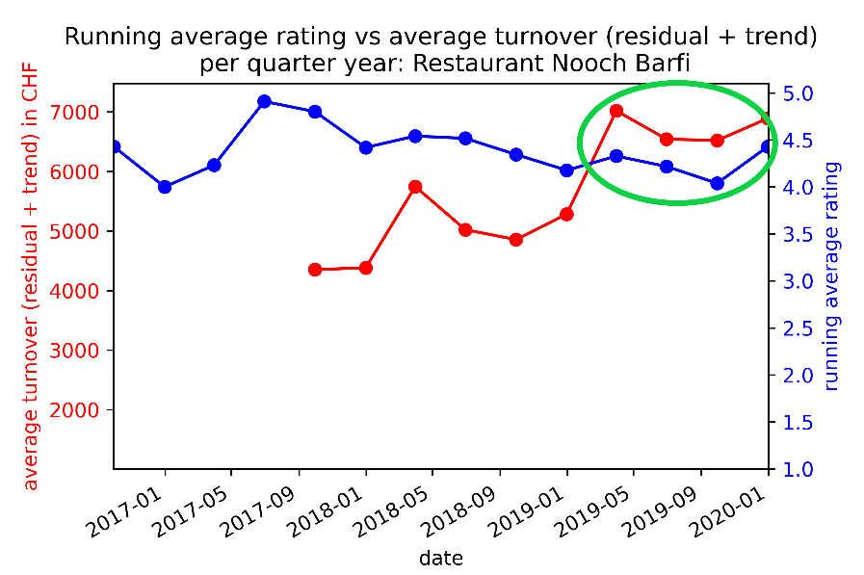  
There are several instances where some correlation between the two datasets can be observed, yet a definite conclusion cannot be drawn. We suspect that it is quite impossible to derive correlations since there are many variables, that can impact the revenue of a restaurant e.g., eWOM, influence by social media and many others unknown factors.

Figure : Line plot of the scatterplot with label **K**

## Correlation between Tripadvisor restaurant rating and Prognolite turnover data

Our final hypothesis states that Tripadvisor ratings and restaurant revenue show positive correlation but in a smaller magnitude than Google ratings. We once again consulted the scatterplots with their correlation coefficients (see Table 7). Note, that only the restaurants with more than 3 common data points are considered for the analysis. Furthermore, seasonal decomposition was applied on average turnover, which is labelled accordingly.

|  |  |
| --- | --- |
| **A** | **B** |
| r = 0.35, ρ = 0.42 | r = 0.32, ρ = 0.38 |
| **C** | **D** |
| r = 0.27, ρ = 0.21 | r = 0.15, ρ = 0.22 |
| **E** | **F** |
| r = 0.04, ρ = 0.16 | r = 0.11, ρ = 0.13 |

|  |  |
| --- | --- |
| **G** | **H** |
| r = 0.10, ρ = 0.01 | r = -0.22, ρ = -0.12 |
| **I** | **J** |
| r = -0.16, ρ = -0.14 | r = -0.34, ρ = -0.21 |
| **K** |  |
| r = -0.40, ρ = -0.41 |  |

Table 7: Scatterplots of running average rating Tripadvisor versus average turnover

Surprisingly, these findings resulted better than Google ratings, the opposite of what we assumed. Most of them show positive correlations in the measurement values; only 4 restaurants show negative values. Out of curiosity, why Google ratings performed worse, we decided to put up a comparison between Google and Tripadvisor ratings for the same restaurants (see Table 8).

|  |  |
| --- | --- |
| **Google** | **Tripadvisor** |
|  |  |
|  |  |
| r = 1.40, ρ = -0.28 | r = 0.35, ρ = 0.42 |

Table 8: Comparison between Google and Tripadvisor rating versus average turnover

To compare the datasets properly, we used decomposed versions of the restaurant revenue time series in both columns. Visibly, the correlation coefficients show a better correlation in the Tripadvisor ratings. It is hard to suspect the reasoning behind this occurrence but based on chapter 3, section 3.3.2, we know that there are a lot more data points available for a quarter year of Google ratings than Tripadvisor ratings. This is also visible in the line plots above. On the left column, you can see that the ratings fluctuate between 3.5 and 5.0. On the other side, the rating values are between 2.0 and 5.0. We had the same issues when deciding between running average rating and overall rating in section. Overall ratings stabilize over time and the same is happening here. Google ratings are more stable over a 3-month period and using a 1-month period isn't feasible either, as explained in section 4.2.5. This leads to the inability of capturing changes distinctively for Google ratings. Another explanation could be that due to Google most likely having a much more diverse audience, it might have more outliers in the dataset. This results in worse outcomes in the correlation coefficients.

# Conclusion

The results indicate that Google and Tripadvisor ratings do not correlate as we expected. Google ratings rarely showed any positive correlations with revenue data, which contradicts our assumption in our research questions. On the other hand, Tripadvisor had more positive correlations than anticipated. The data also suggests that Tripadvisor ratings correlate better with restaurant revenue than Google ratings.

This would imply that Tripadvisor ratings have a bigger impact on restaurant revenue than Google ratings, but the reliability of this data could be impacted by many variables. For example, Google has a high amount of ratings per chosen time period. This results in Google stabilizing around a fixed point more frequently. Tripadvisor, on the other hand, when computing the running average rating, fluctuates a lot more due to the low amount of ratings. Consequently, we were unable to capture changes in customer satisfaction more distinctively for Google ratings. In addition, the revenue data we received are only from certain chain restaurants in Switzerland. If we had a more diverse set of restaurant data, it could have resulted differently. It was also unfortunate that the global pandemic introduced many unknown factors to our data, which made us opt to use only partial data for our findings.

In the future, we might be able to conduct a better evaluation of these correlations, when more data is gathered. Furthermore, there are many different methods left not experimented with, like comparing overall ratings to the trend of restaurant revenue data over a long period of time or constructing an accurate model for the calculation of the overall rating for Google ratings. Last but not least, there is also a lot of room for experimenting with additional methods, such as performing sentimental analysis of the user rating texts, which we have not been able to explore yet.

# Lists

## Bibliography

[1] L. Fang, ‘The Eﬀects of Online Review Platforms on Restaurant Revenue, Survival Rate, Consumer Learning and Welfare’, p. 74.

[2] E. Fernandes, S. Moro, P. Cortez, F. Batista, and R. Ribeiro, ‘A data-driven approach to measure restaurant performance by combining online reviews with historical sales data’, *International Journal of Hospitality Management*, vol. 94, p. 102830, Apr. 2021, doi: 10.1016/j.ijhm.2020.102830.

[3] W. G. Kim, J. (Justin) Li, and R. A. Brymer, ‘The impact of social media reviews on restaurant performance: The moderating role of excellence certificate’, *International Journal of Hospitality Management*, vol. 55, pp. 41–51, May 2016, doi: 10.1016/j.ijhm.2016.03.001.

[4] M. Luca, ‘Reviews, Reputation, and Revenue: The Case of Yelp.Com’, *SSRN Journal*, 2011, doi: 10.2139/ssrn.1928601.

[5] A. Sayfuddin and Y. Chen, ‘The signaling and reputational effects of customer ratings on hotel revenues: Evidence from TripAdvisor’, *International Journal of Hospitality Management*, vol. 99, p. 103065, Oct. 2021, doi: 10.1016/j.ijhm.2021.103065.

[6] S. Hyrynsalmi, M. Seppänen, L. Aarikka-Stenroos, A. Suominen, J. Järveläinen, and V. Harkke, ‘Busting Myths of Electronic Word of Mouth: The Relationship between Customer Ratings and the Sales of Mobile Applications’, *J. theor. appl. electron. commer. res.*, vol. 10, no. 2, pp. 1–18, May 2015, doi: 10.4067/S0718-18762015000200002.

[7] P. Schober, C. Boer, and L. A. Schwarte, ‘Correlation Coefficients: Appropriate Use and Interpretation’, *Anesthesia & Analgesia*, vol. 126, no. 5, pp. 1763–1768, May 2018, doi: 10.1213/ANE.0000000000002864.

[8] ‘Chapter 6 Time series decomposition | Forecasting: Principles and Practice (2nd ed)’. https://otexts.com/fpp2/decomposition.html (accessed Jun. 10, 2022).

[9] B. Bonaros, ‘Time Series Decomposition In Python’, *Medium*, Apr. 22, 2021. https://towardsdatascience.com/time-series-decomposition-in-python-8acac385a5b2 (accessed Jun. 10, 2022).

[10] ‘2.3 Time series patterns | Forecasting: Principles and Practice (2nd ed)’. https://otexts.com/fpp2/tspatterns.html (accessed Jun. 10, 2022).

[11] J. Brownlee, ‘How to Decompose Time Series Data into Trend and Seasonality’, *Machine Learning Mastery*, Jan. 29, 2017. https://machinelearningmastery.com/decompose-time-series-data-trend-seasonality/ (accessed Jun. 10, 2022).

[12] ‘6.1 Time series components | Forecasting: Principles and Practice (2nd ed)’. https://otexts.com/fpp2/components.html (accessed Jun. 10, 2022).

[13] ‘Python vs. R: What’s the Difference?’, Mar. 23, 2021. https://www.ibm.com/cloud/blog/python-vs-r (accessed Jun. 10, 2022).

[14] ‘CAPTCHA’, *Wikipedia*. Jun. 03, 2022. Accessed: Jun. 10, 2022. [Online]. Available: https://en.wikipedia.org/w/index.php?title=CAPTCHA&oldid=1091259650

[15] ‘Tripadvisor Help Center’. https://www.tripadvisorsupport.com/en-GB/hc/traveler/articles/438 (accessed Jun. 10, 2022).

[16] ‘Find review scores for local places and businesses - Google Business Profile Help’. https://support.google.com/business/answer/4801187?hl=en-GB (accessed Jun. 10, 2022).

## List of figures

Figure 1: Scatterplots of sample data with different Pearson correlation coefficients [7] 4

Figure 2: Scatterplots of sample data with both correlation coefficients [7] 5

Figure 3: Airline passengers dataset [11] 7

Figure 4: Multiplicative decomposition of airline passengers dataset [11] 7

Figure 5: Additive decomposition of linearly increasing trend with random noise [11] 8

Figure 6: Tripadvisor webpage with restaurant reviews. Note that for purpose of presentation, only two reviews are listed. 11

Figure 7: Review container, which comprises the review data of an individual customer. 12

Figure 8: Example of a restaurant review section on Google Maps. 13

Figure 9: Error message in the browser after attempting to load too many reviews 14

Figure 10: Network traffic before and after scrolling to the bottom of the review section 14

Figure 11: Comparison of the request links before scrolling down (left) with the one after scrolling down (right). 15

Figure 12: Scatterplots which describe the relationship between Tripadvisor overall rating and the computed overall rating. The vertical red dashed lines represent the bounds. 18

Figure 13: Scatterplots which describe the relationship between Google overall rating and the computed overall rating. The vertical red dashed lines represent the bounds. 19

Figure 14: Time series decomposition of average turnover for the restaurants Butcher Metalli (top) and Nooch Richti (bottom) 22

Figure 15: Line plot of the scatterplot with label **E** 27

Figure 16: Line plot of the scatterplot with label **F** 27

Figure 17: Line plot of the scatterplot with label **H** 30

Figure 18: Line plot of the scatterplot with label **K** 30

Figure 19: Formatted JSON file preview of Google review 39

Figure 20: The actual Google review 39

## List of tables

Table 1: The scraped review data in numbers 10

Table 2: Running average rating versus Overall rating 20

Table 3: Data before COVID-19 versus data before and during COVID-19 21

Table 4: Original average turnover time series versus the decomposed time series 23

Table 5: Scatterplots of running average ratings of Google and Tripadvisor 26

Table 6: Scatterplots of running average rating Google versus average turnover 29

Table 7: Scatterplots of running average rating Tripadvisor versus average turnover 32

Table 8: Comparison between Google and Tripadvisor rating versus average turnover 33

# Appendix

## JSON schema of the restaurant review data for a restaurant

**{**

**"restaurant_name": string,**

**"overall_rating": int,**

**"reviews_count": int,**

**"all_reviews": [**

**{**

**"author_data": {**

**"author_level": int,**

**"author_member_since": int,**

**"author_stats": {**

**"contributions": int,**

**"cities_visited": int,**

**"helpful_votes": int,**

**"photos": int**

**},**

**"author_distribution": {**

**"review_value_5": int,**

**"review_value_4": int,**

**"review_value_3": int,**

**"review_value_2": int,**

**"review_value_1": int**

**}**

**},**

**"review_data": {**

**"date": string,**

**"title": string,**

**"rating": int,**

**"content": string,**

**"likes": int**

**}**

**}, ...]**

**}**

## Comparison between Google review as JSON and the actual Google review

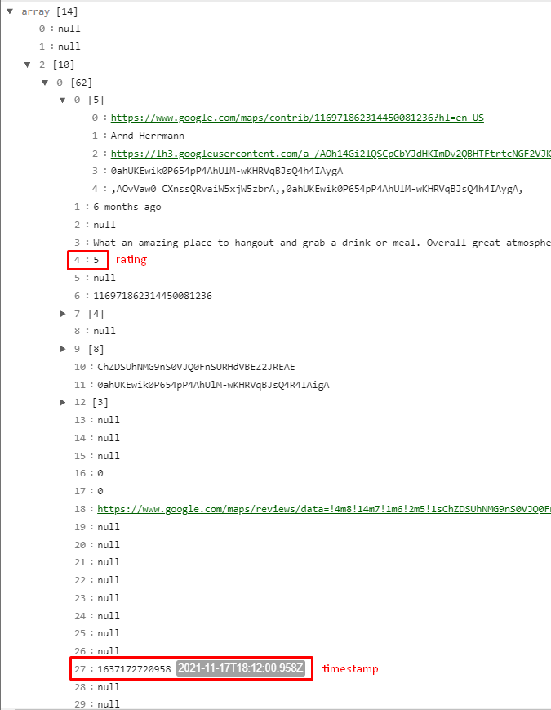

Figure 19: Formatted JSON file preview of Google review



Figure 20: The actual Google review

## Google versus Tripadvisor restaurants ratings

### Running average rating per month

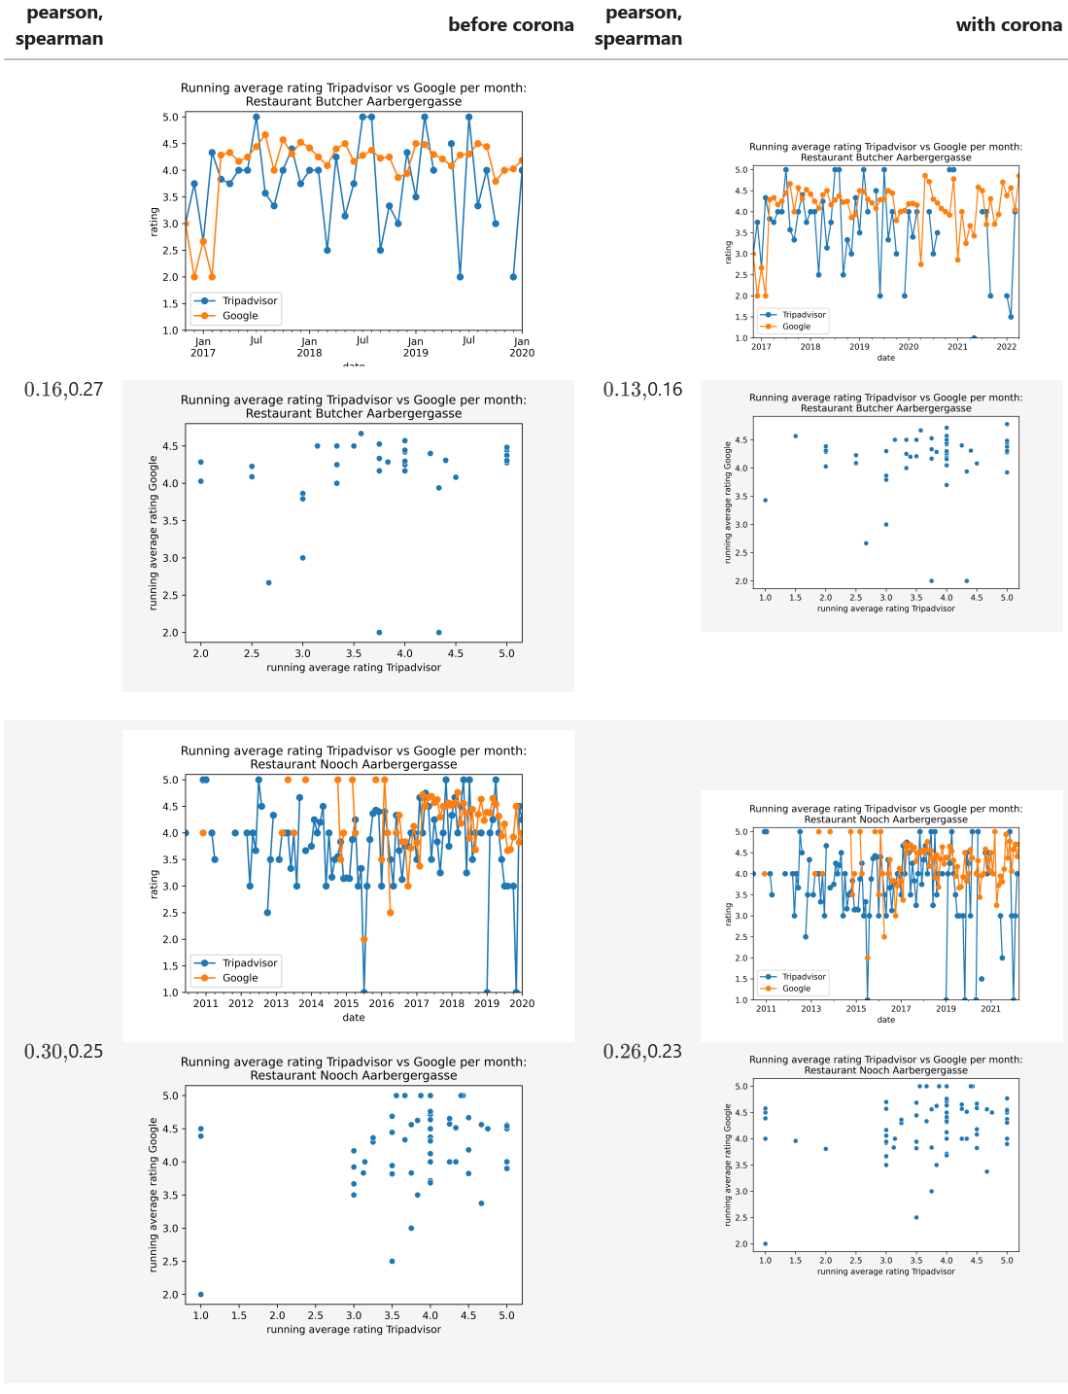

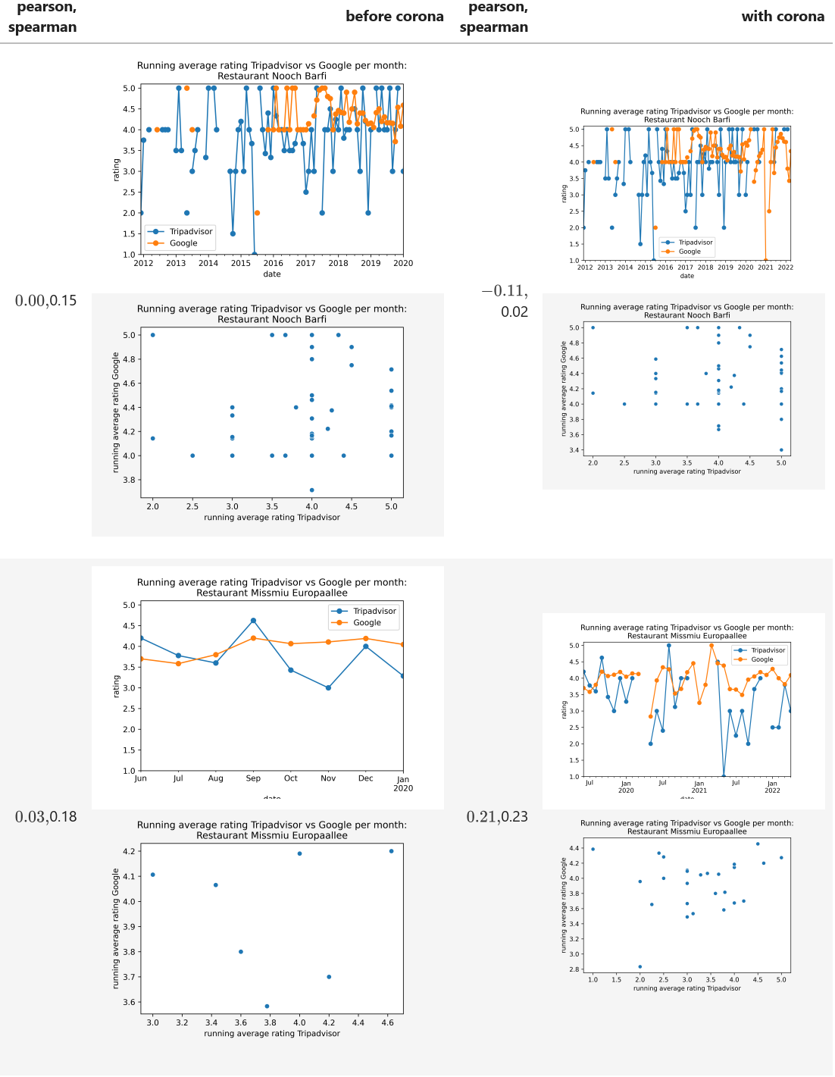

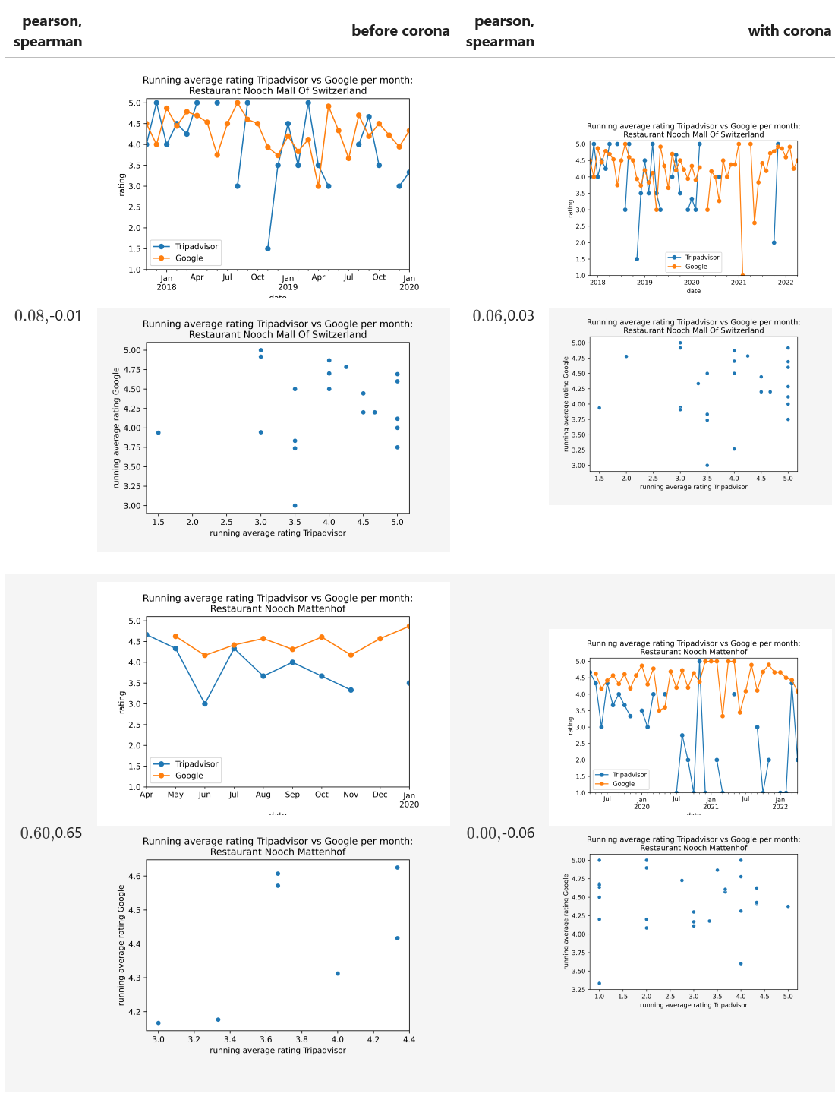

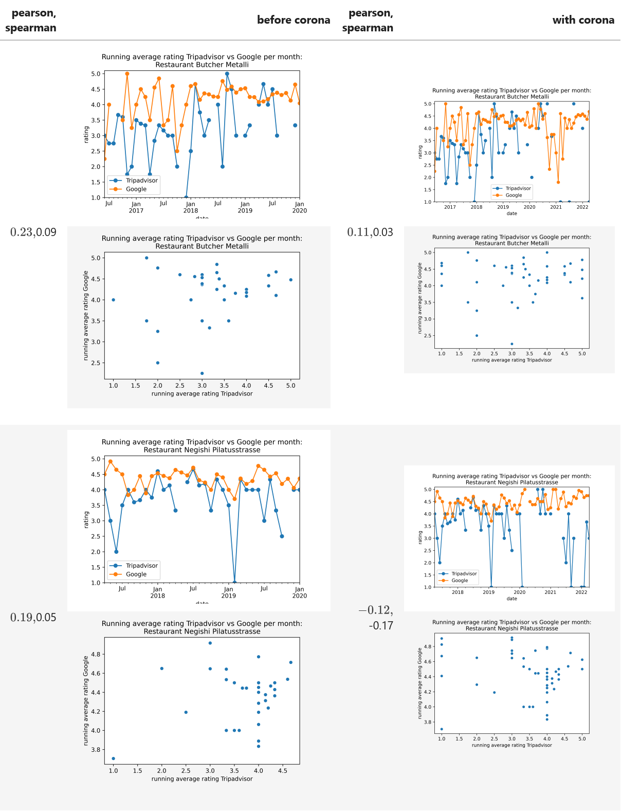

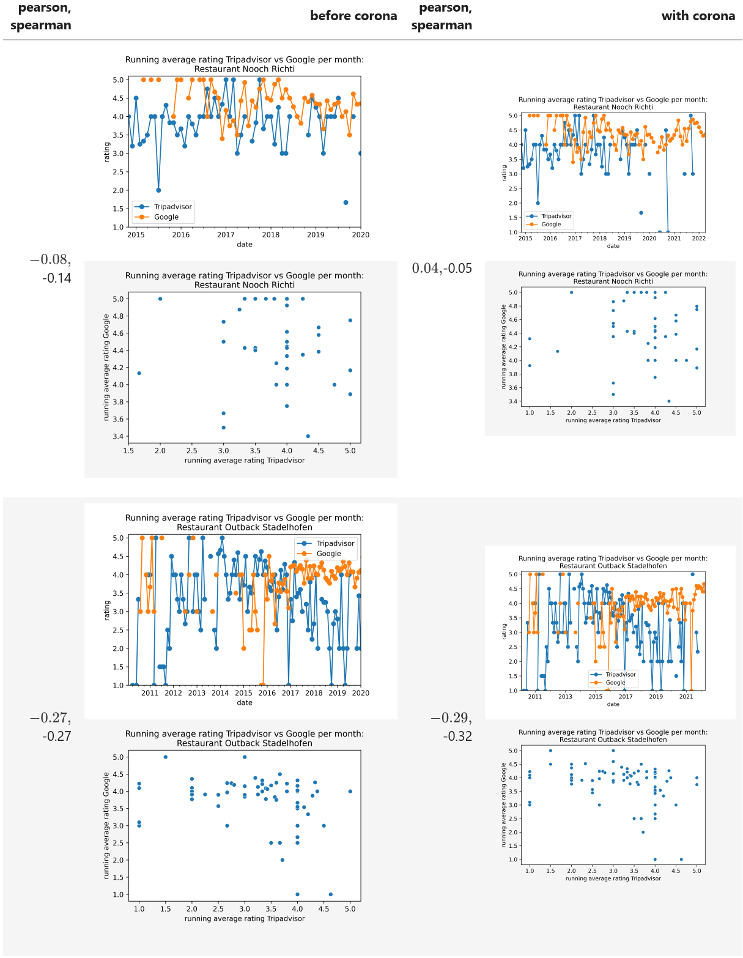

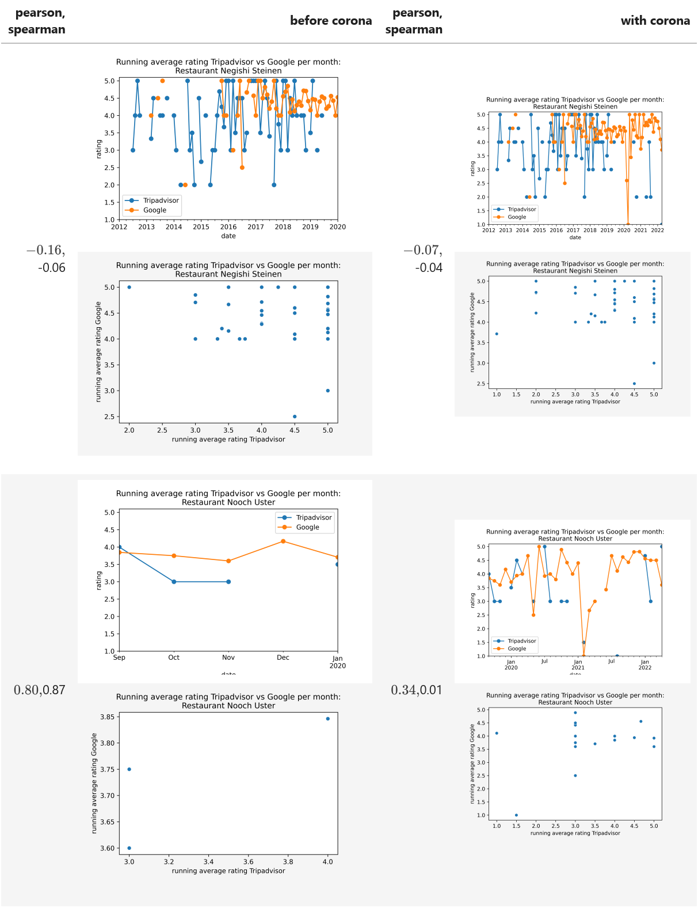

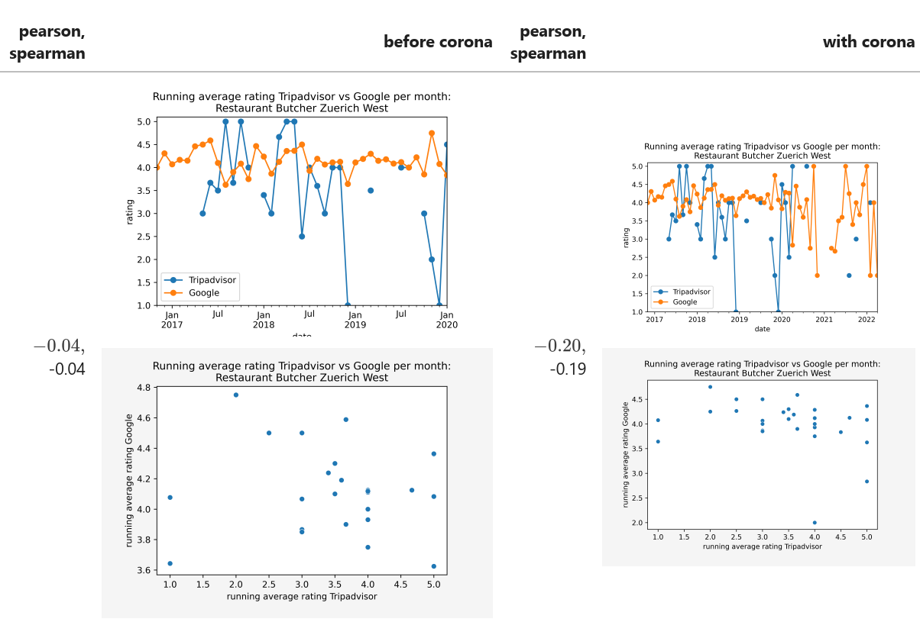

### Running average rating per quarter year

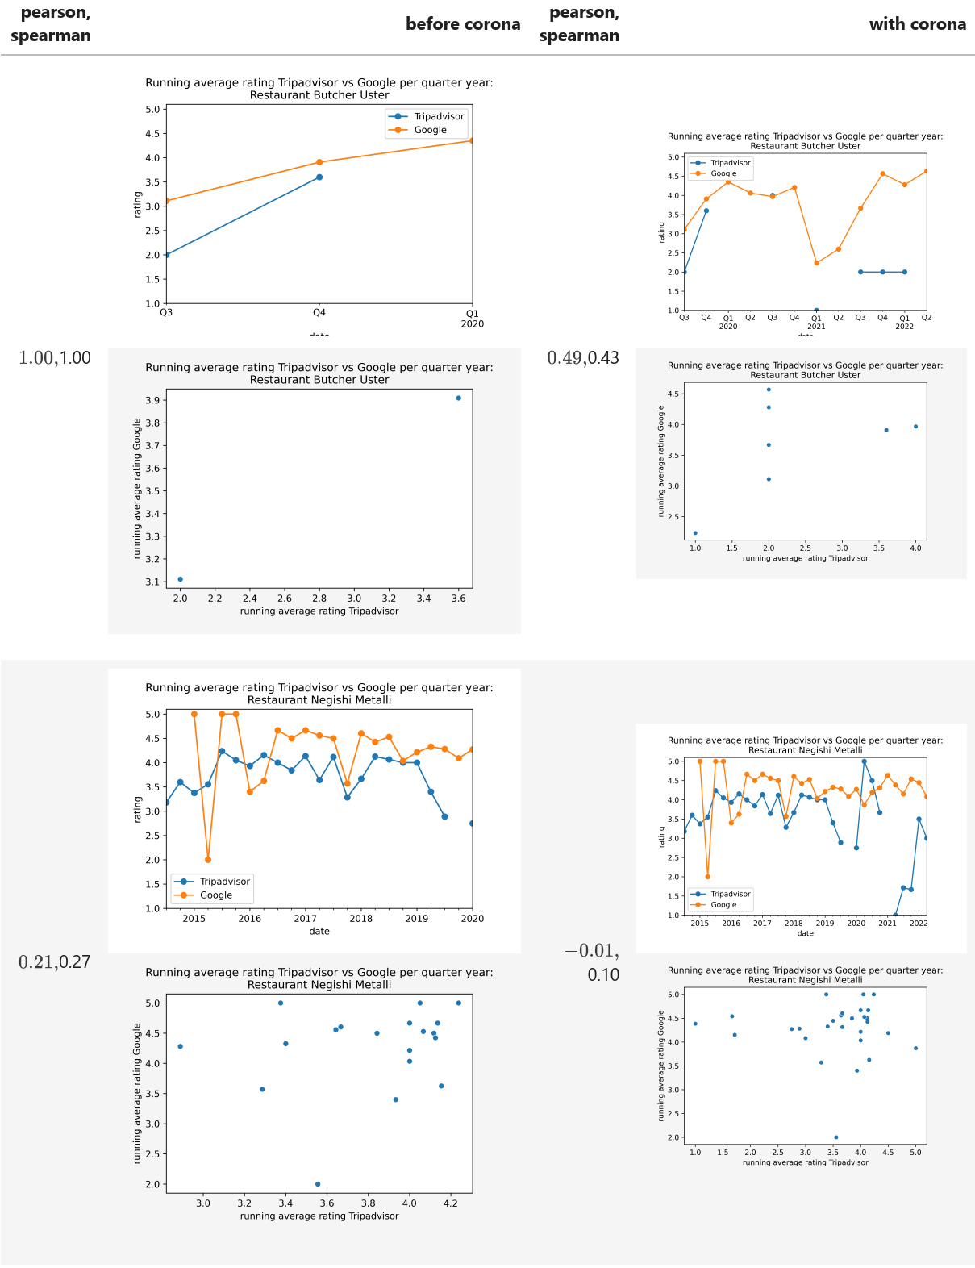

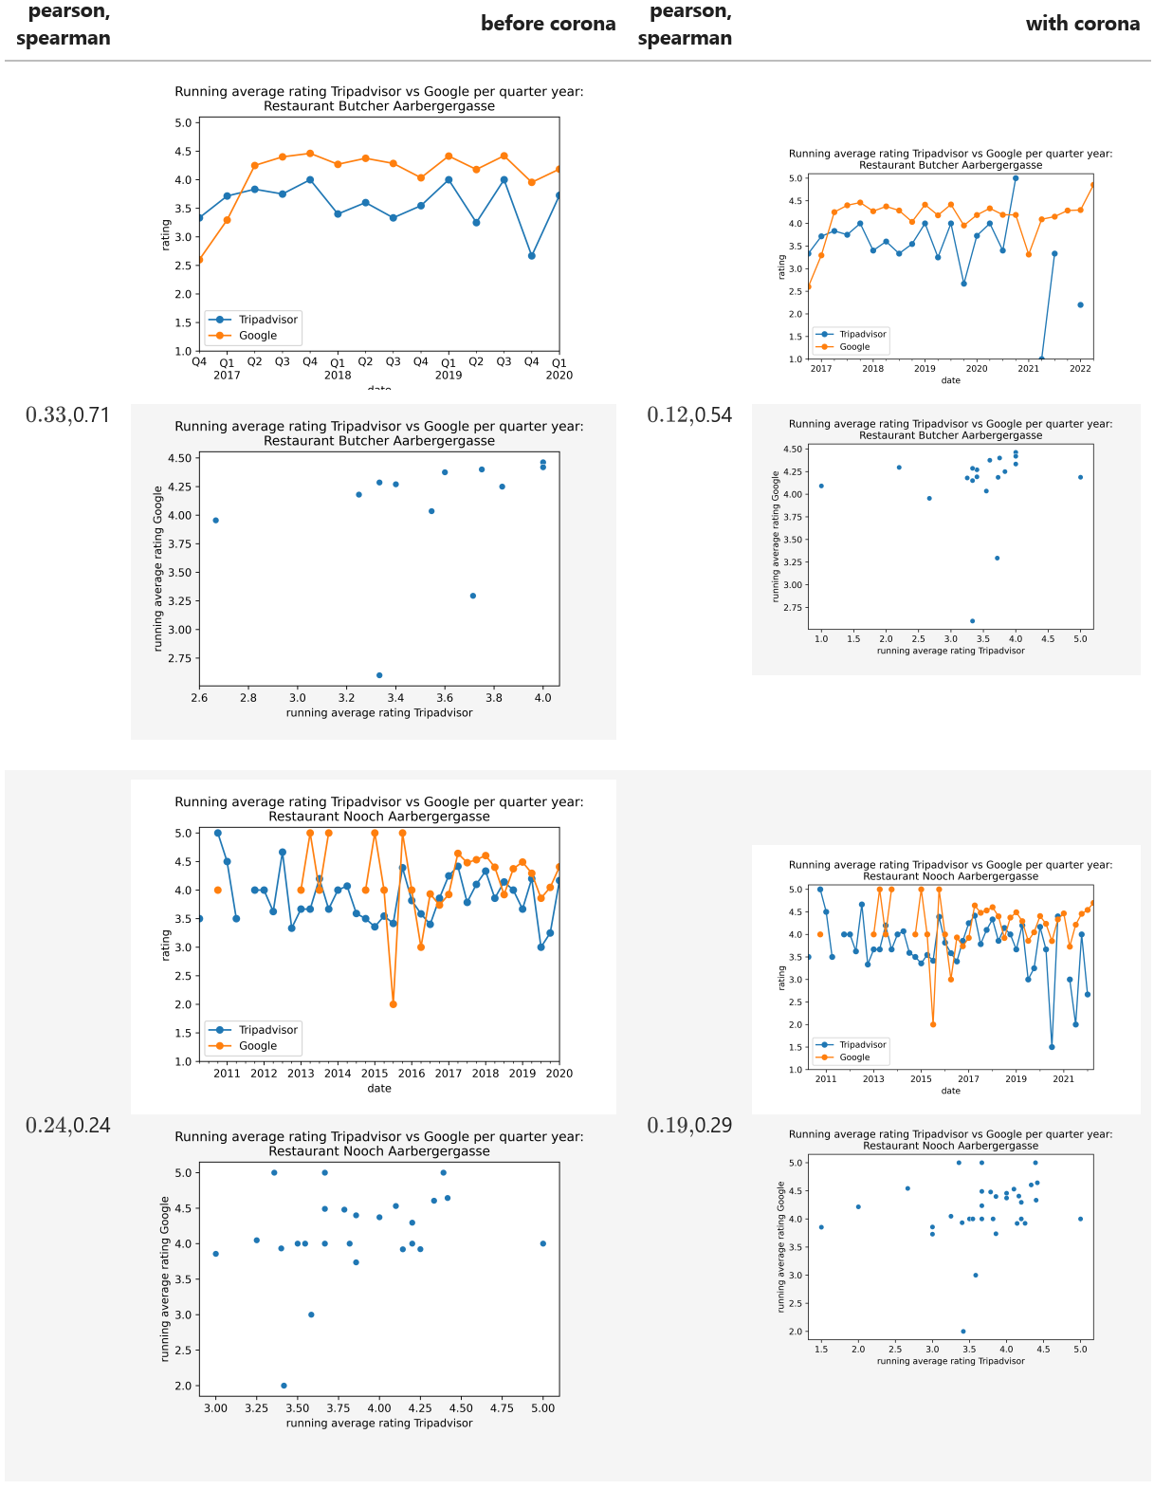

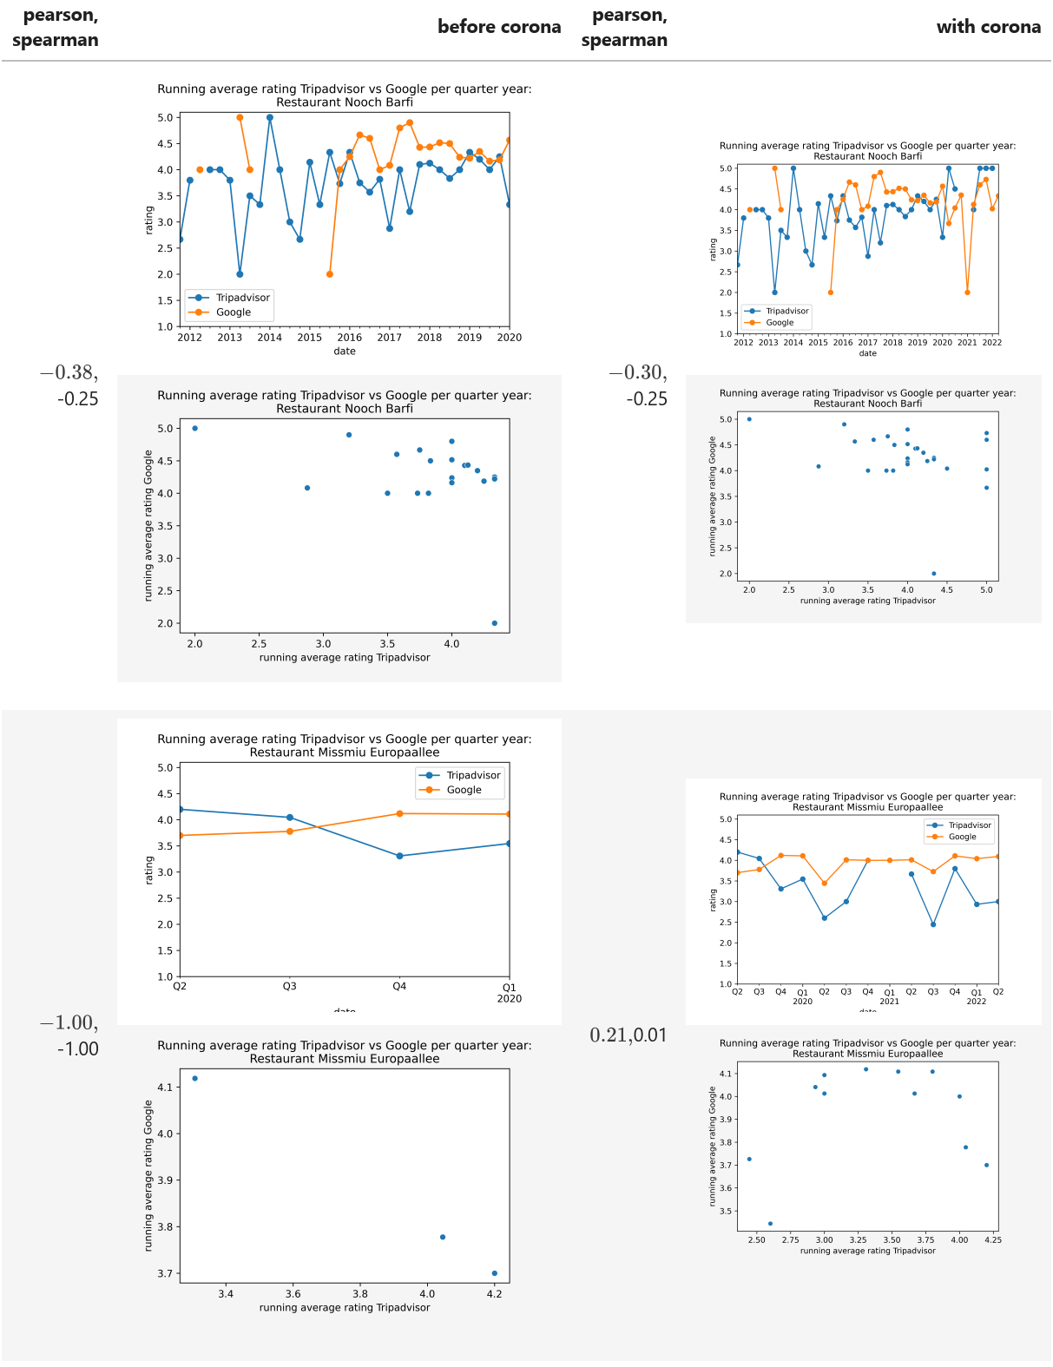

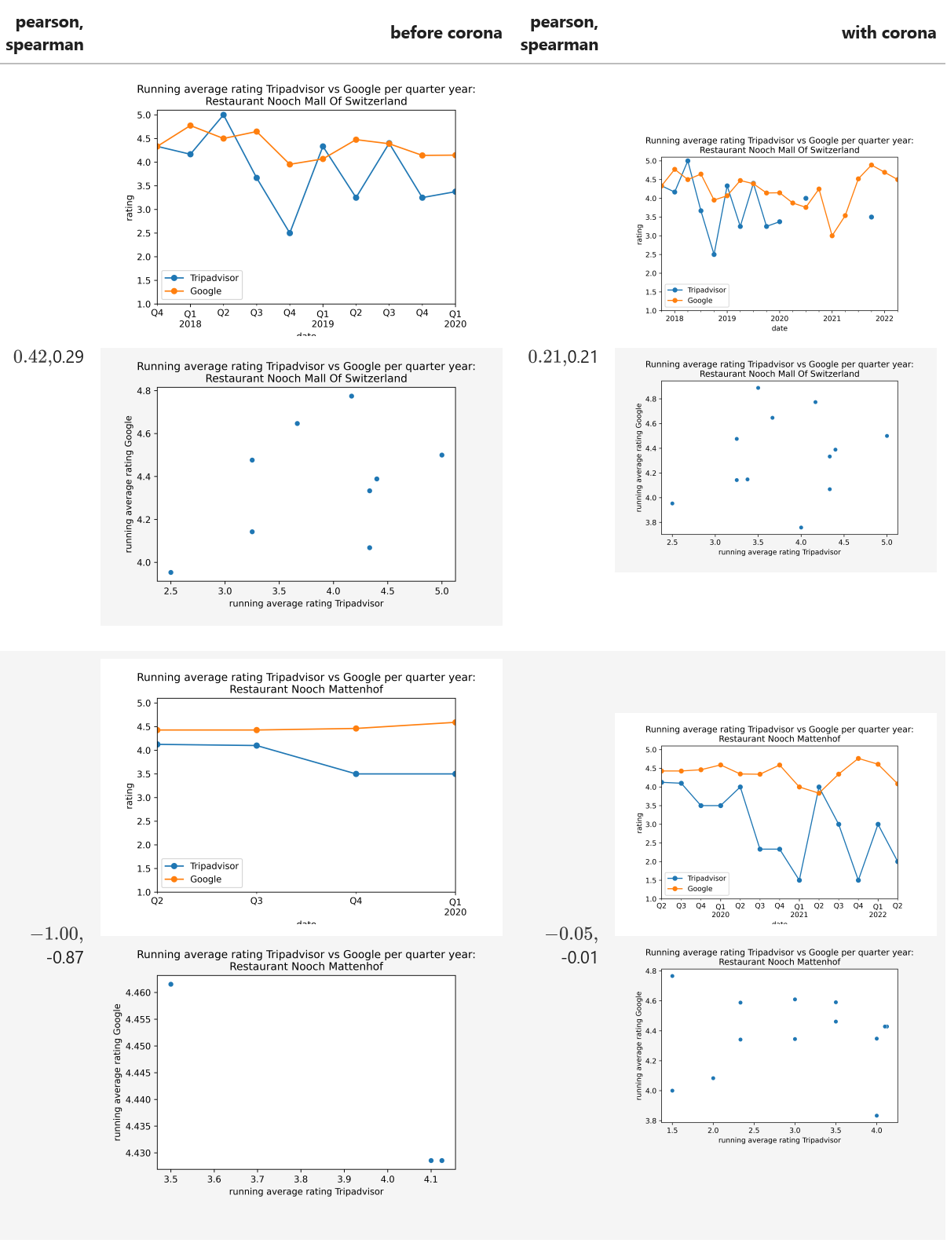

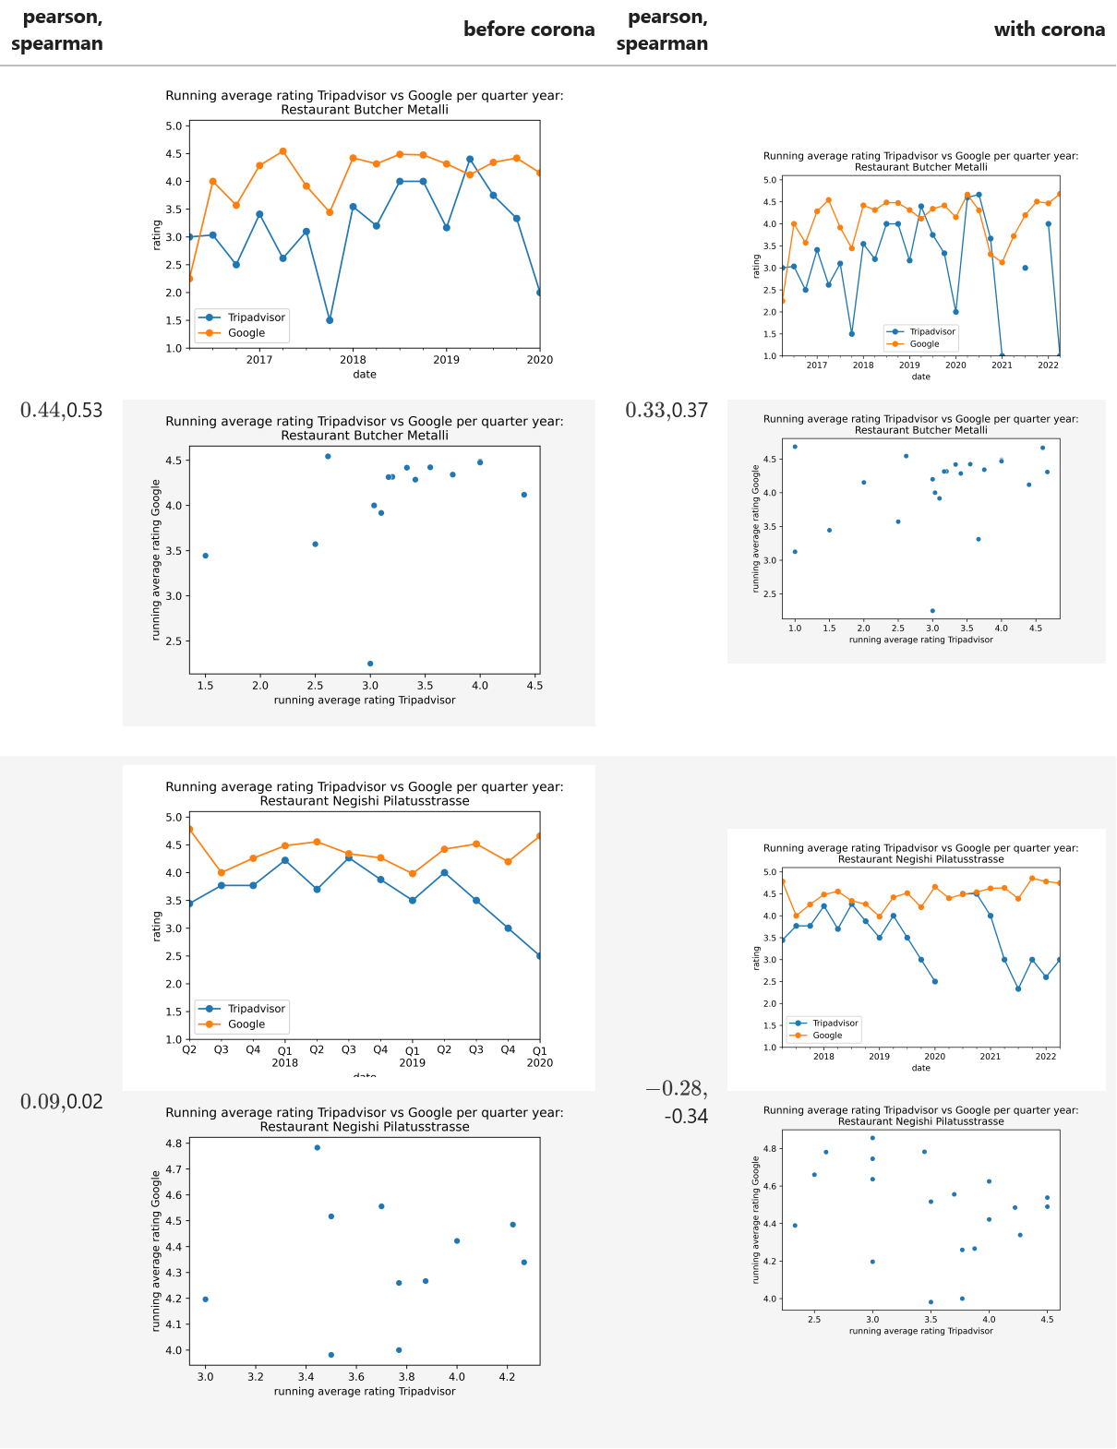

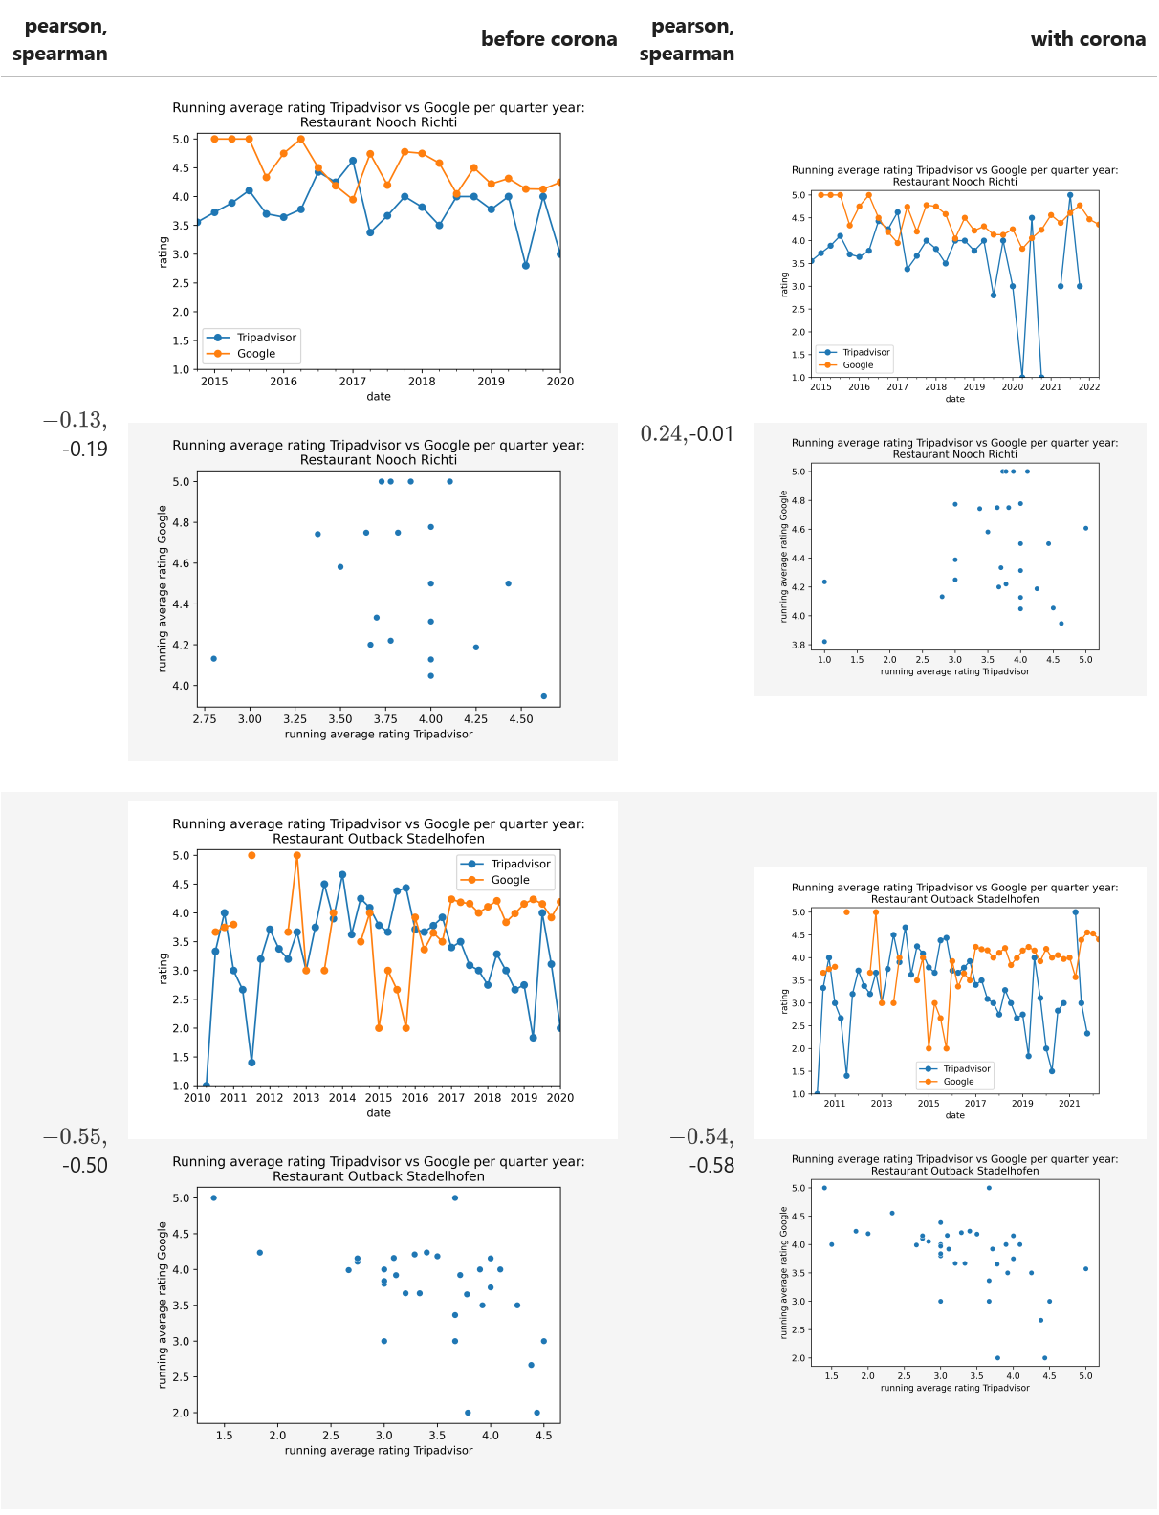

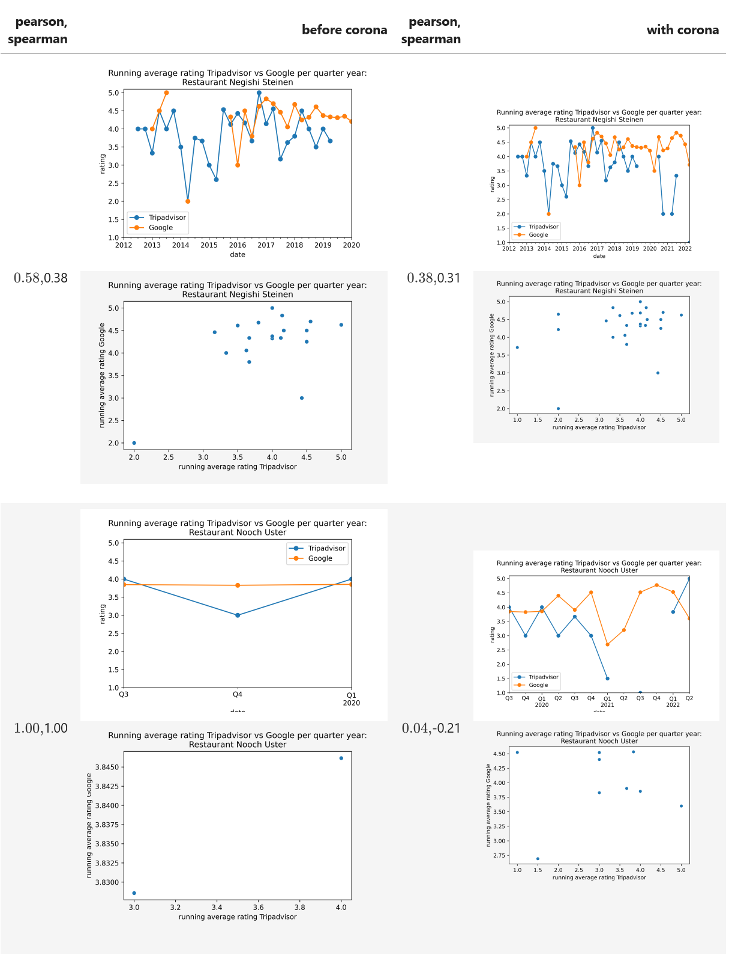

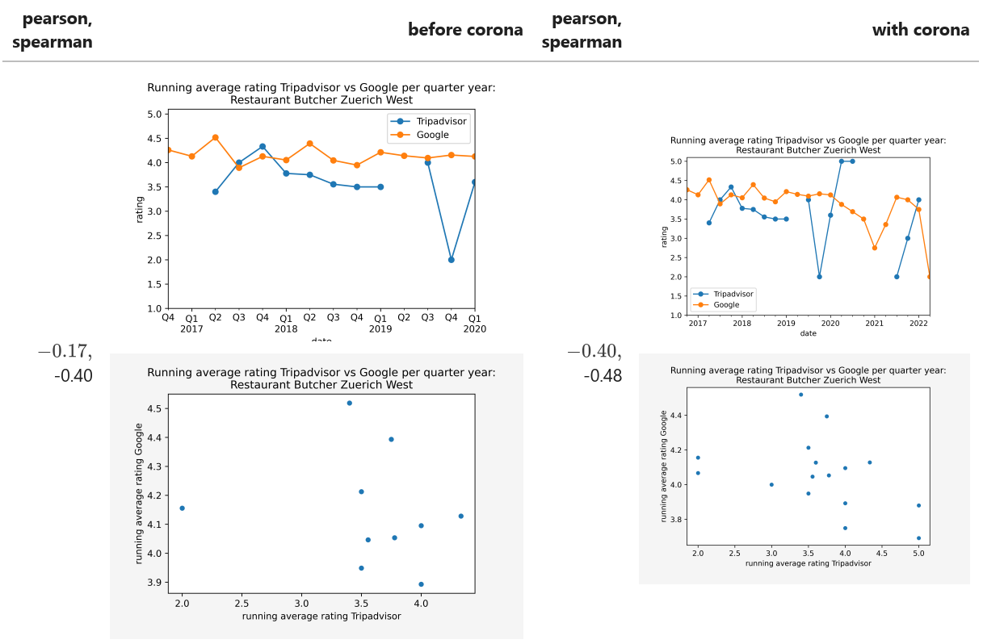

### Overall rating development over months

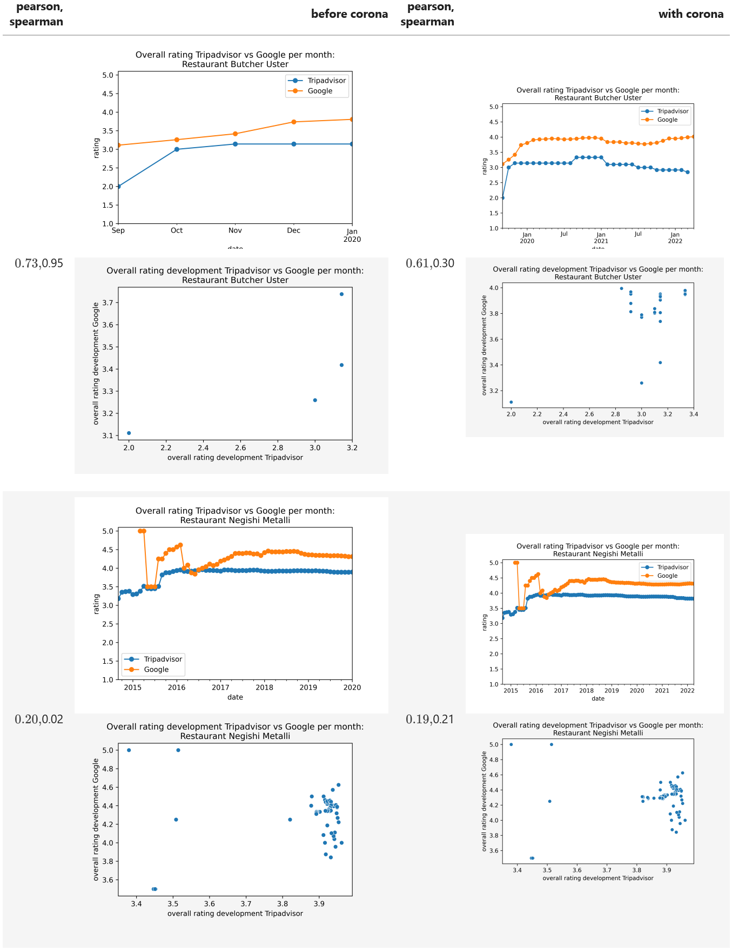

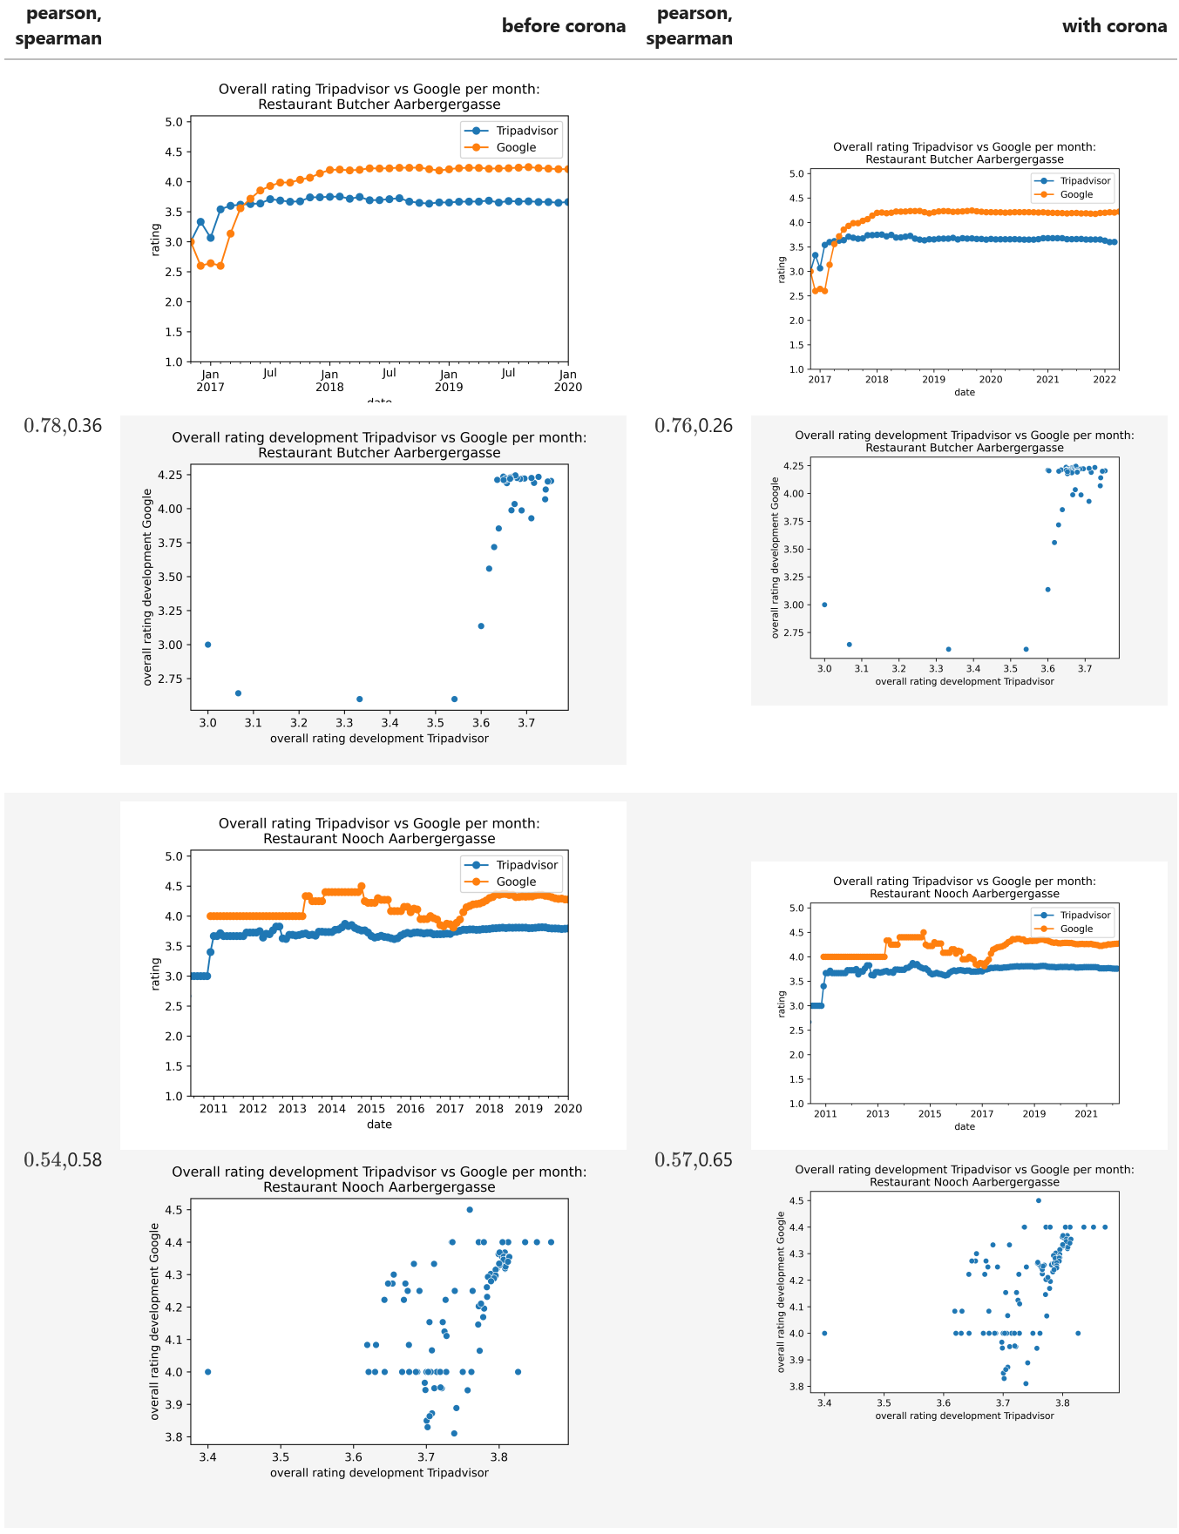

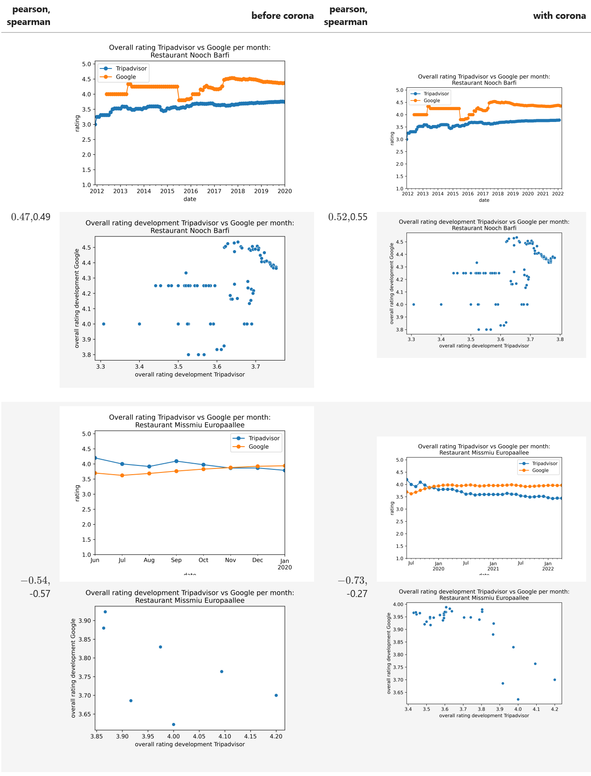

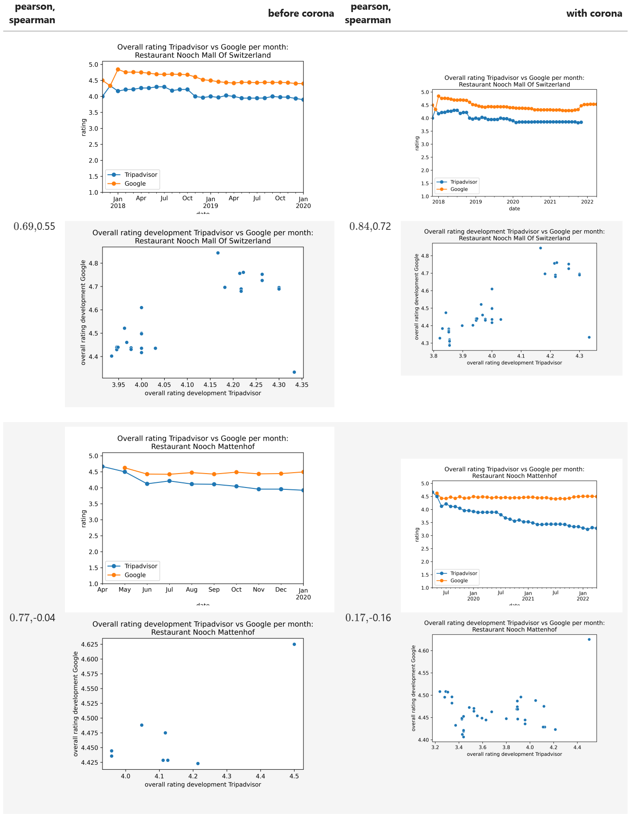

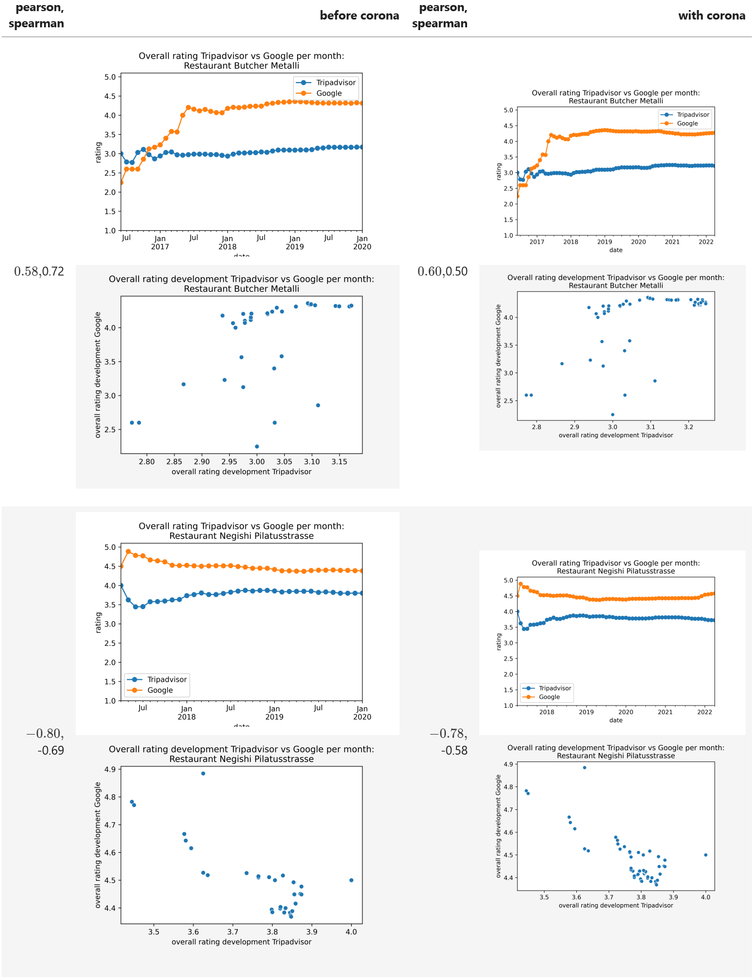

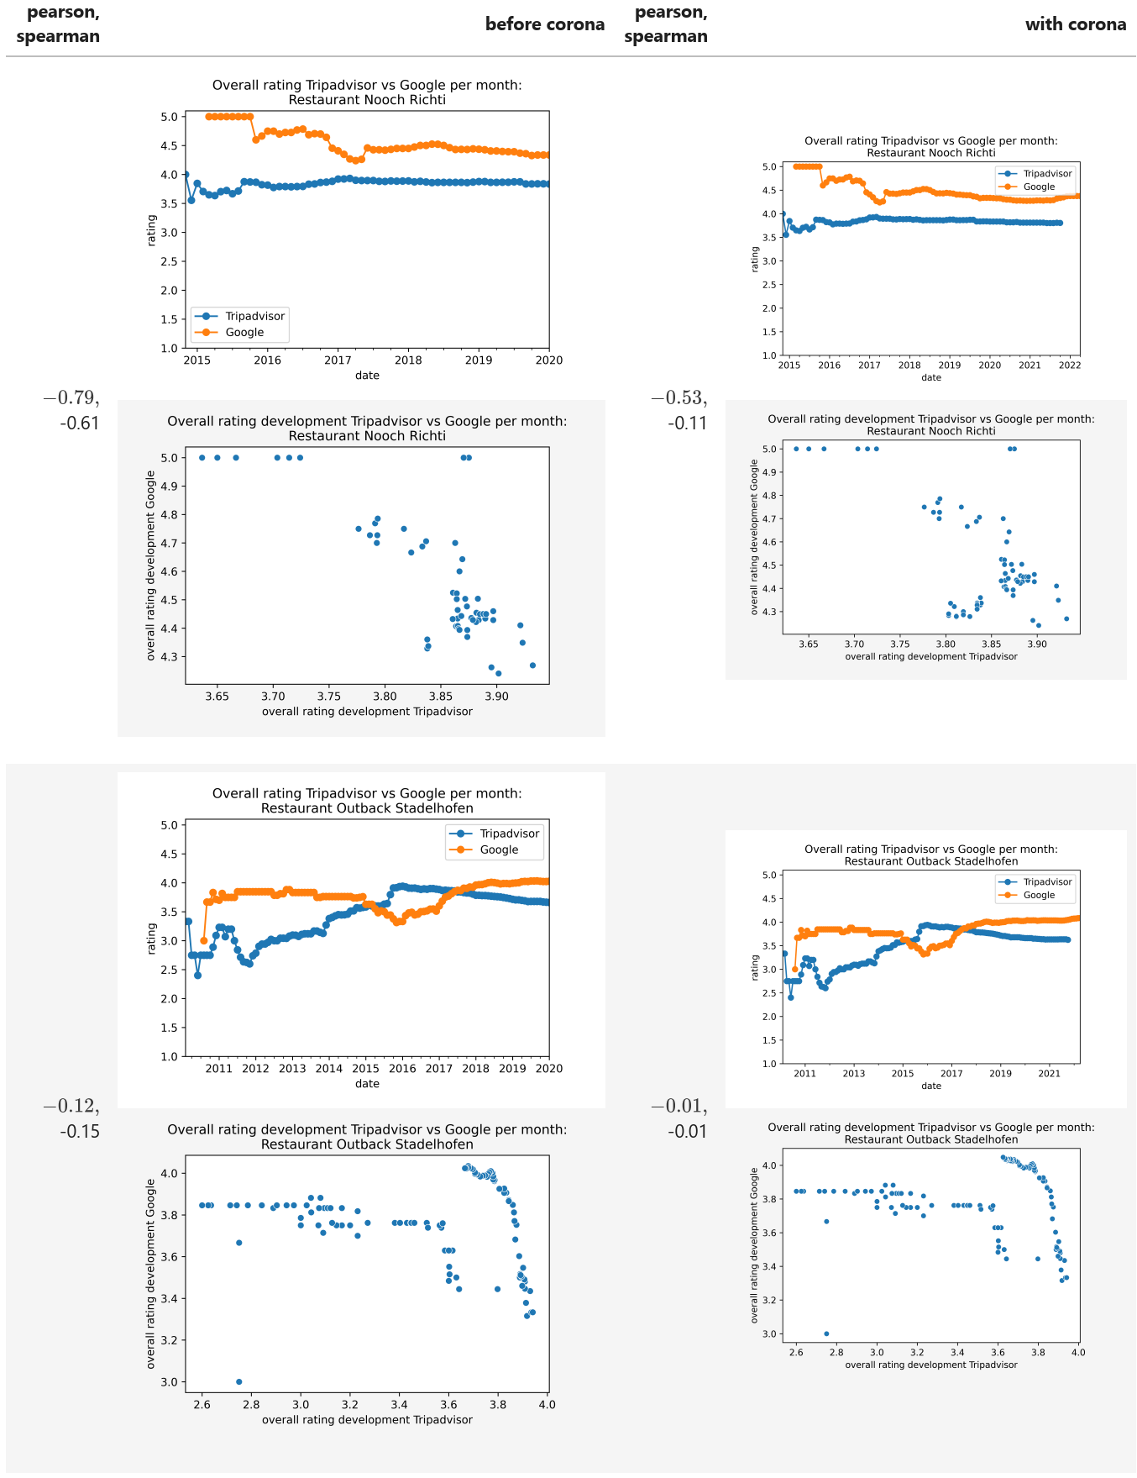

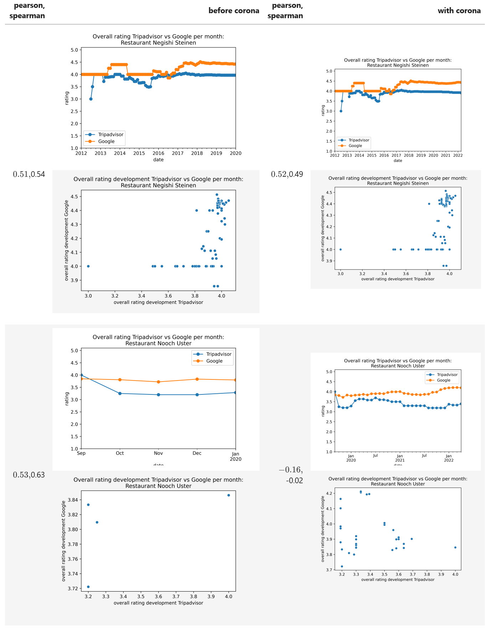

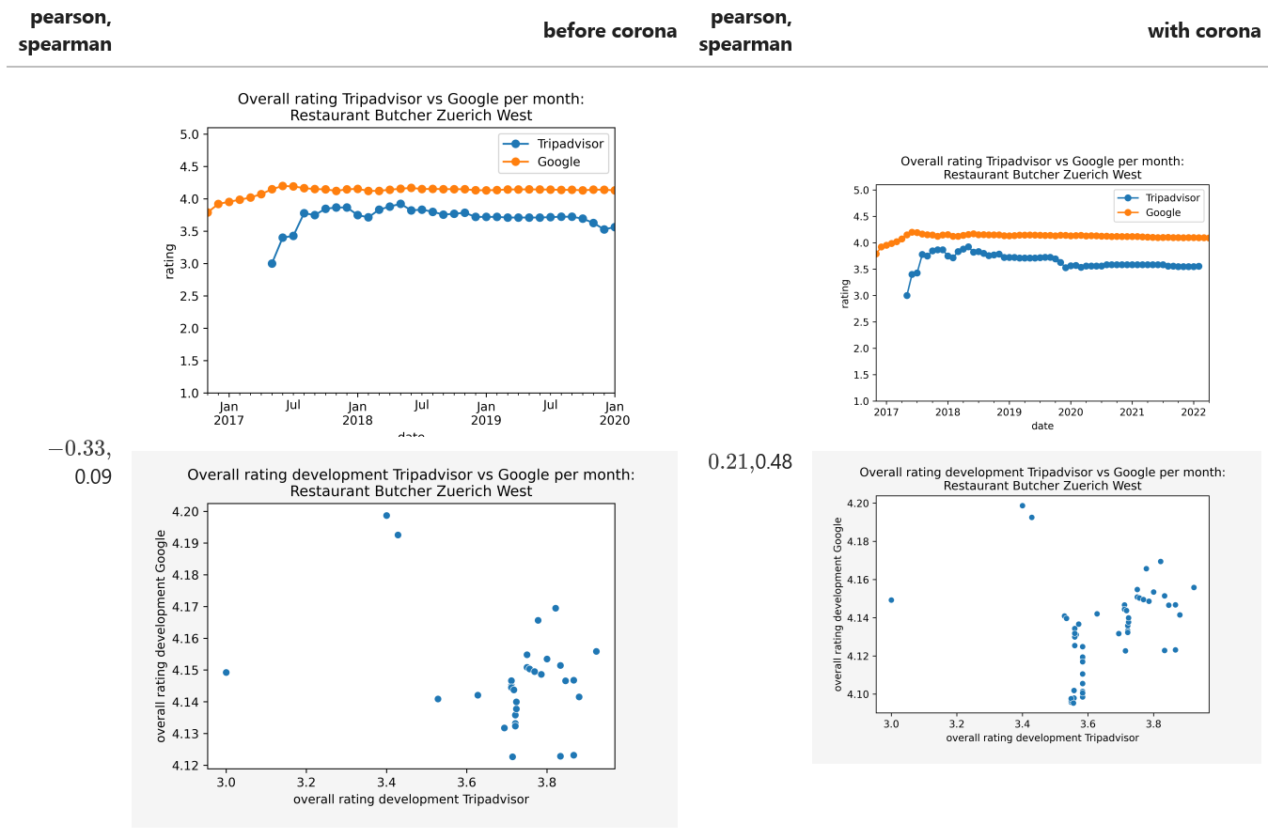

### Overall rating development over quarter years

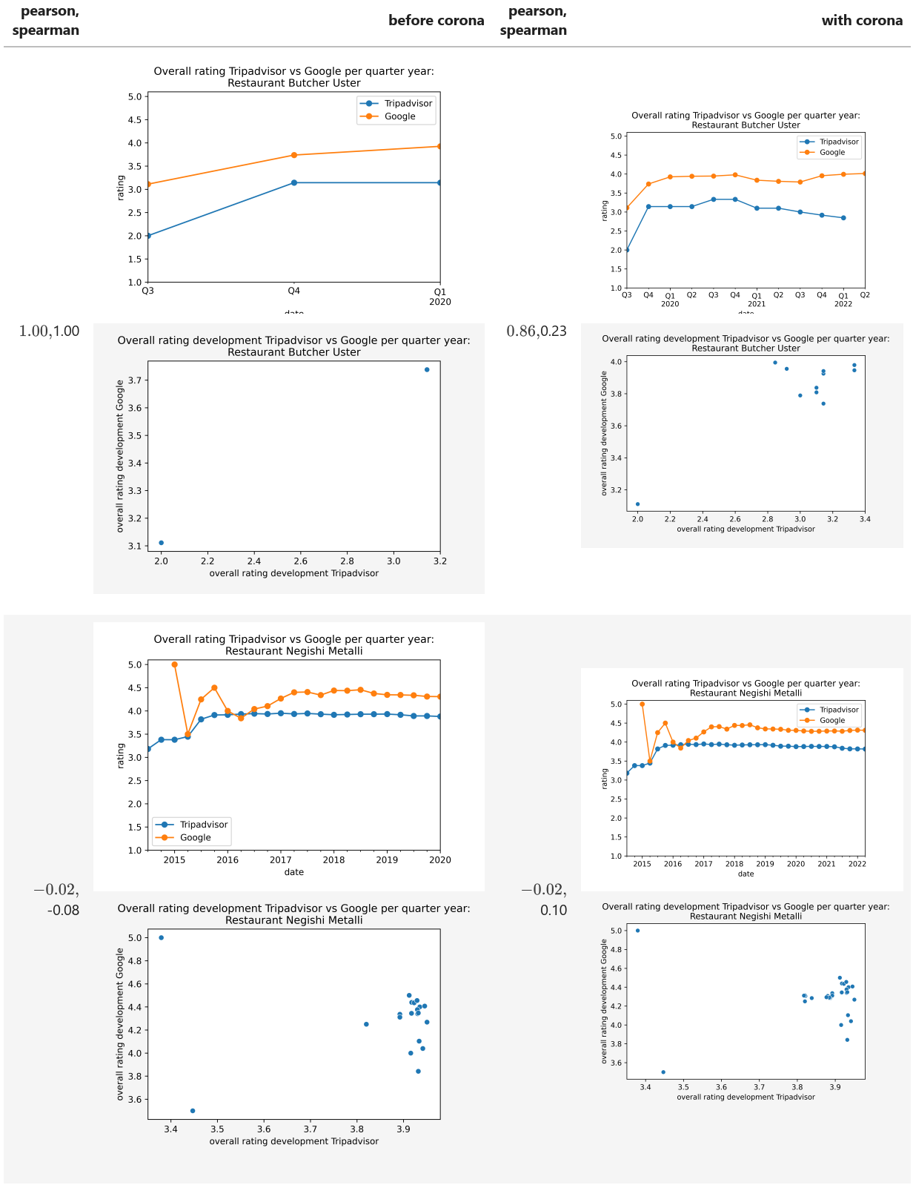

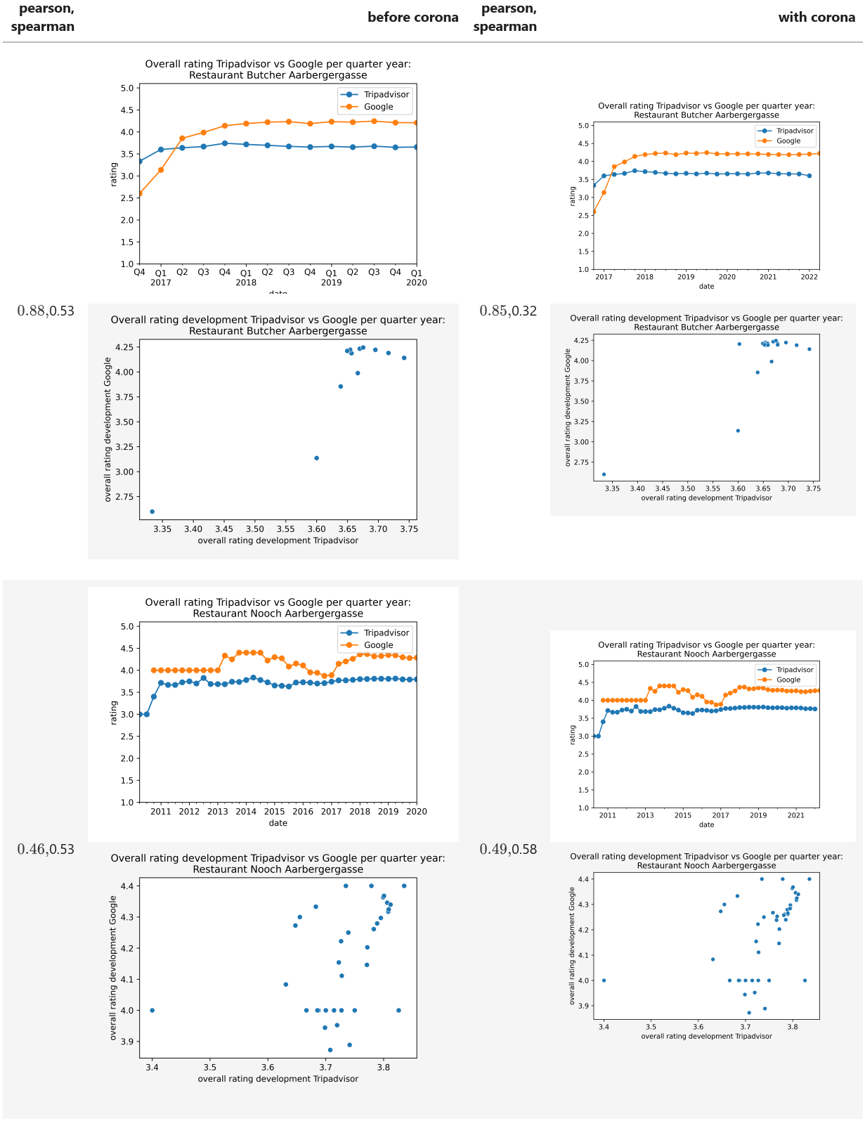

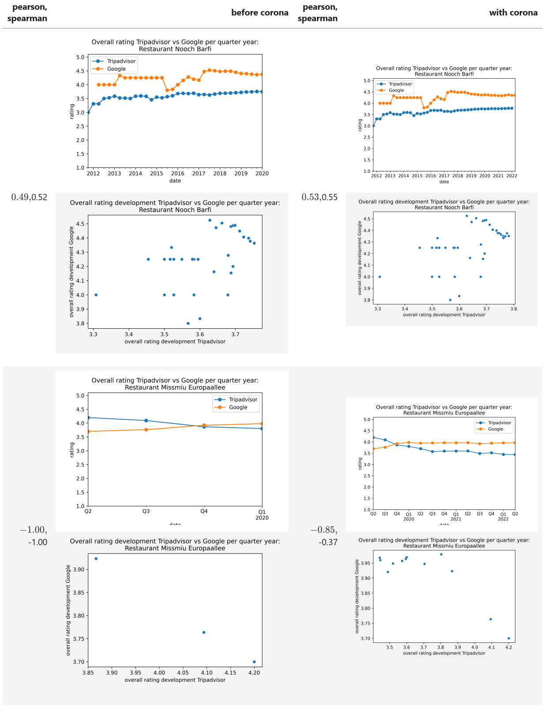

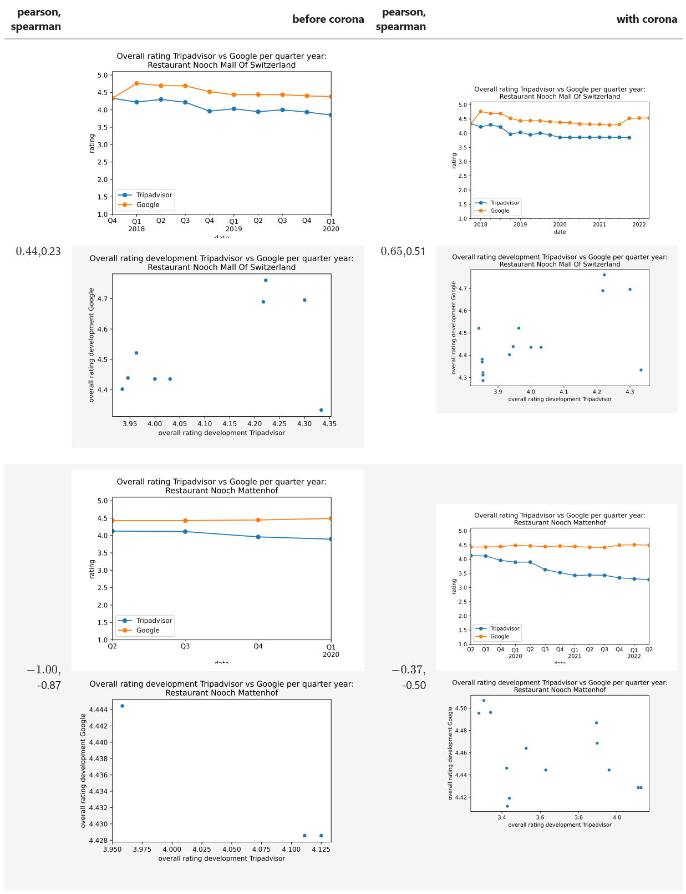

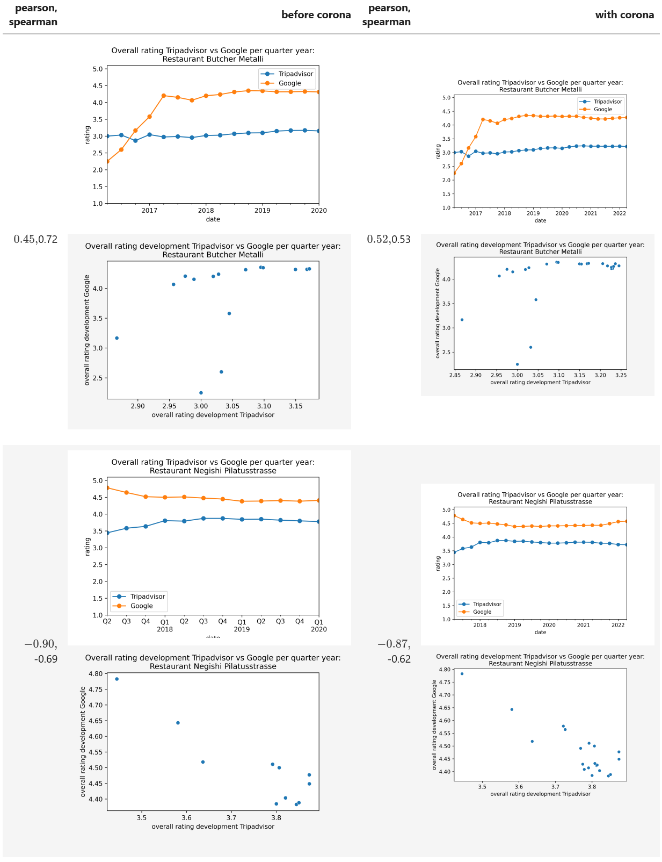

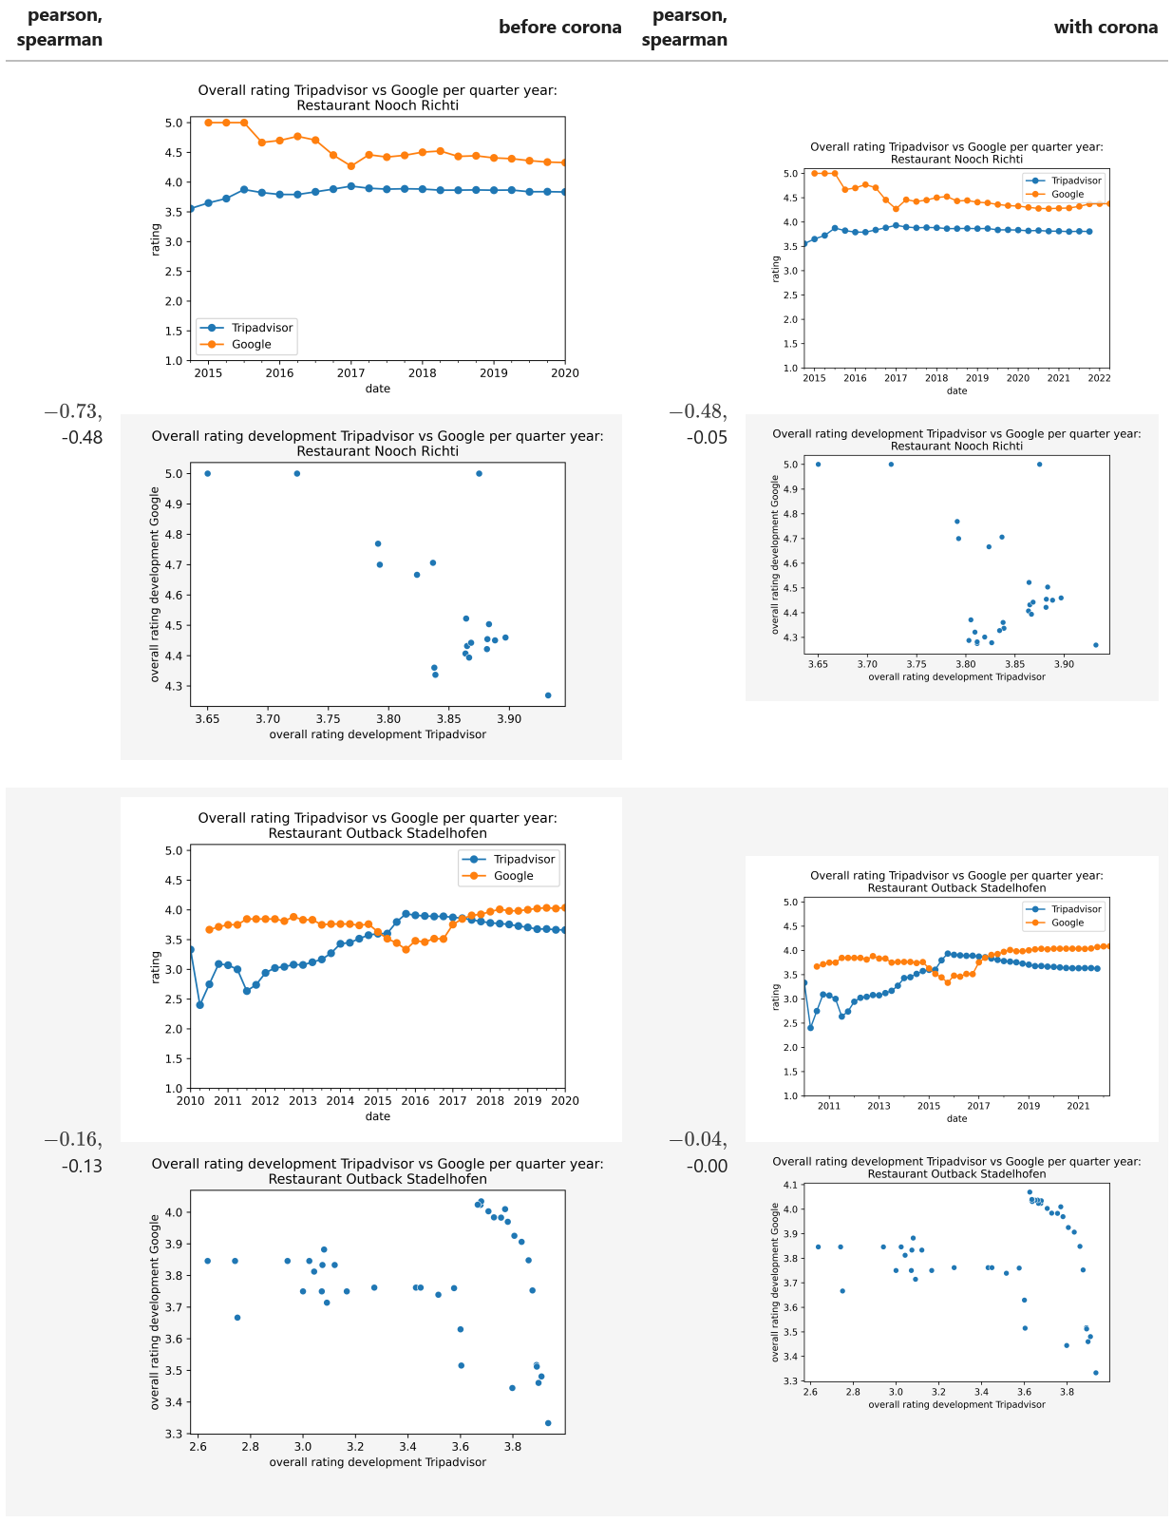

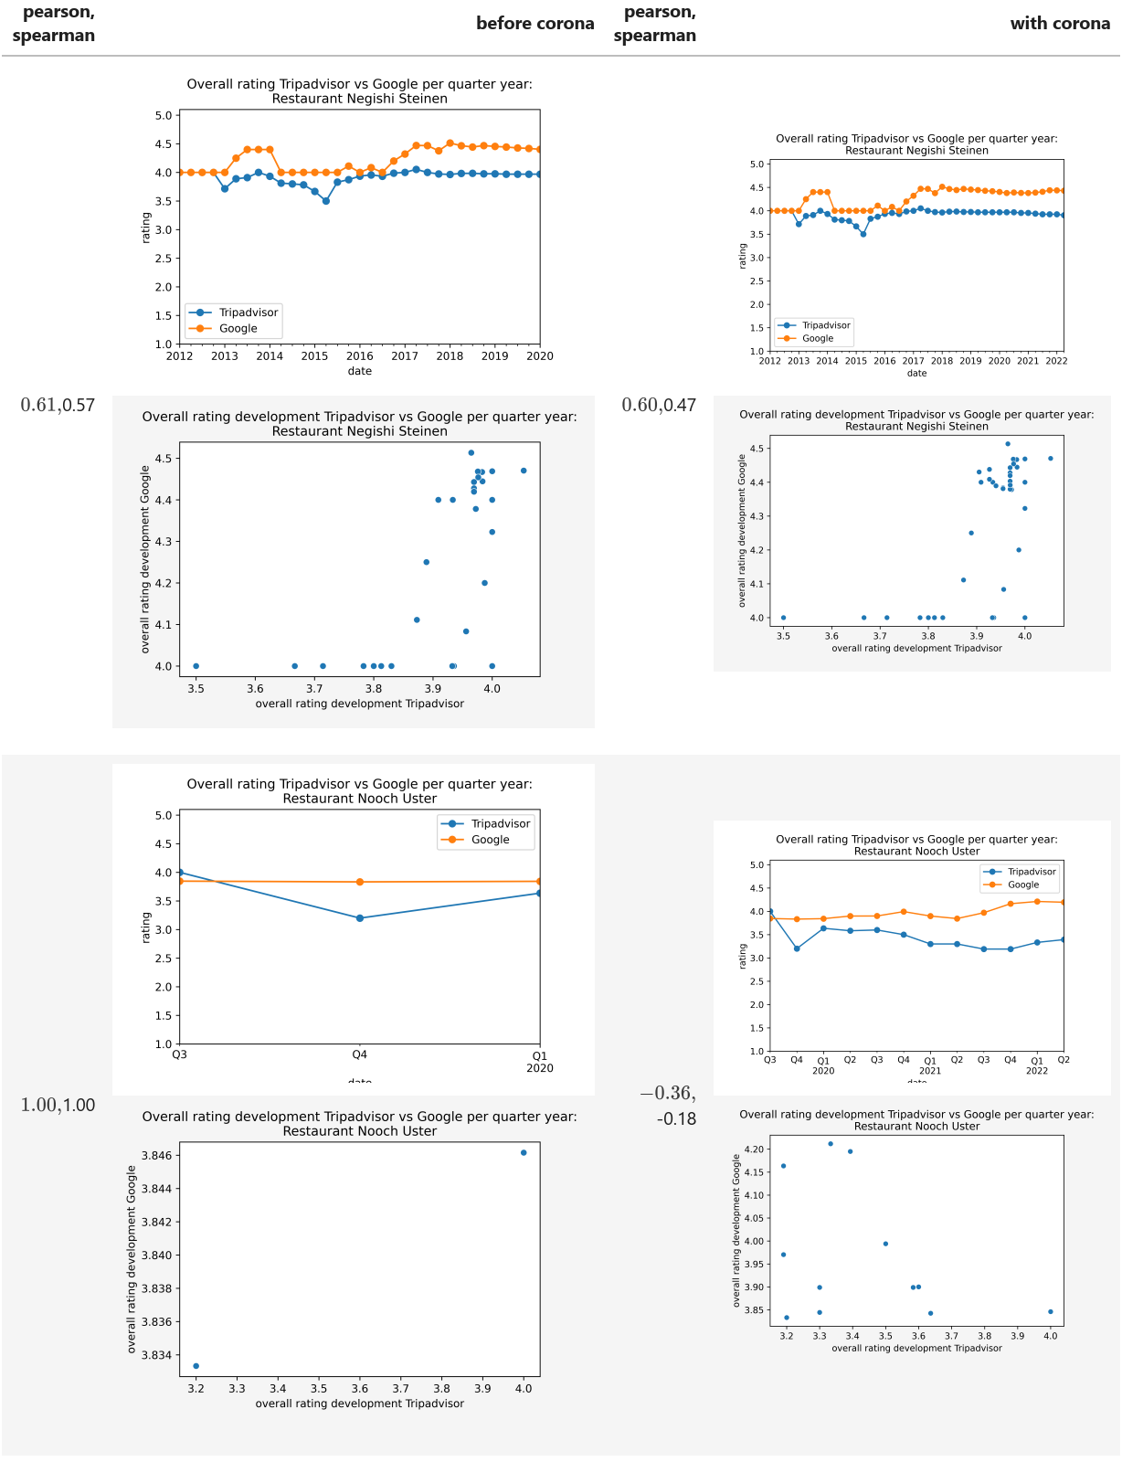

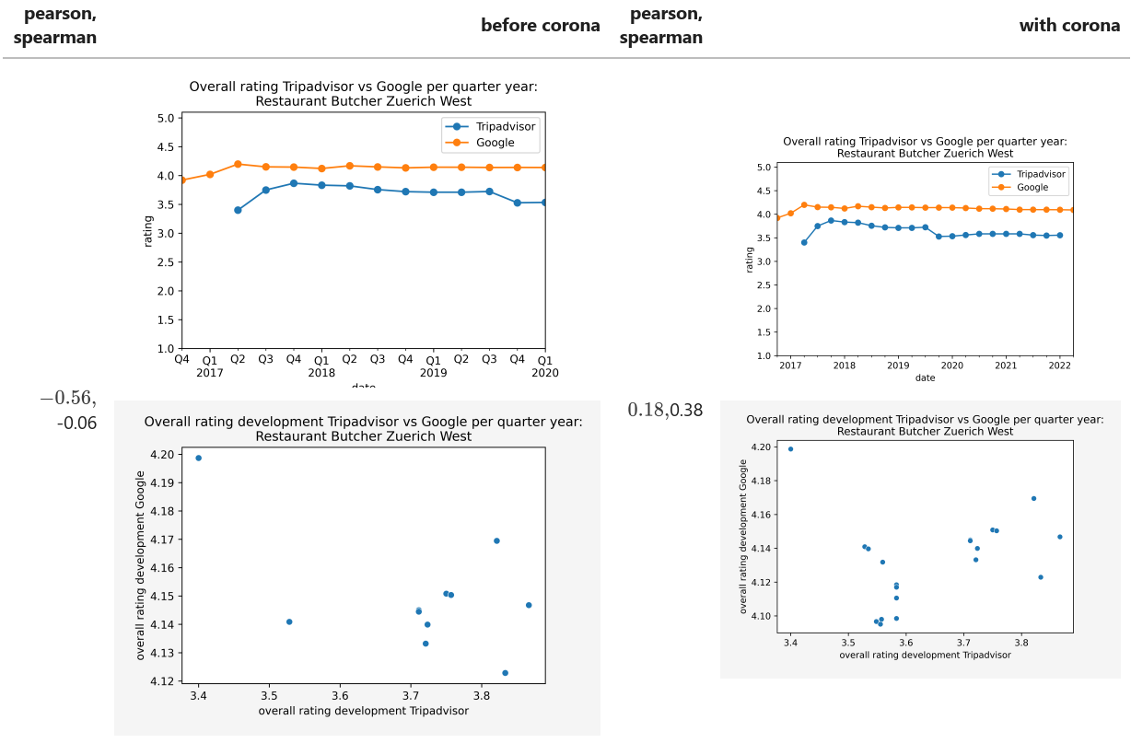

## Google restaurant ratings versus Prognolite restaurant revenues

### Running average rating (observed) vs average turnover per month

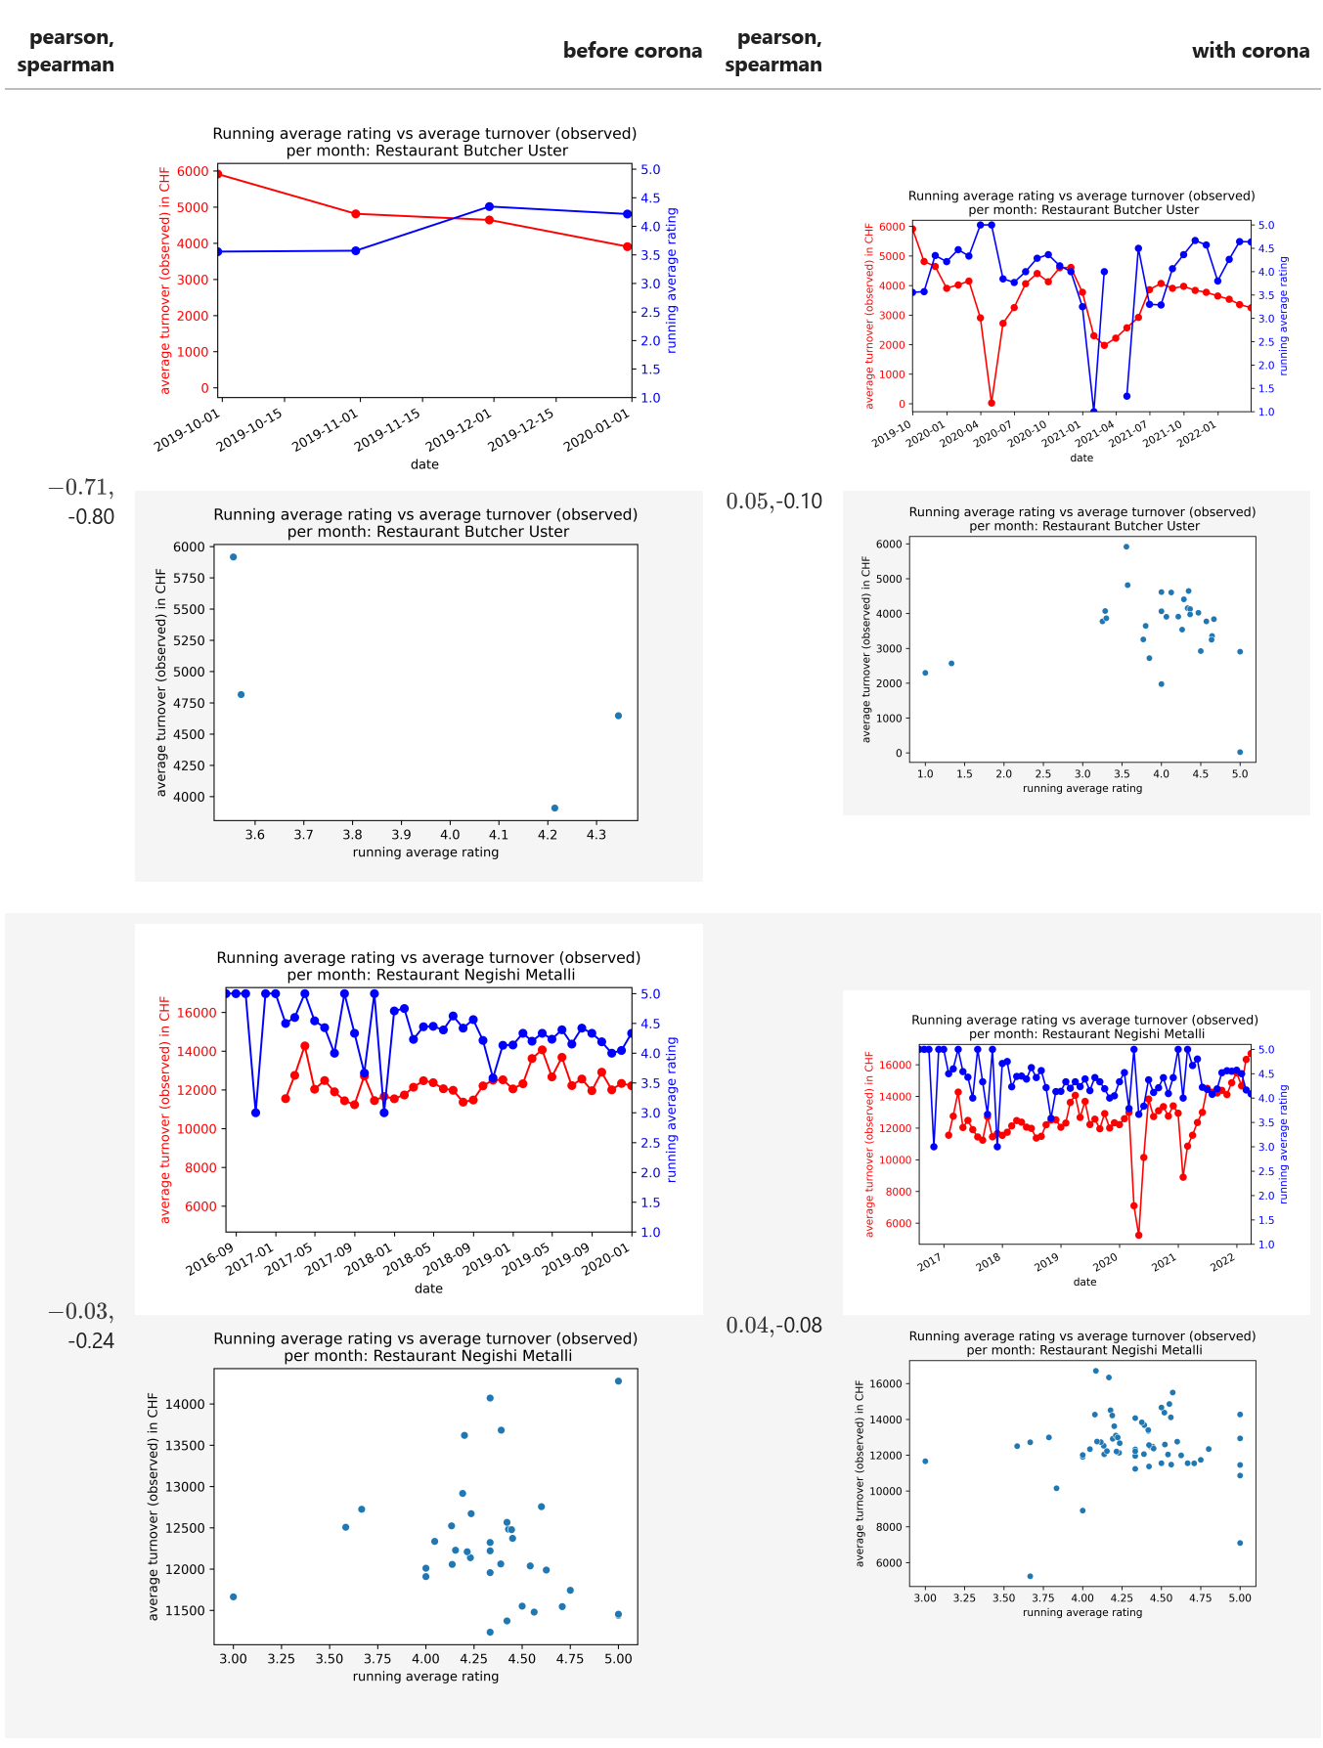

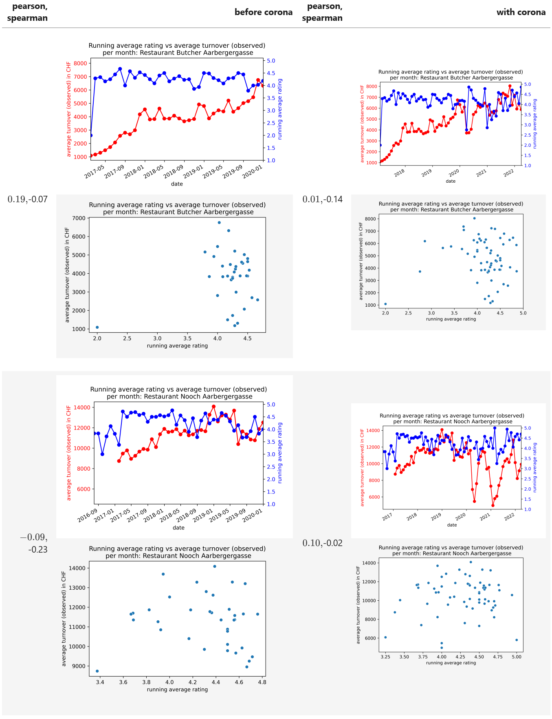

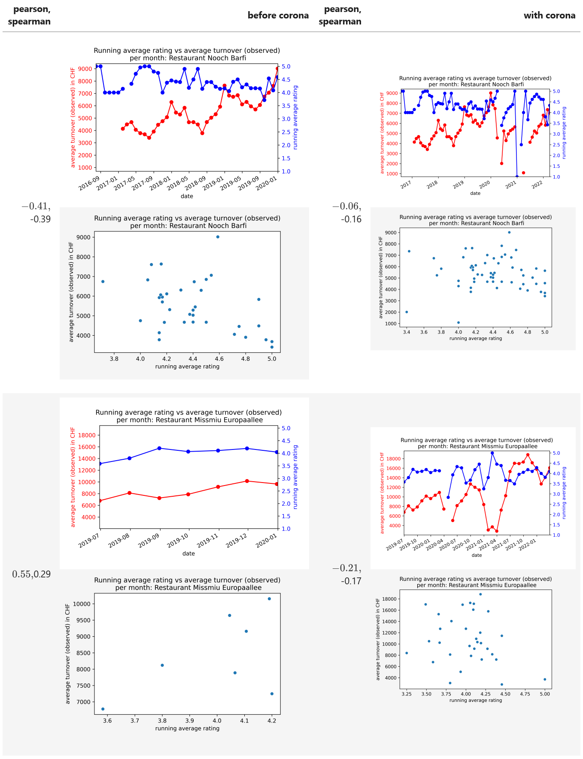

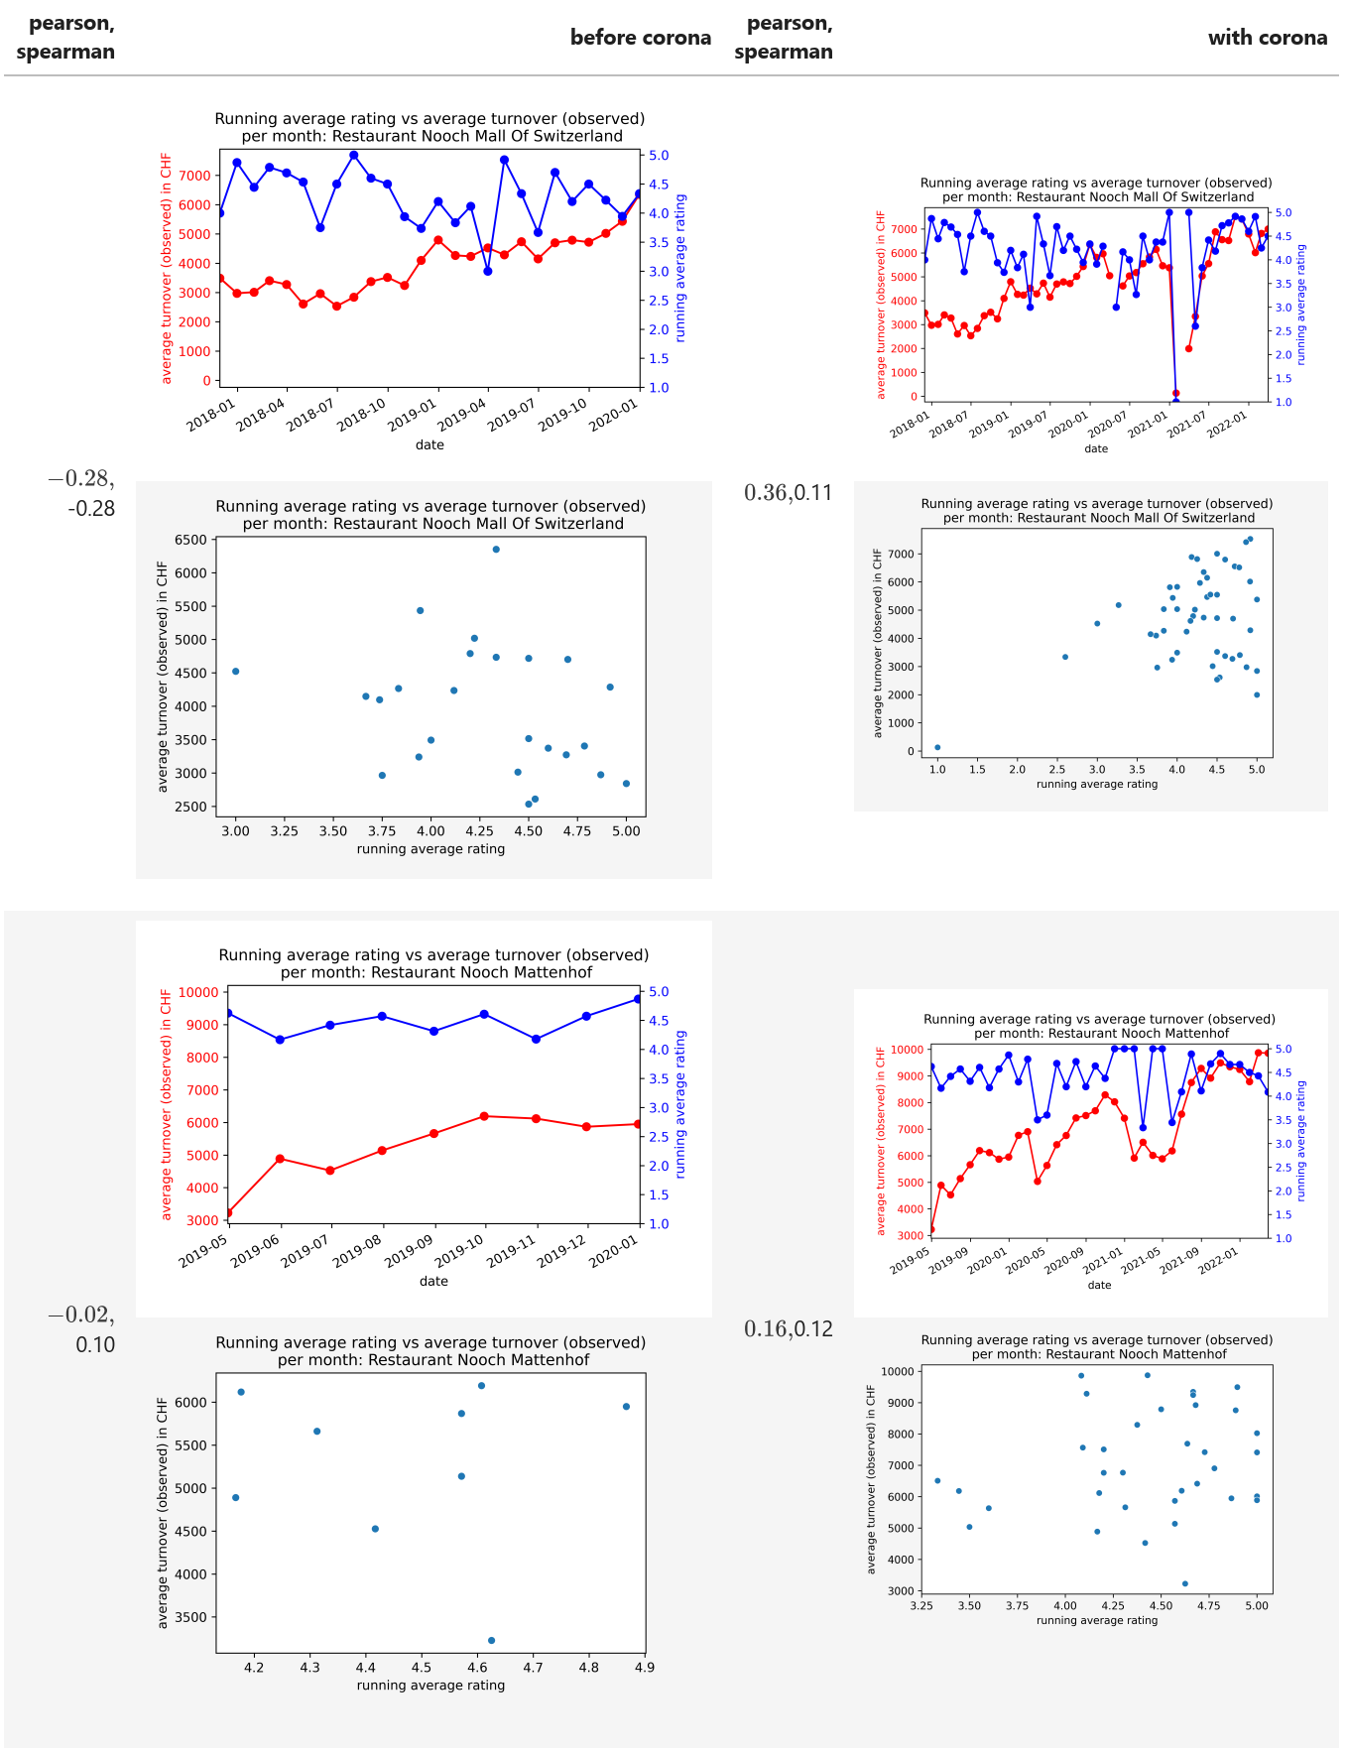

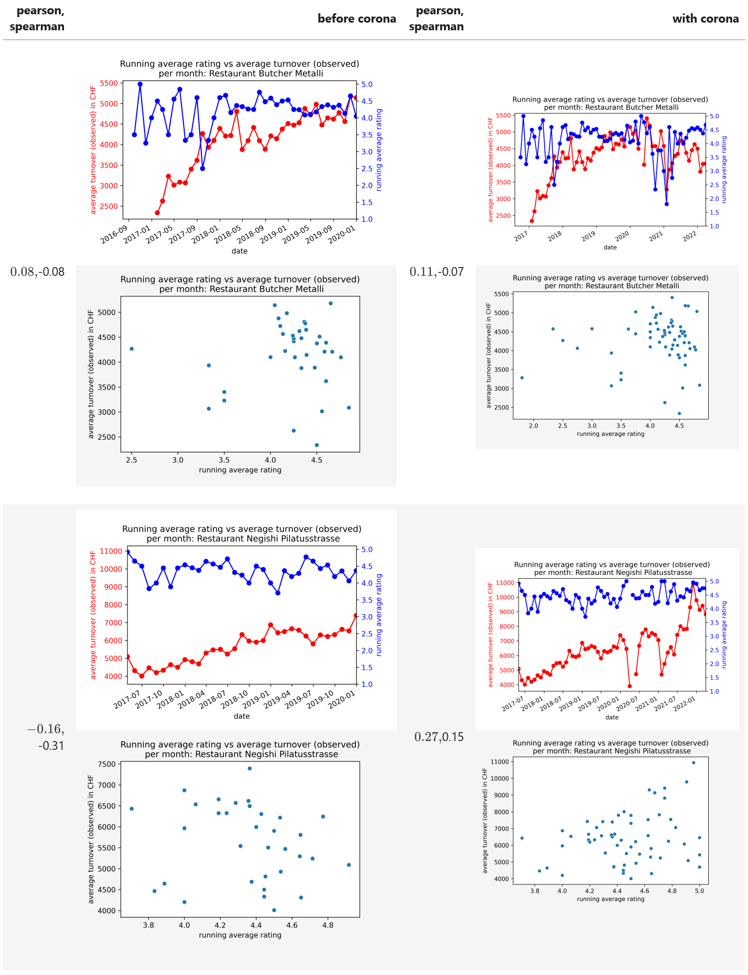

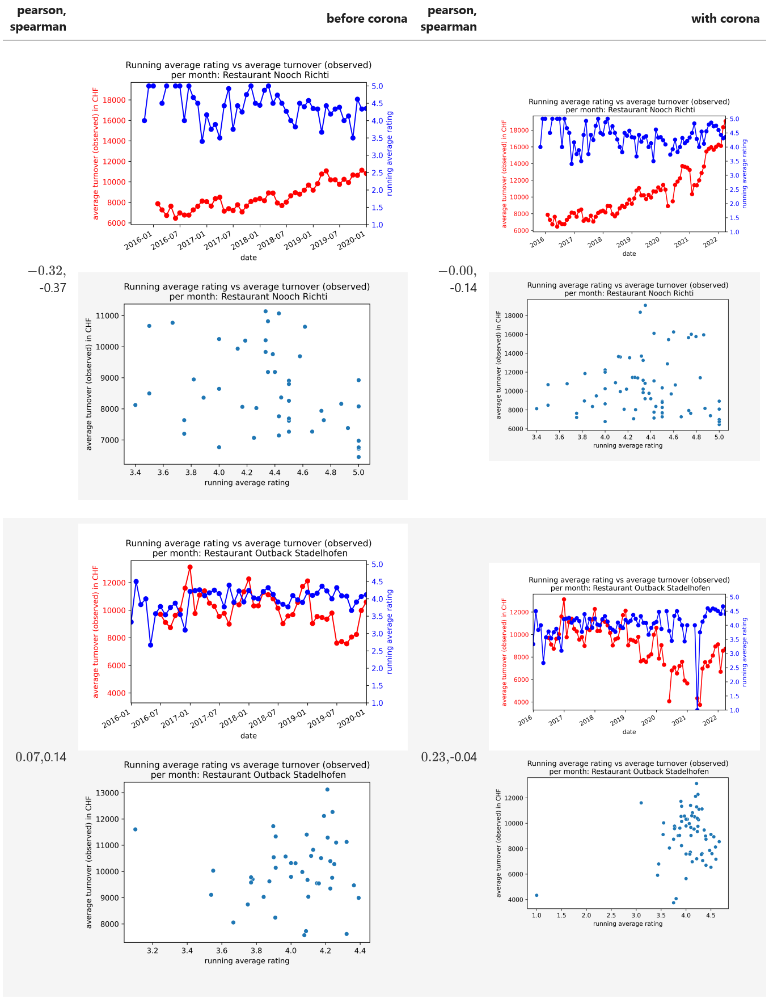

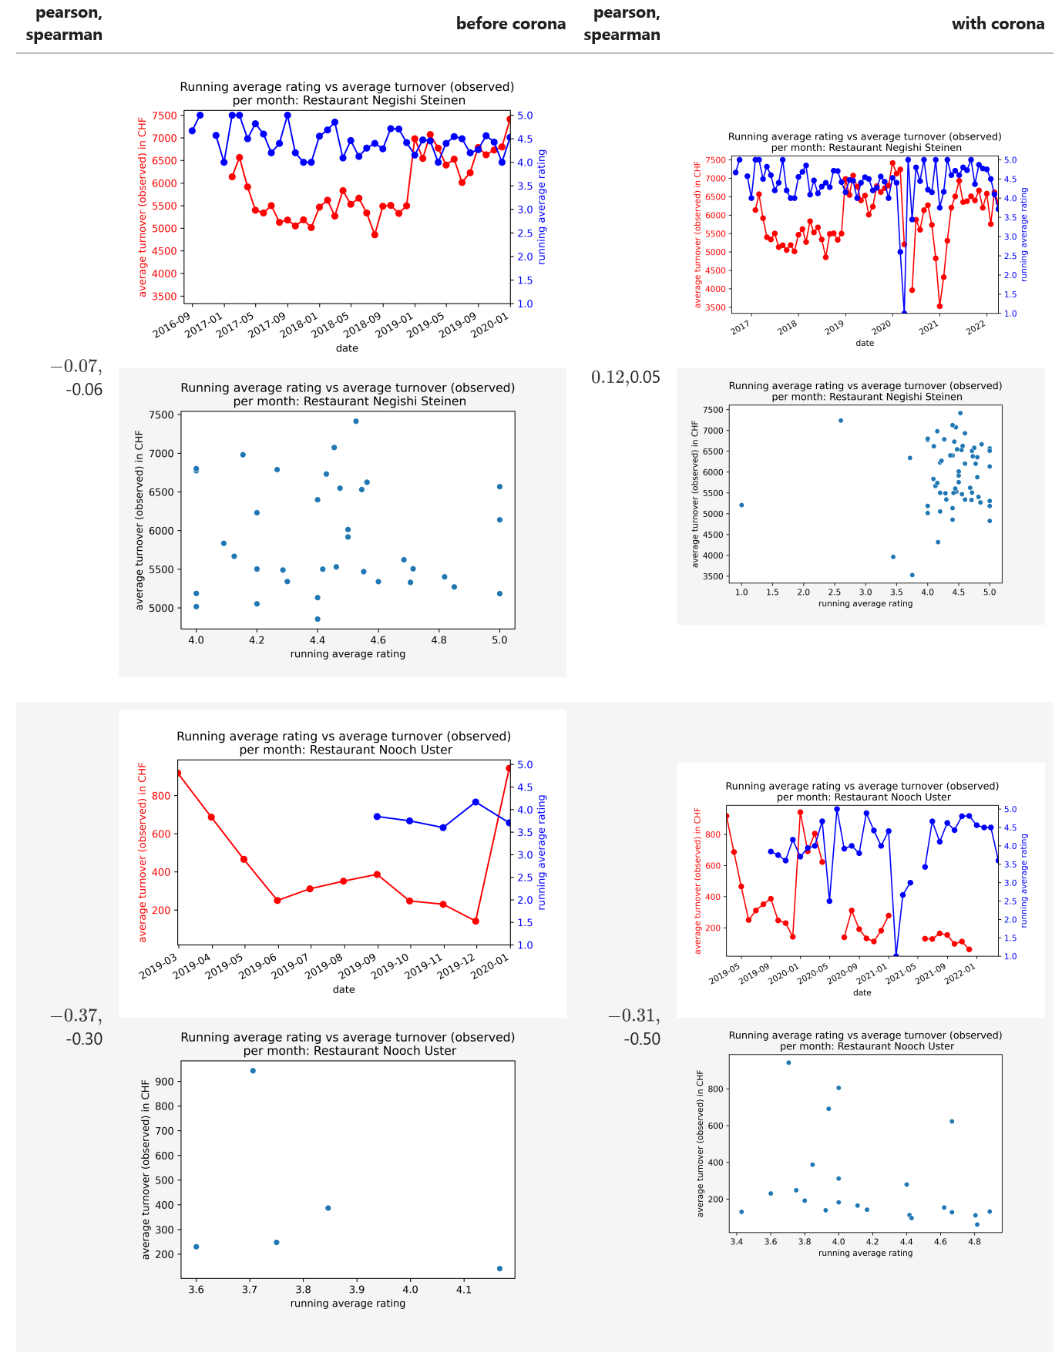

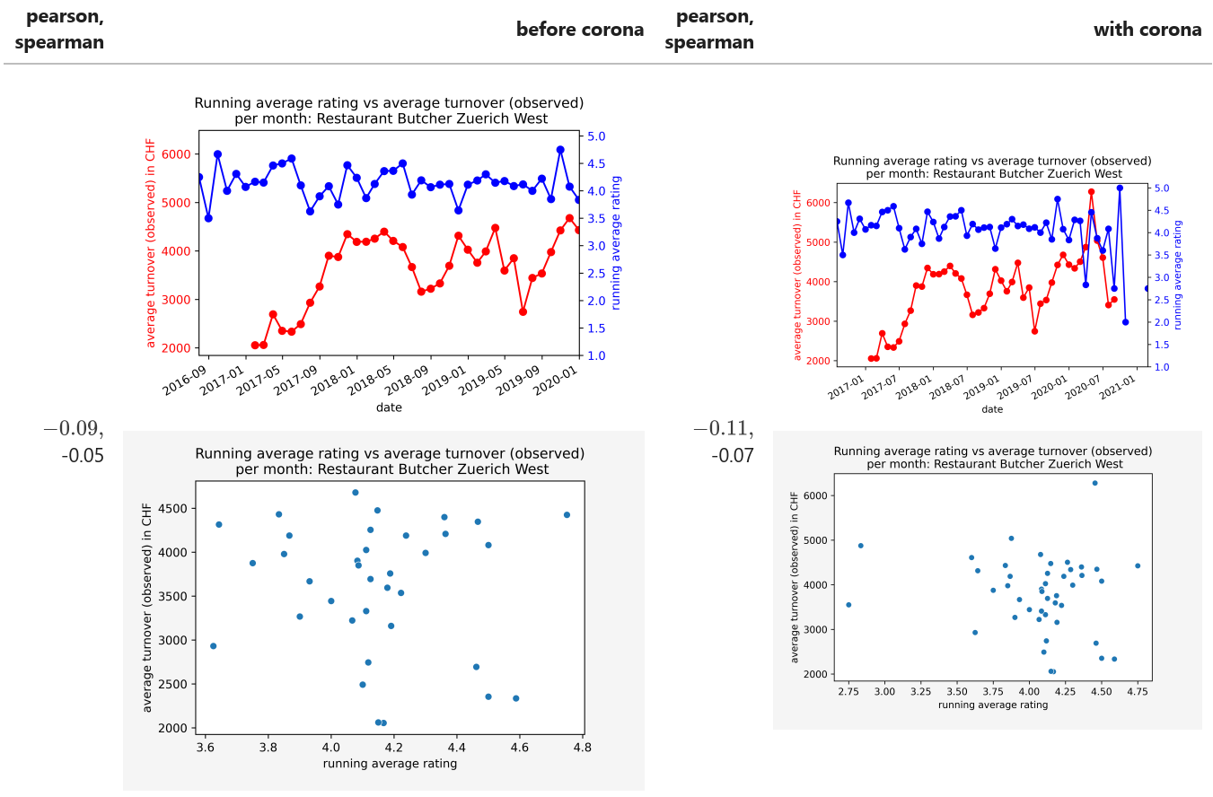

### Running average rating (observed) vs average turnover per quarter year

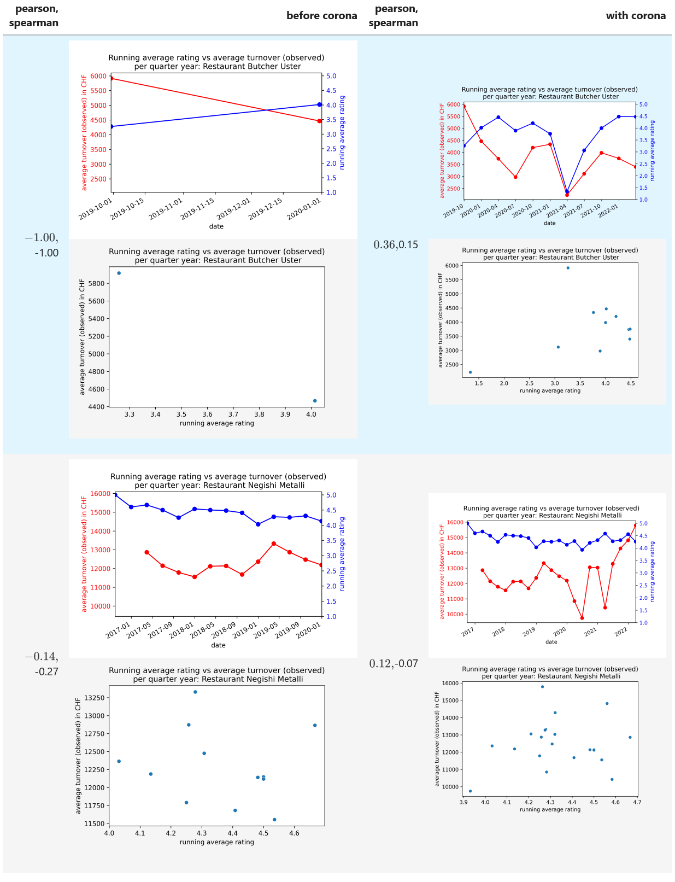

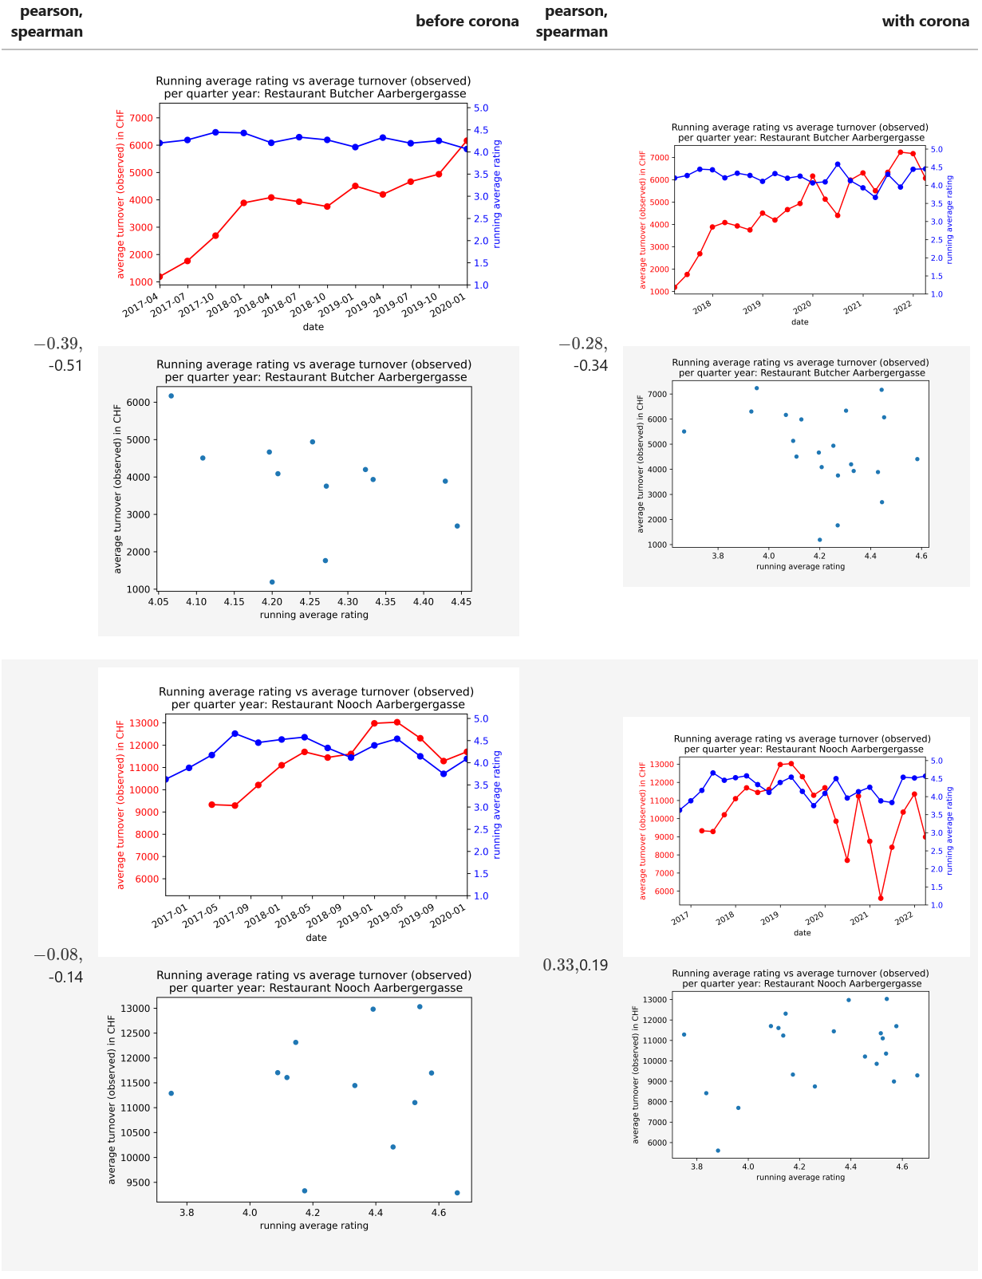

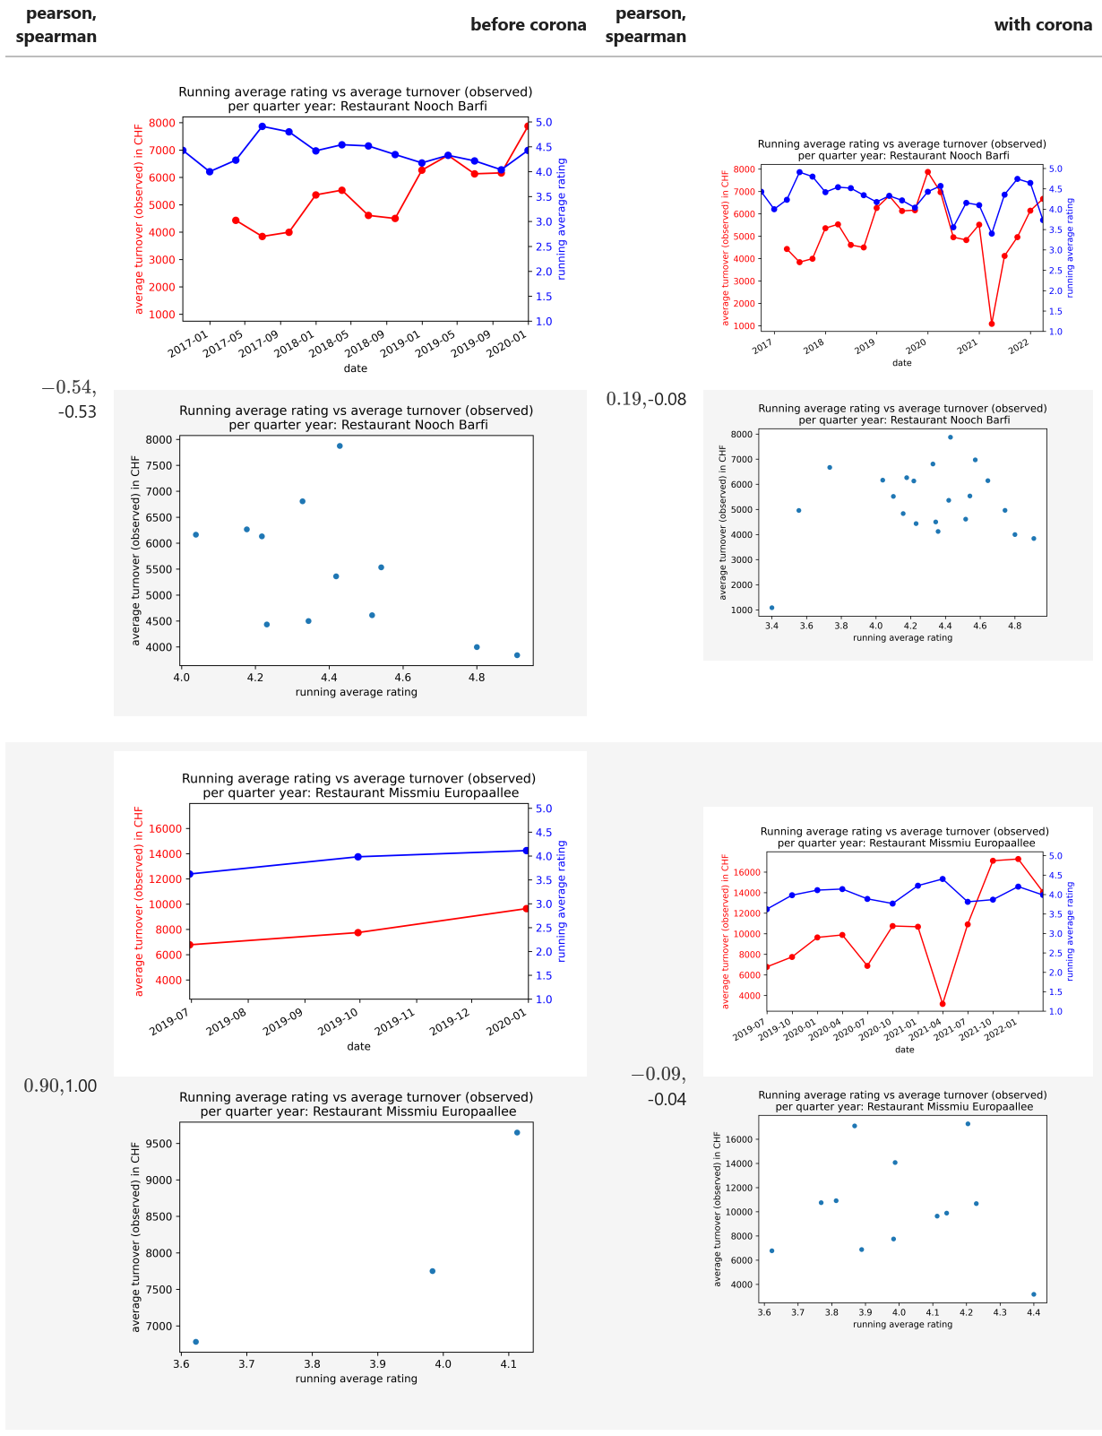

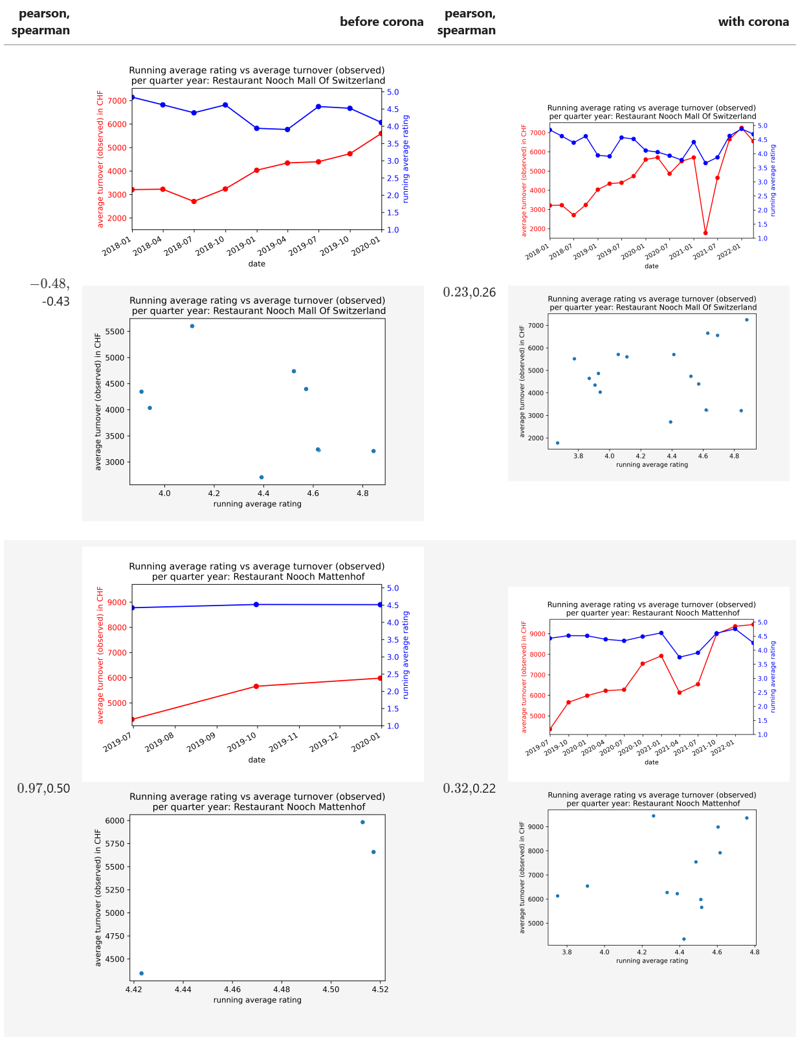

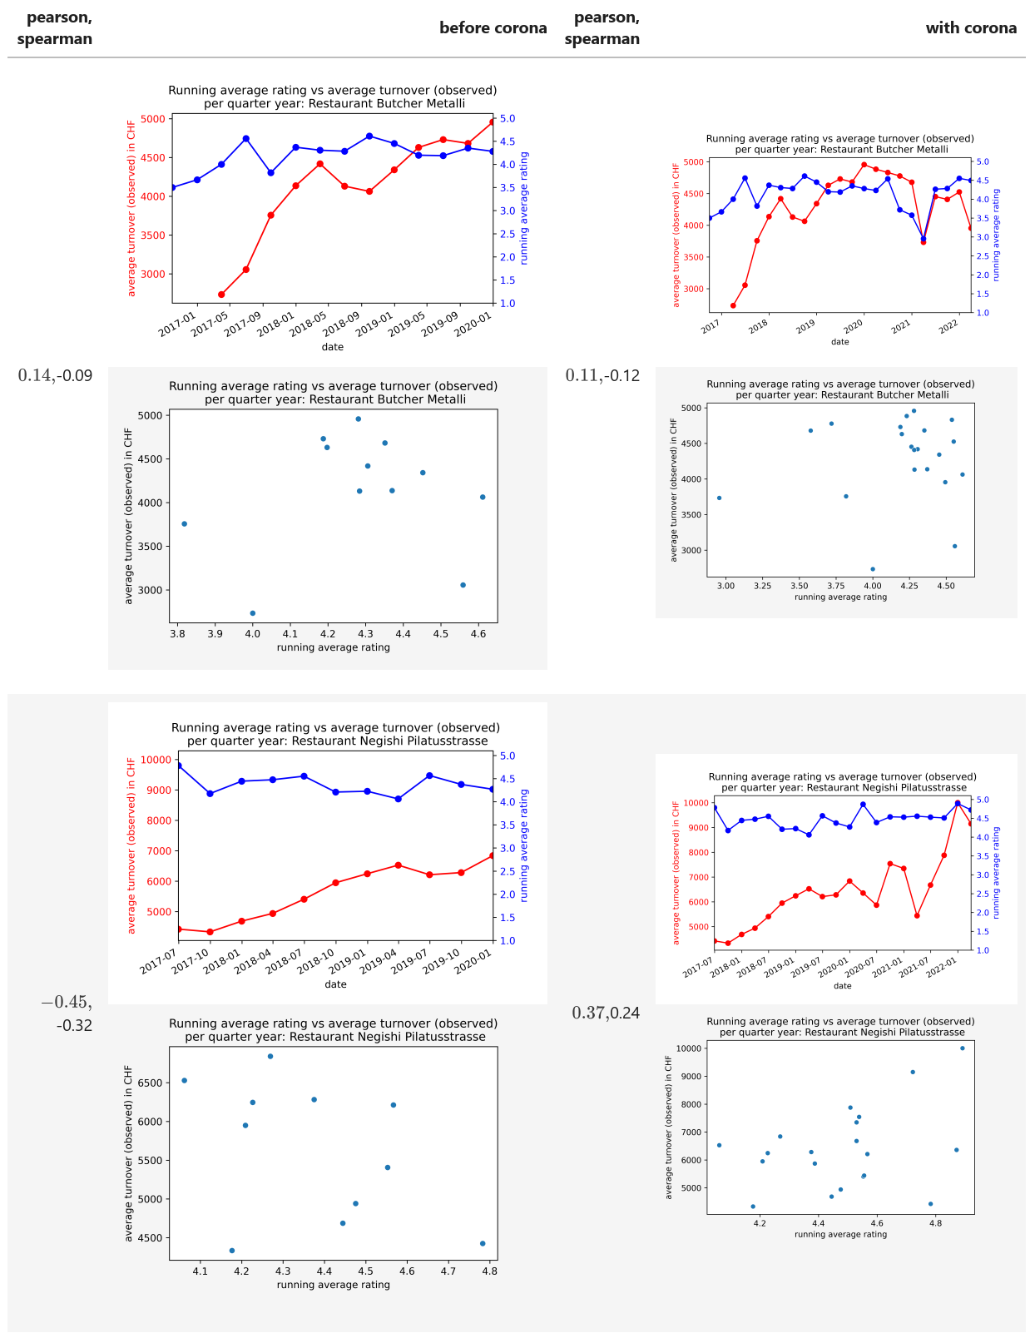

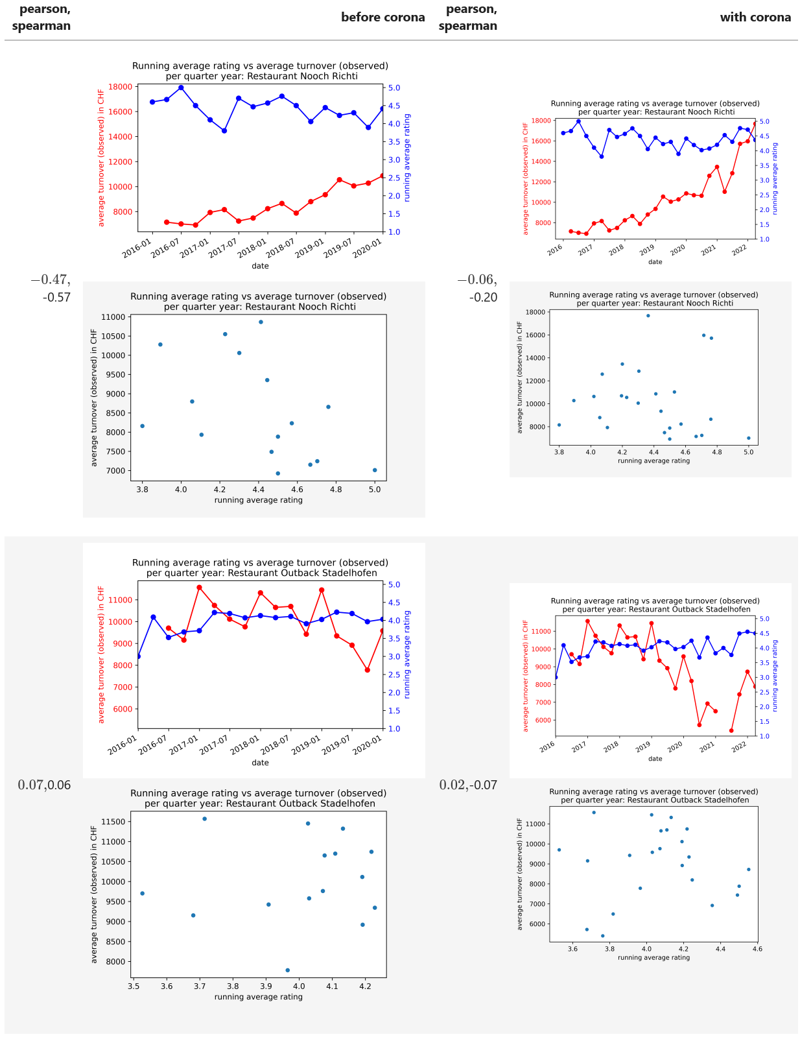

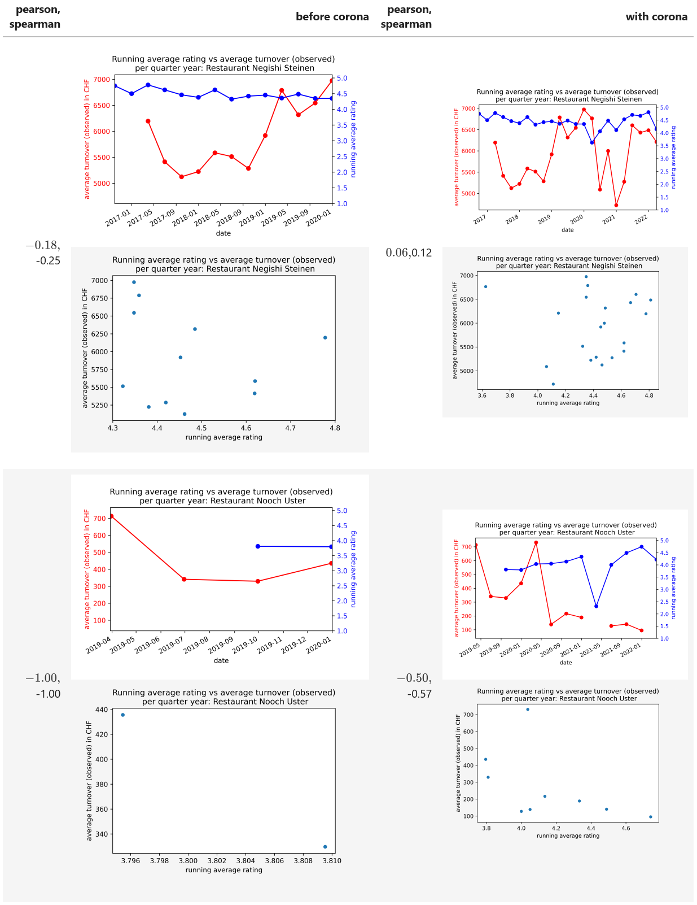

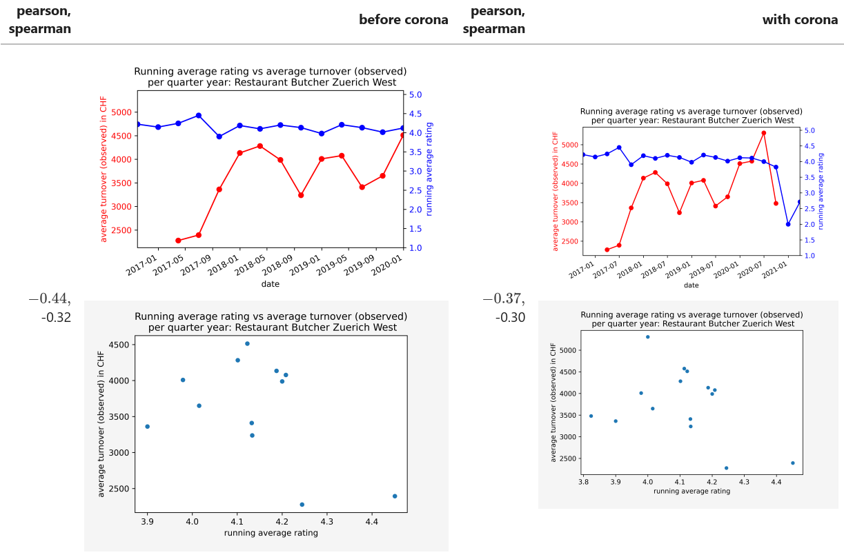

### Running average rating (residual + trend) vs average turnover per month

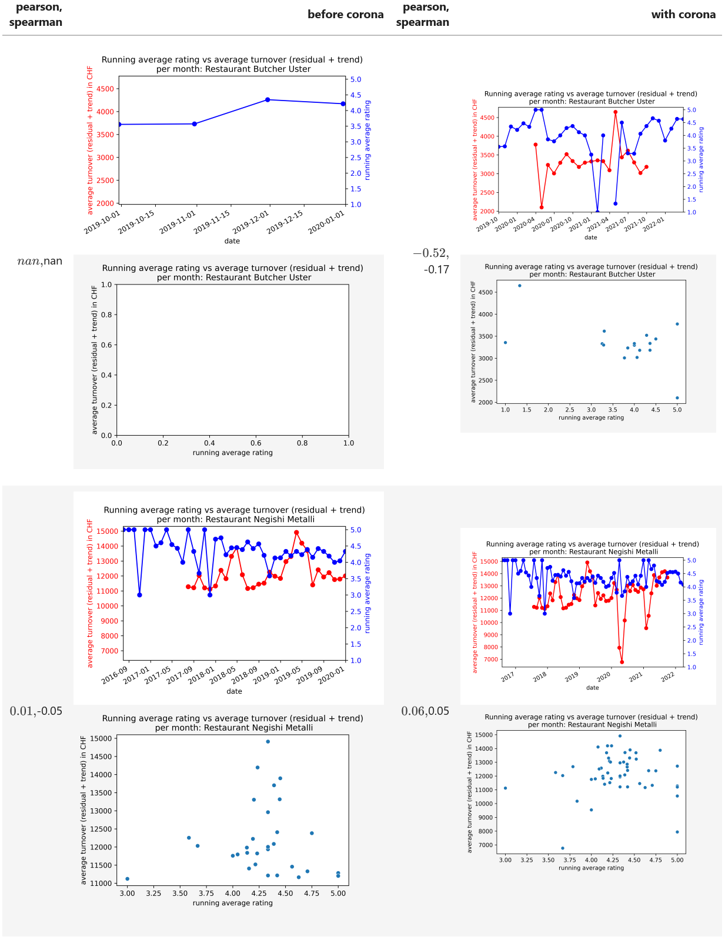

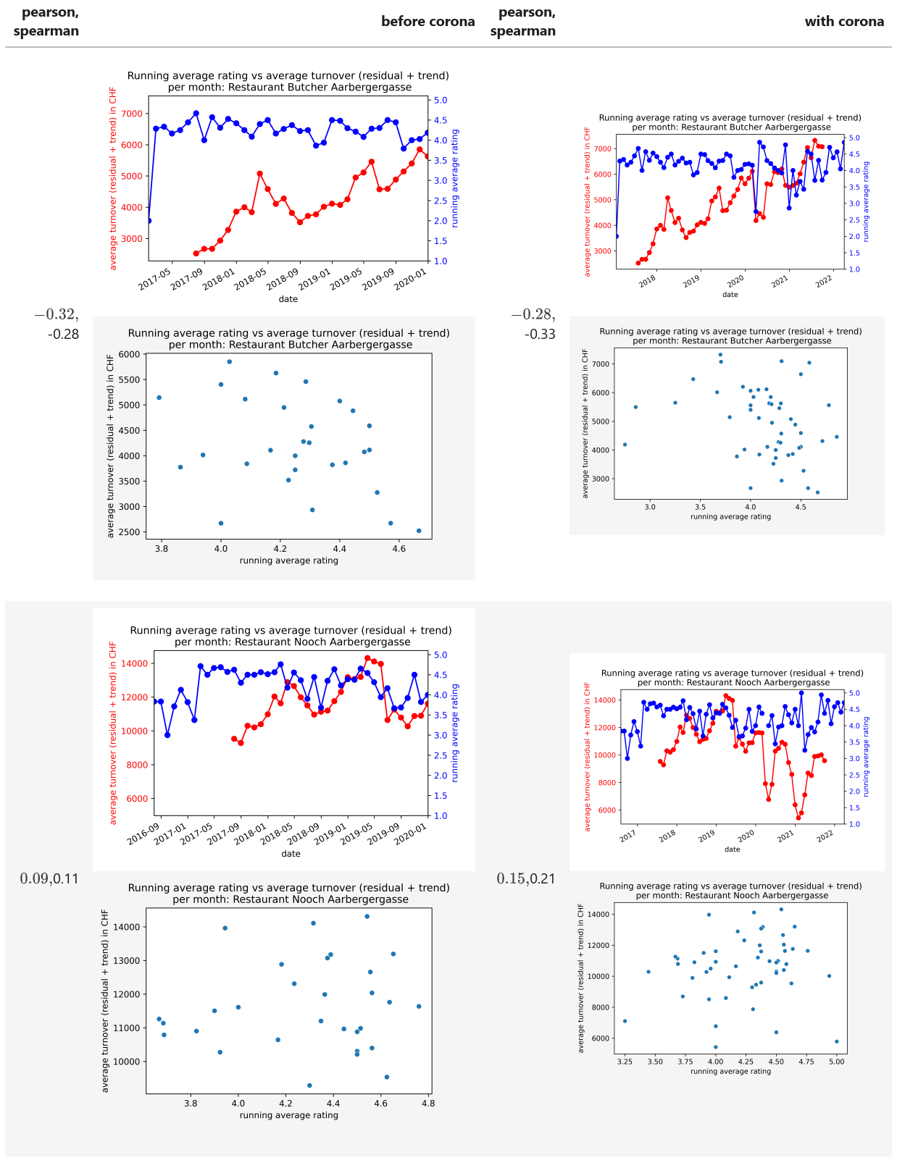

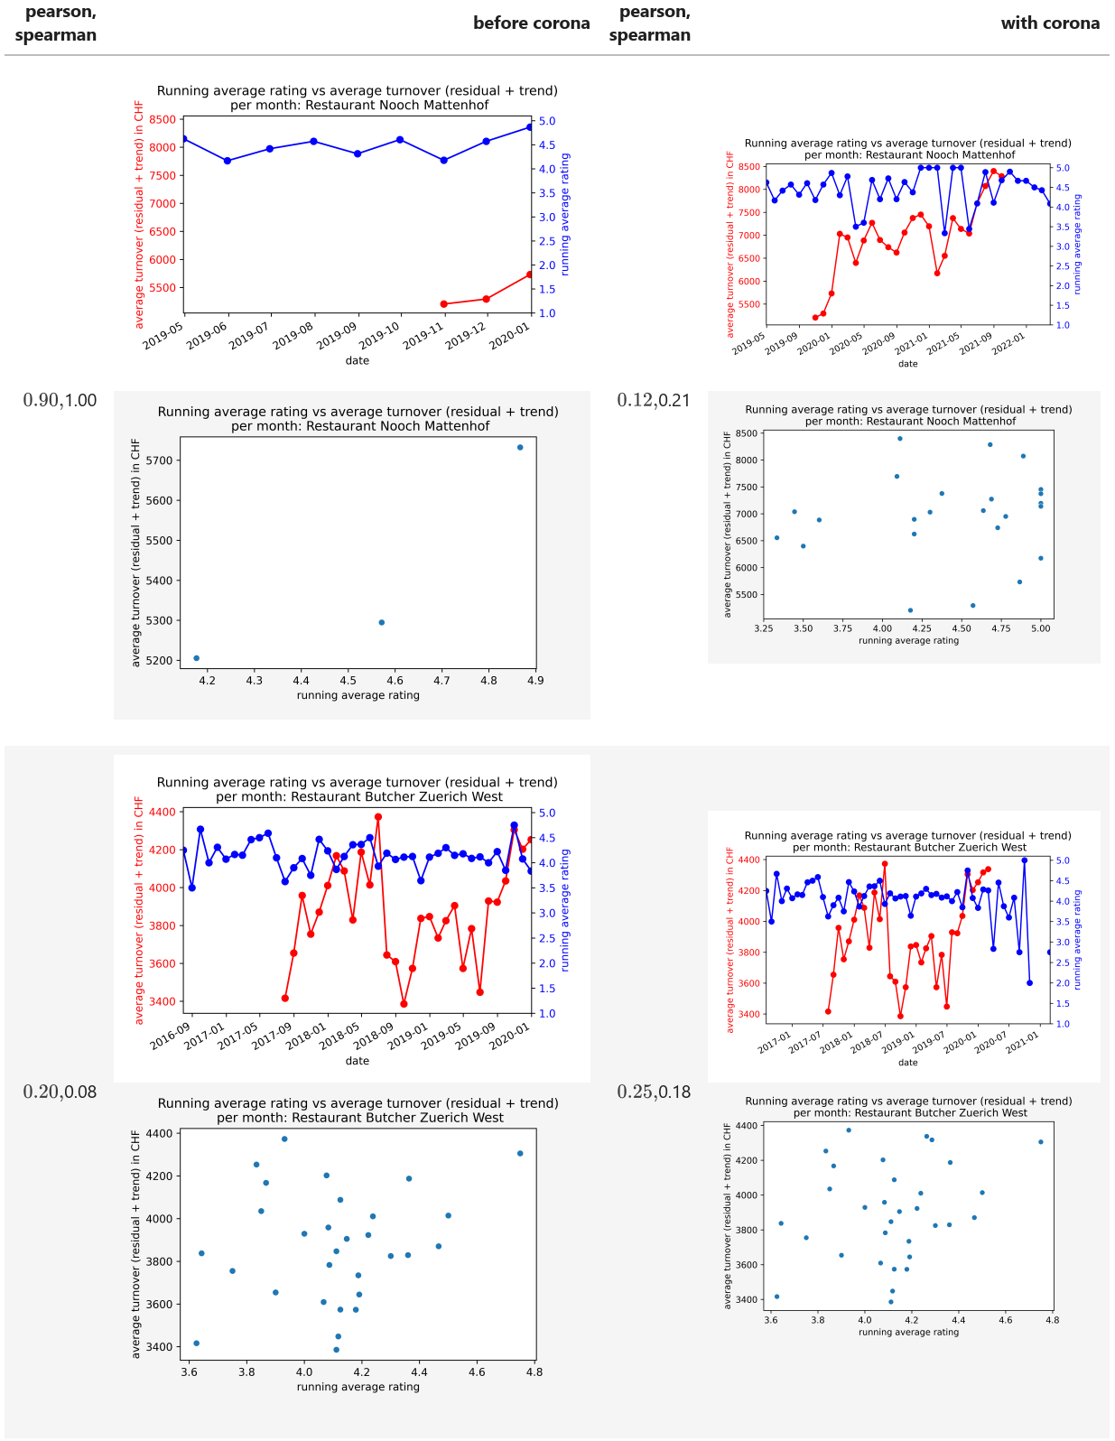

### Running average rating (residual + trend) vs average turnover per quarter year

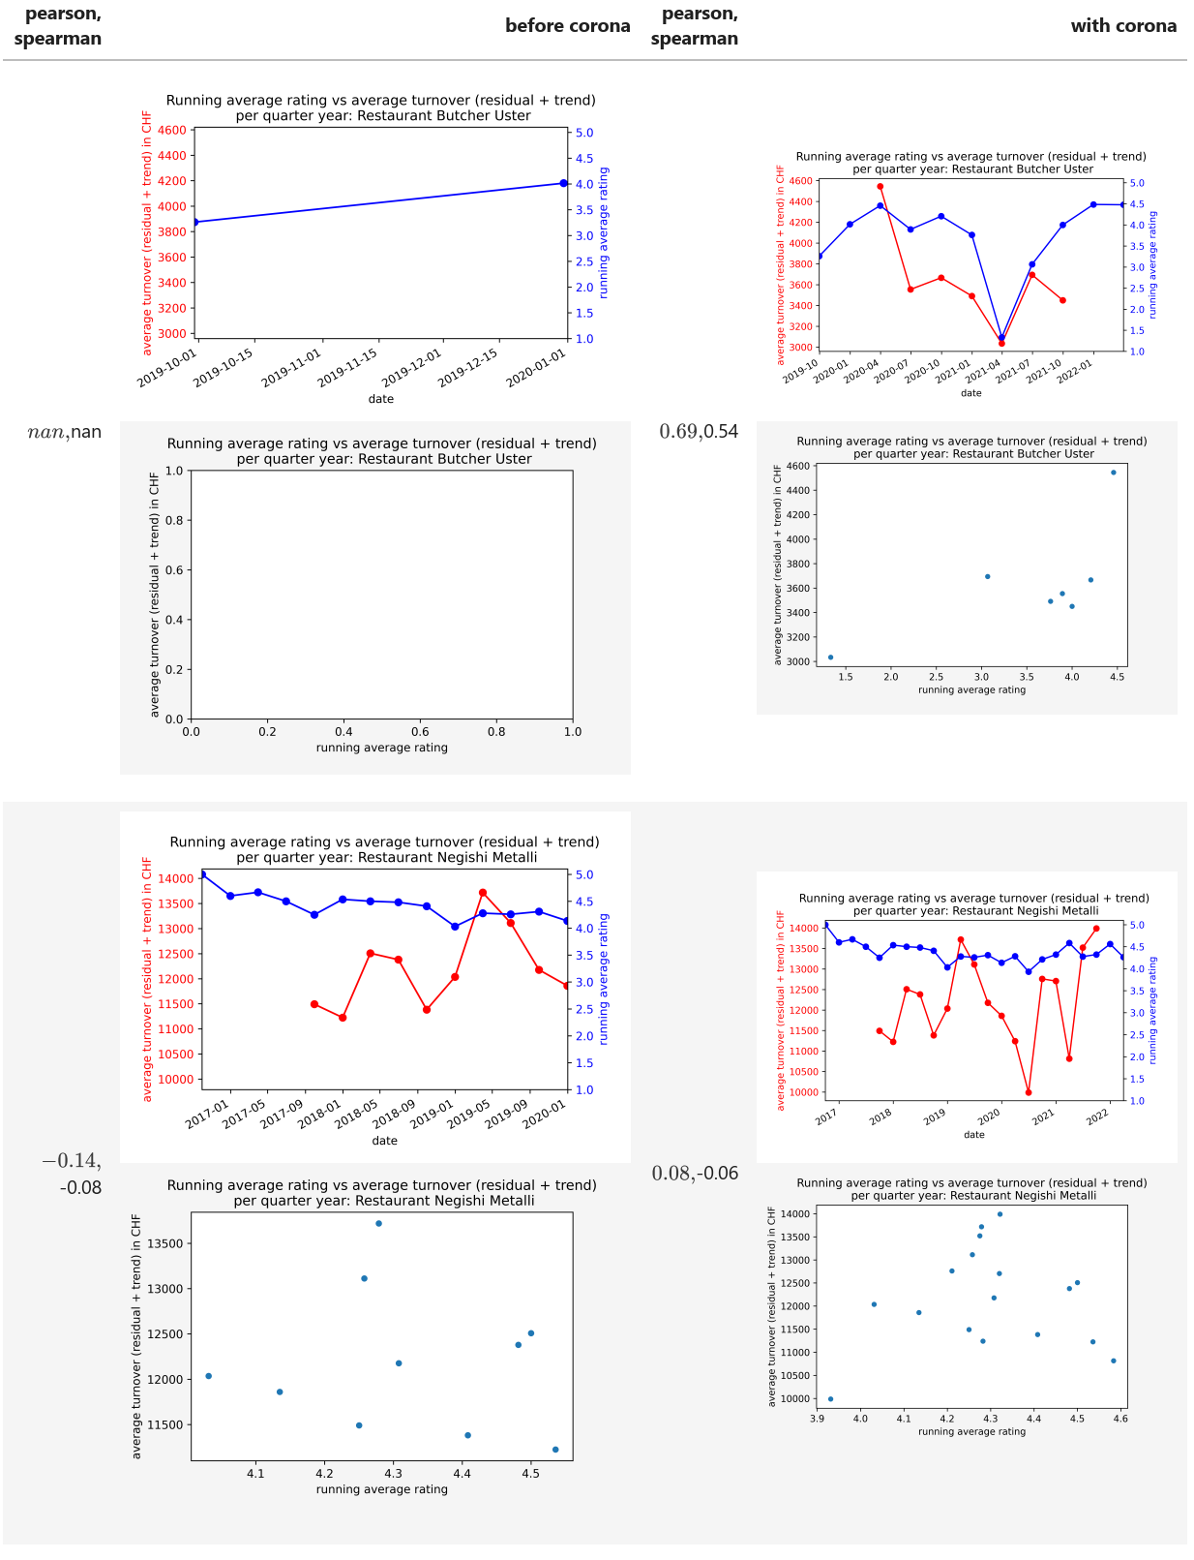

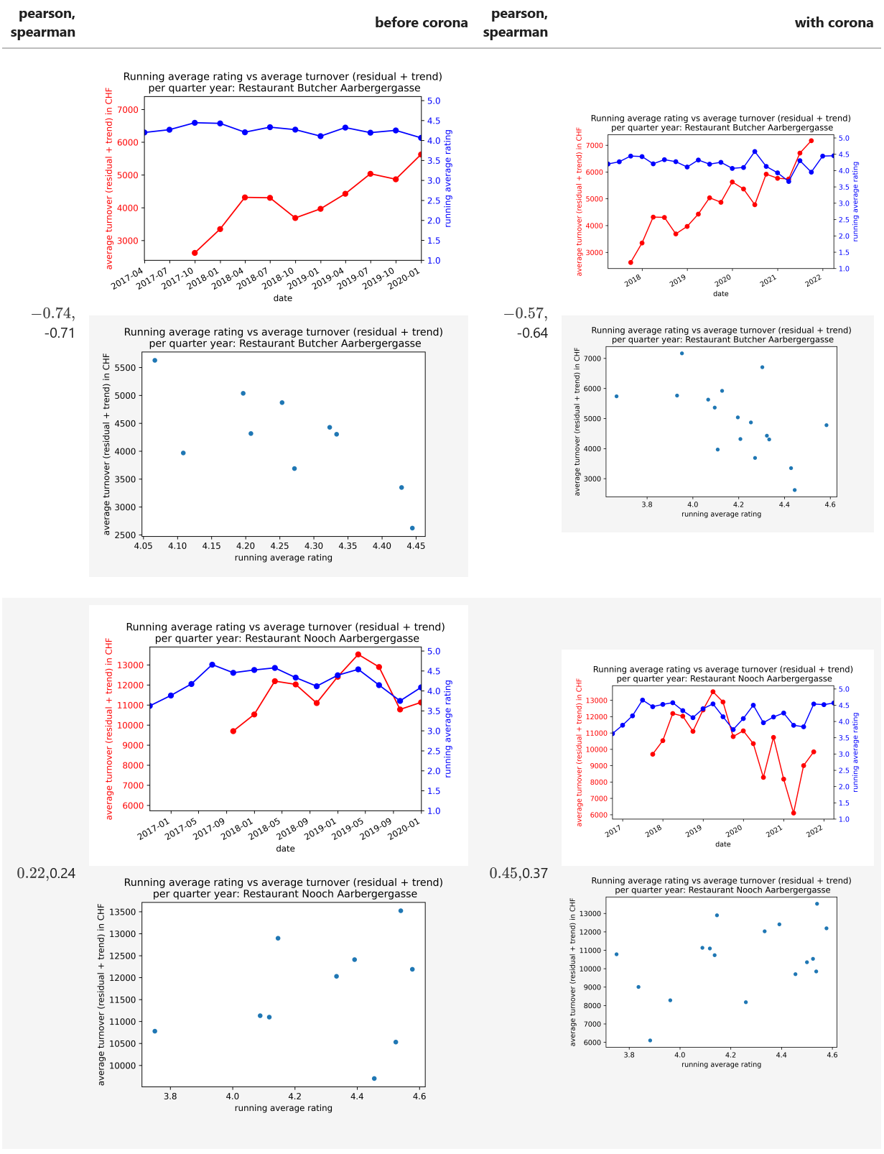

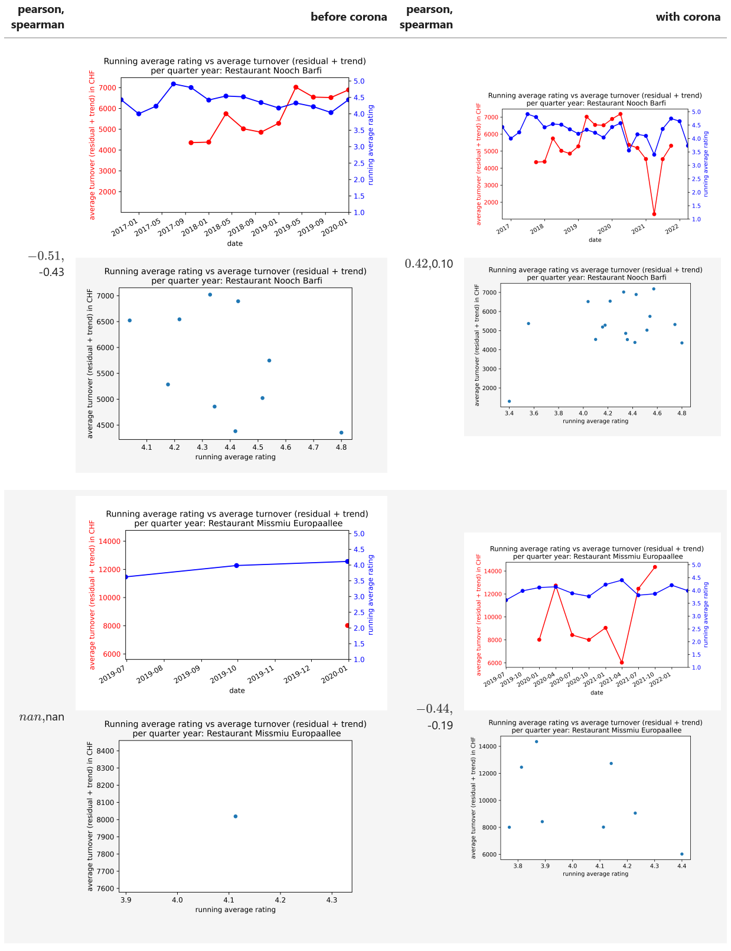

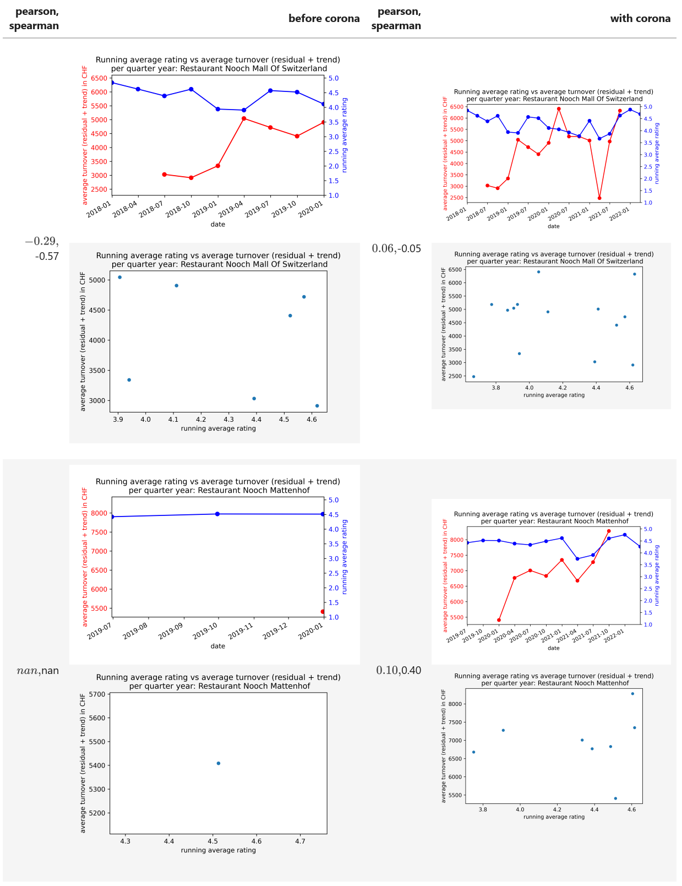

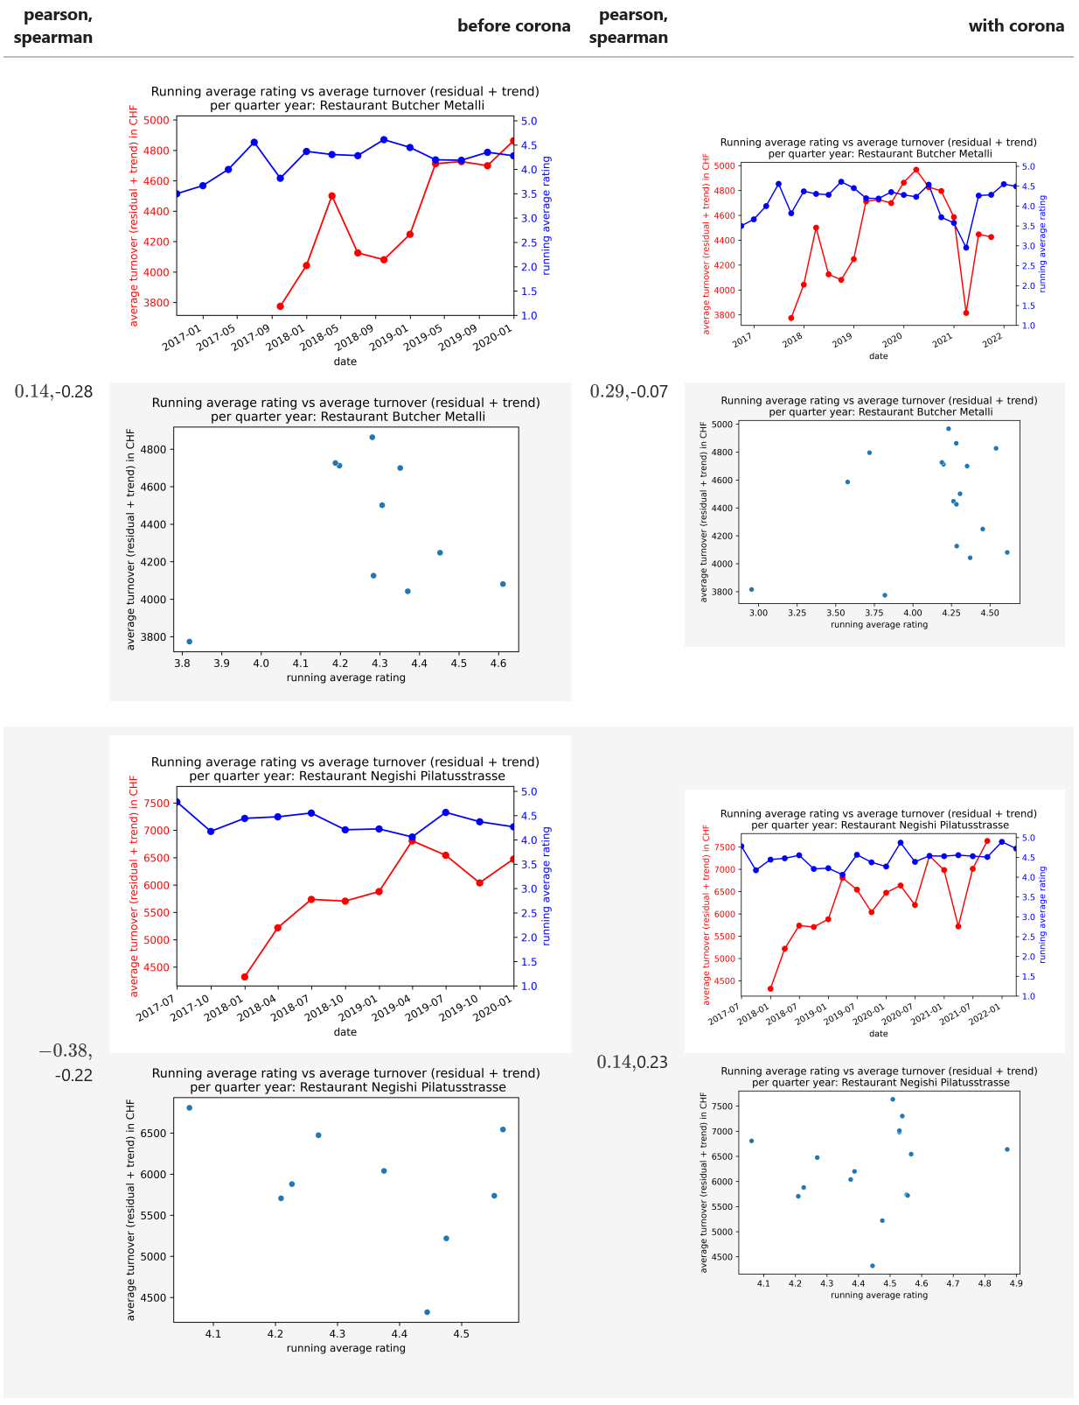

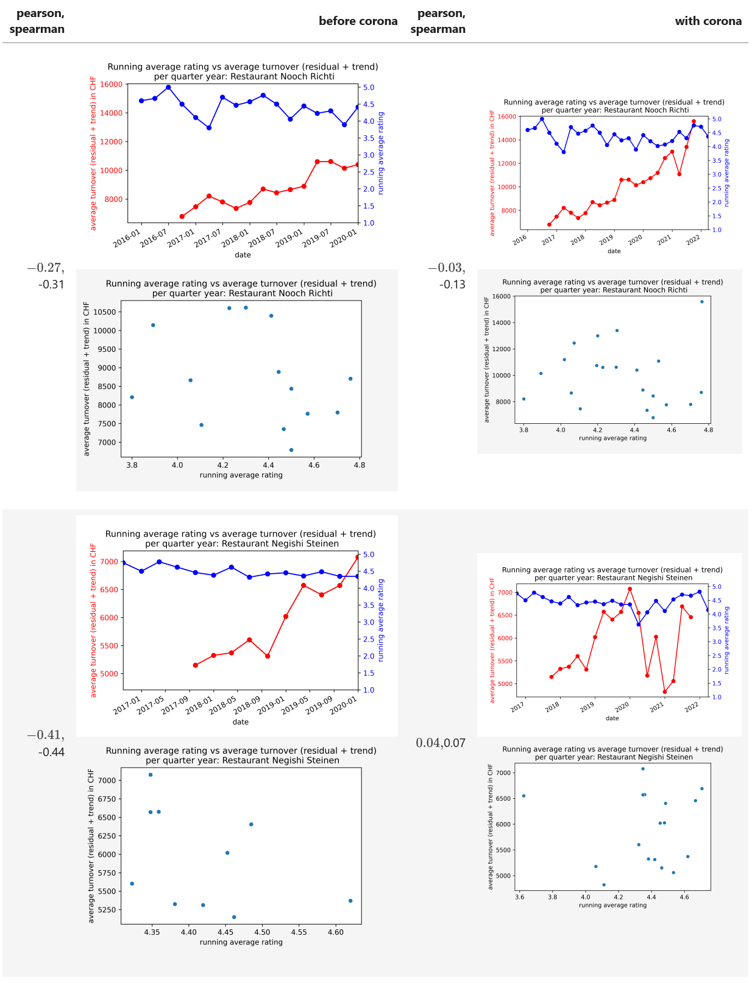

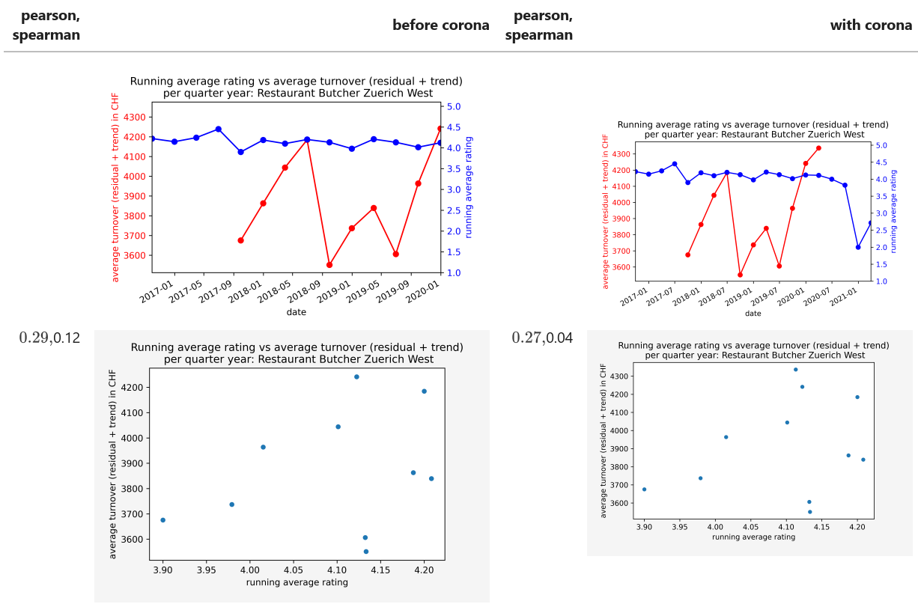

## Tripadvisor restaurant ratings versus Prognolite restaurant revenues

### Running average rating (observed) vs average turnover per month

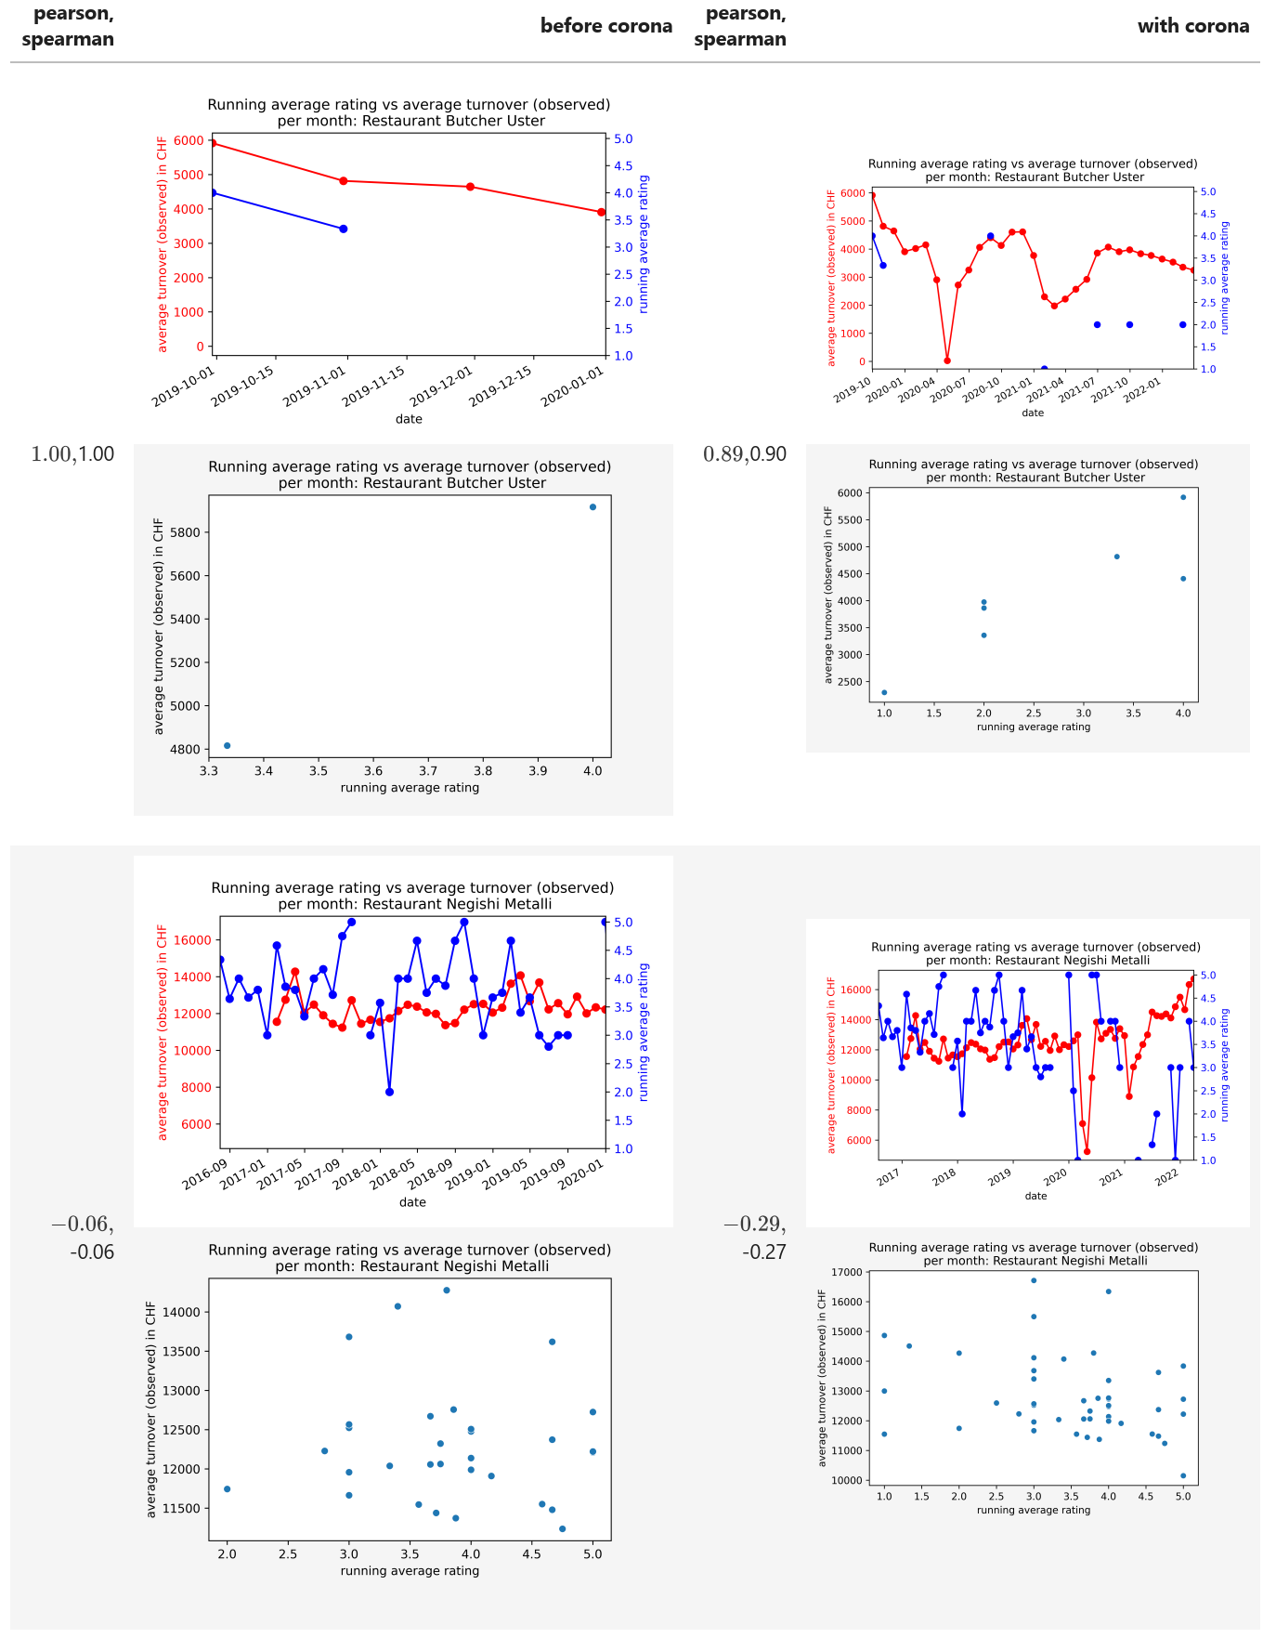

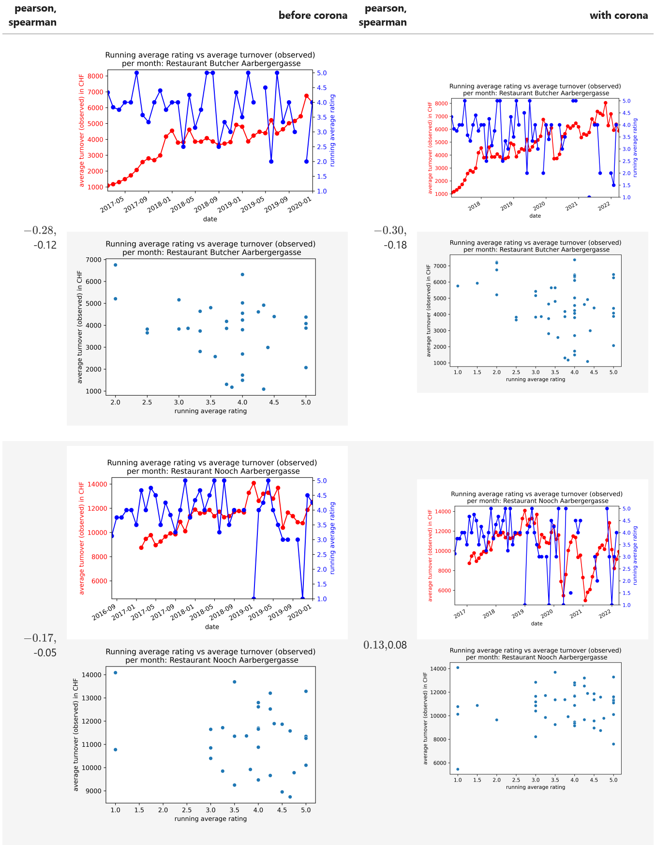

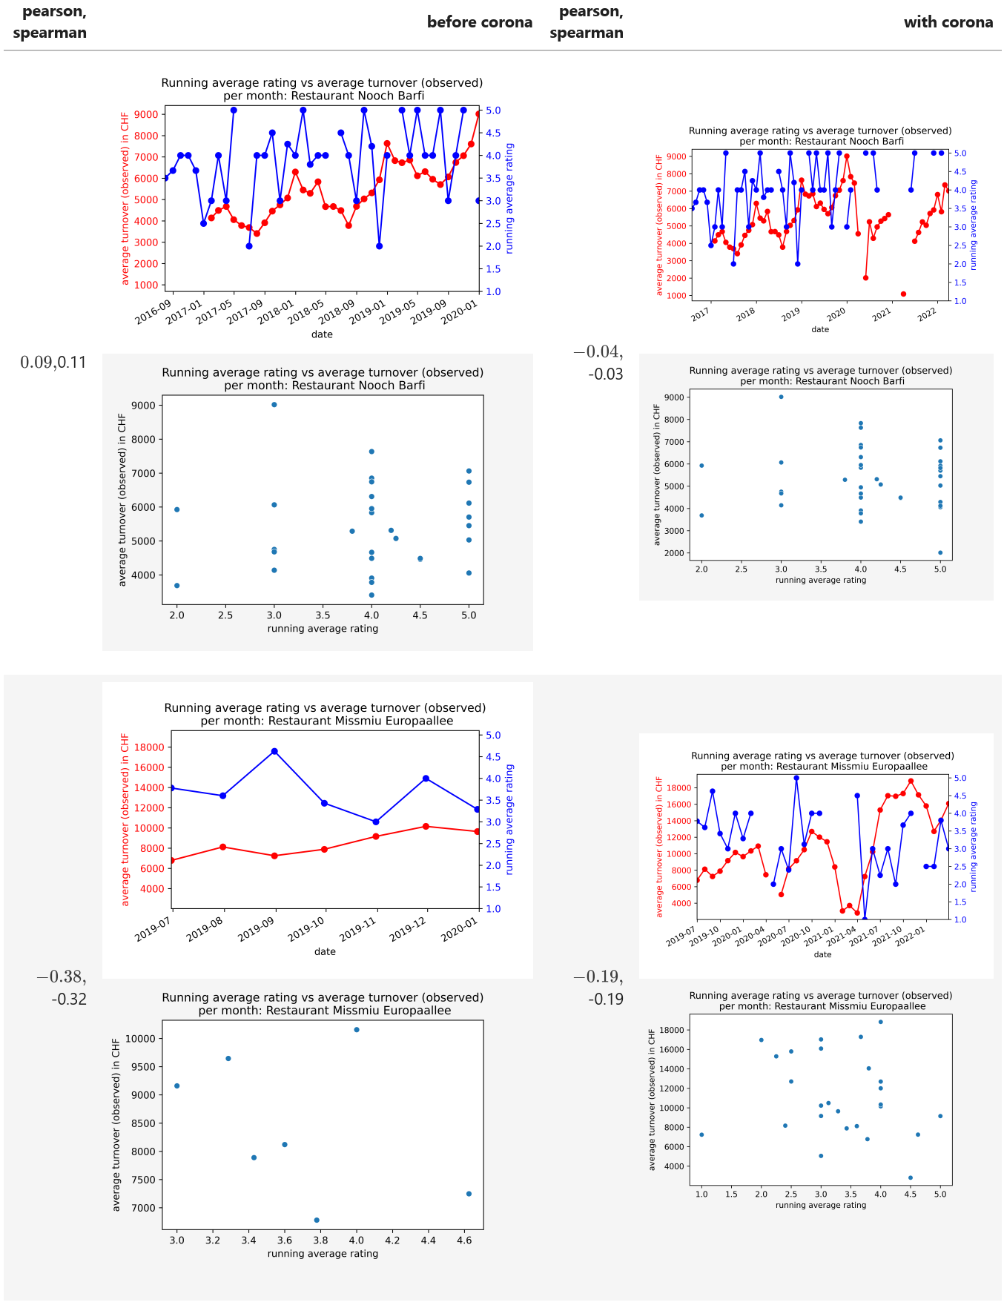

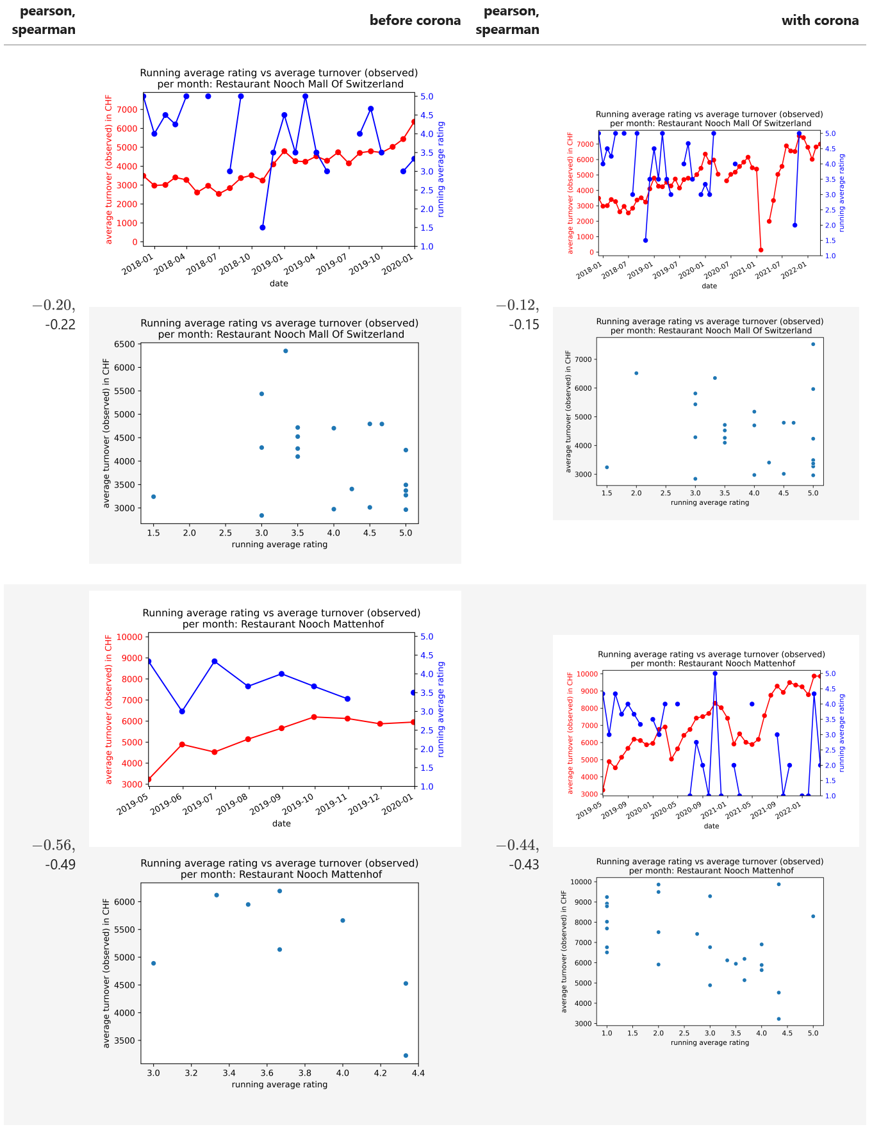

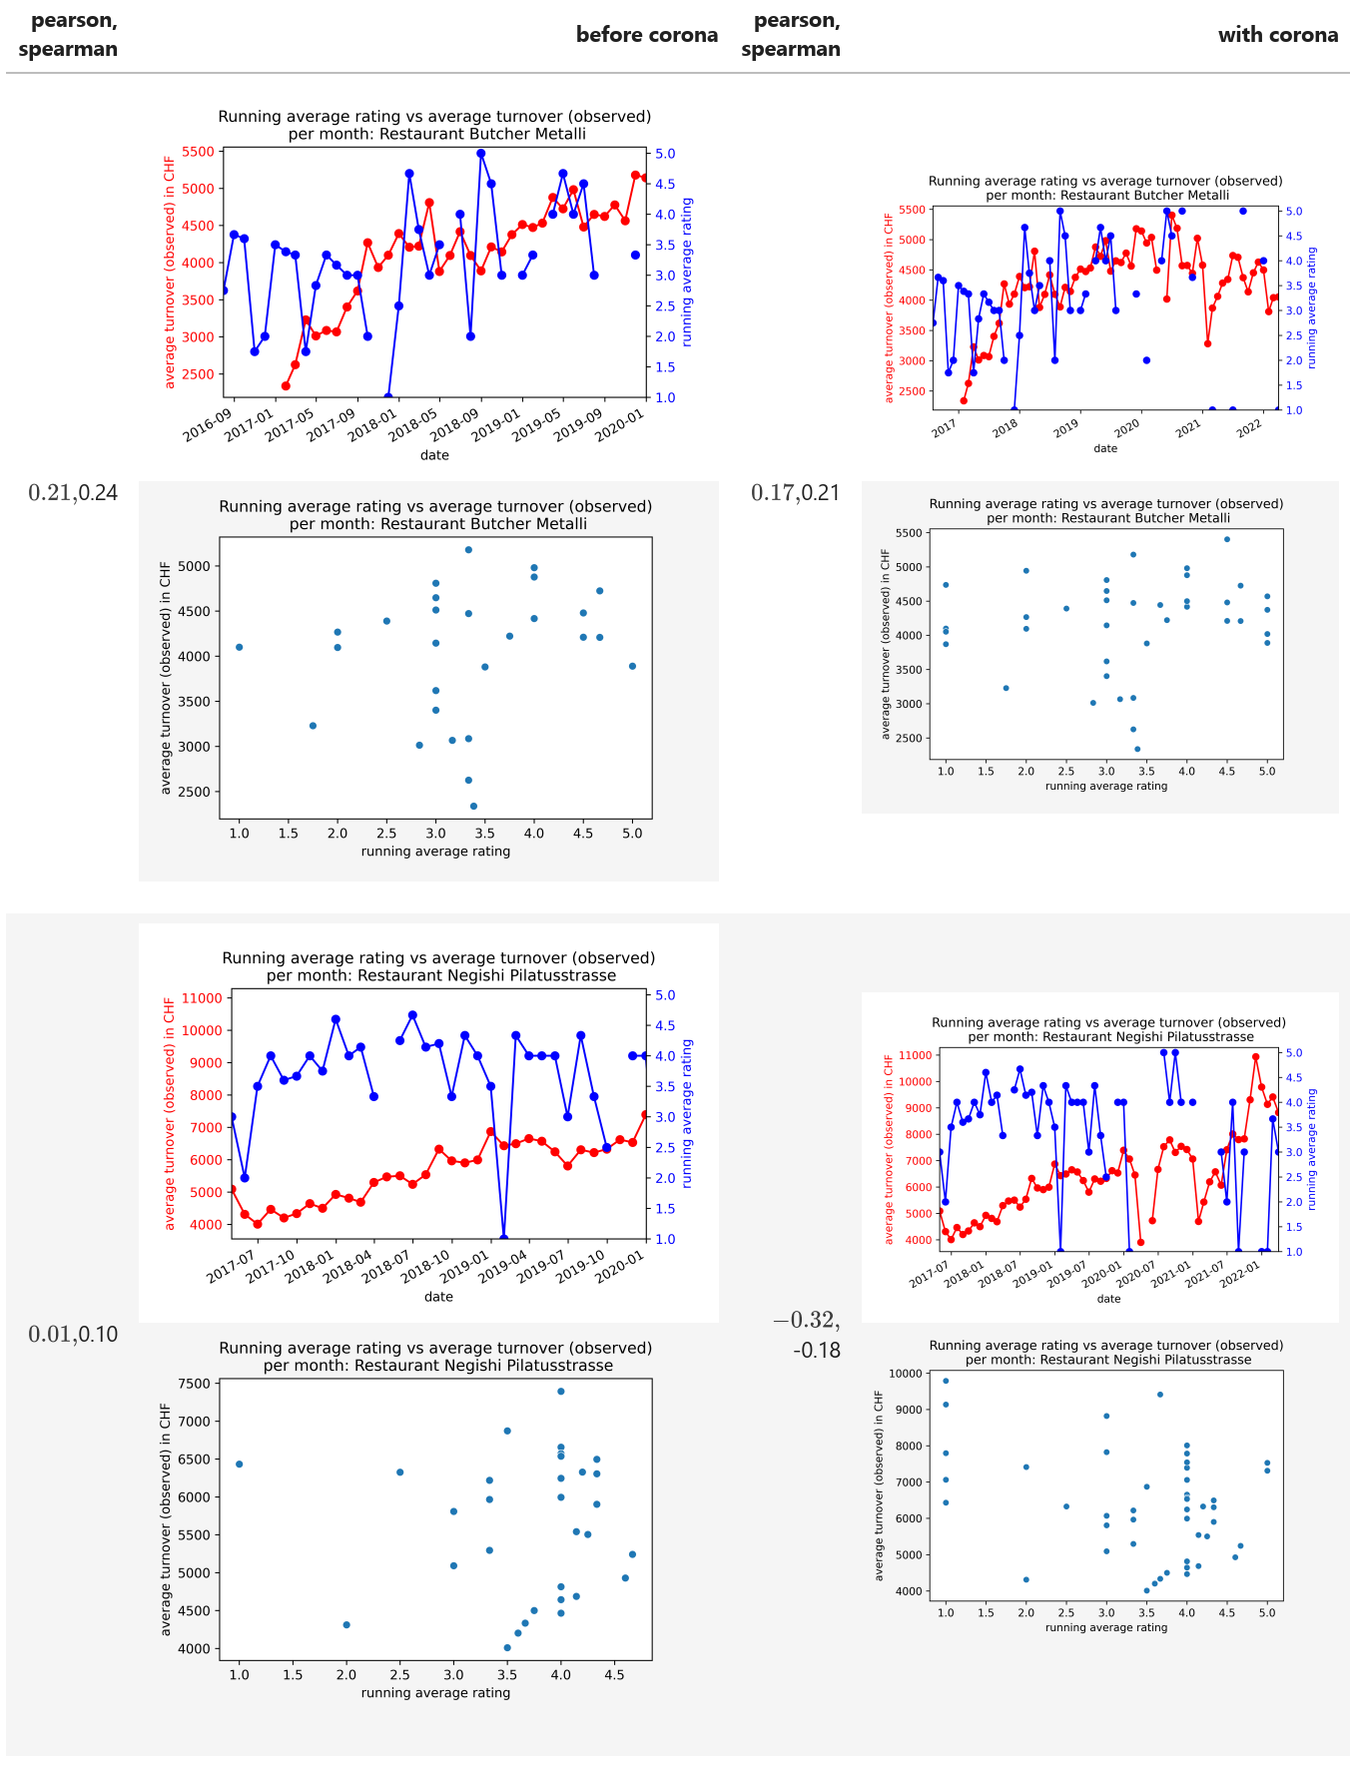

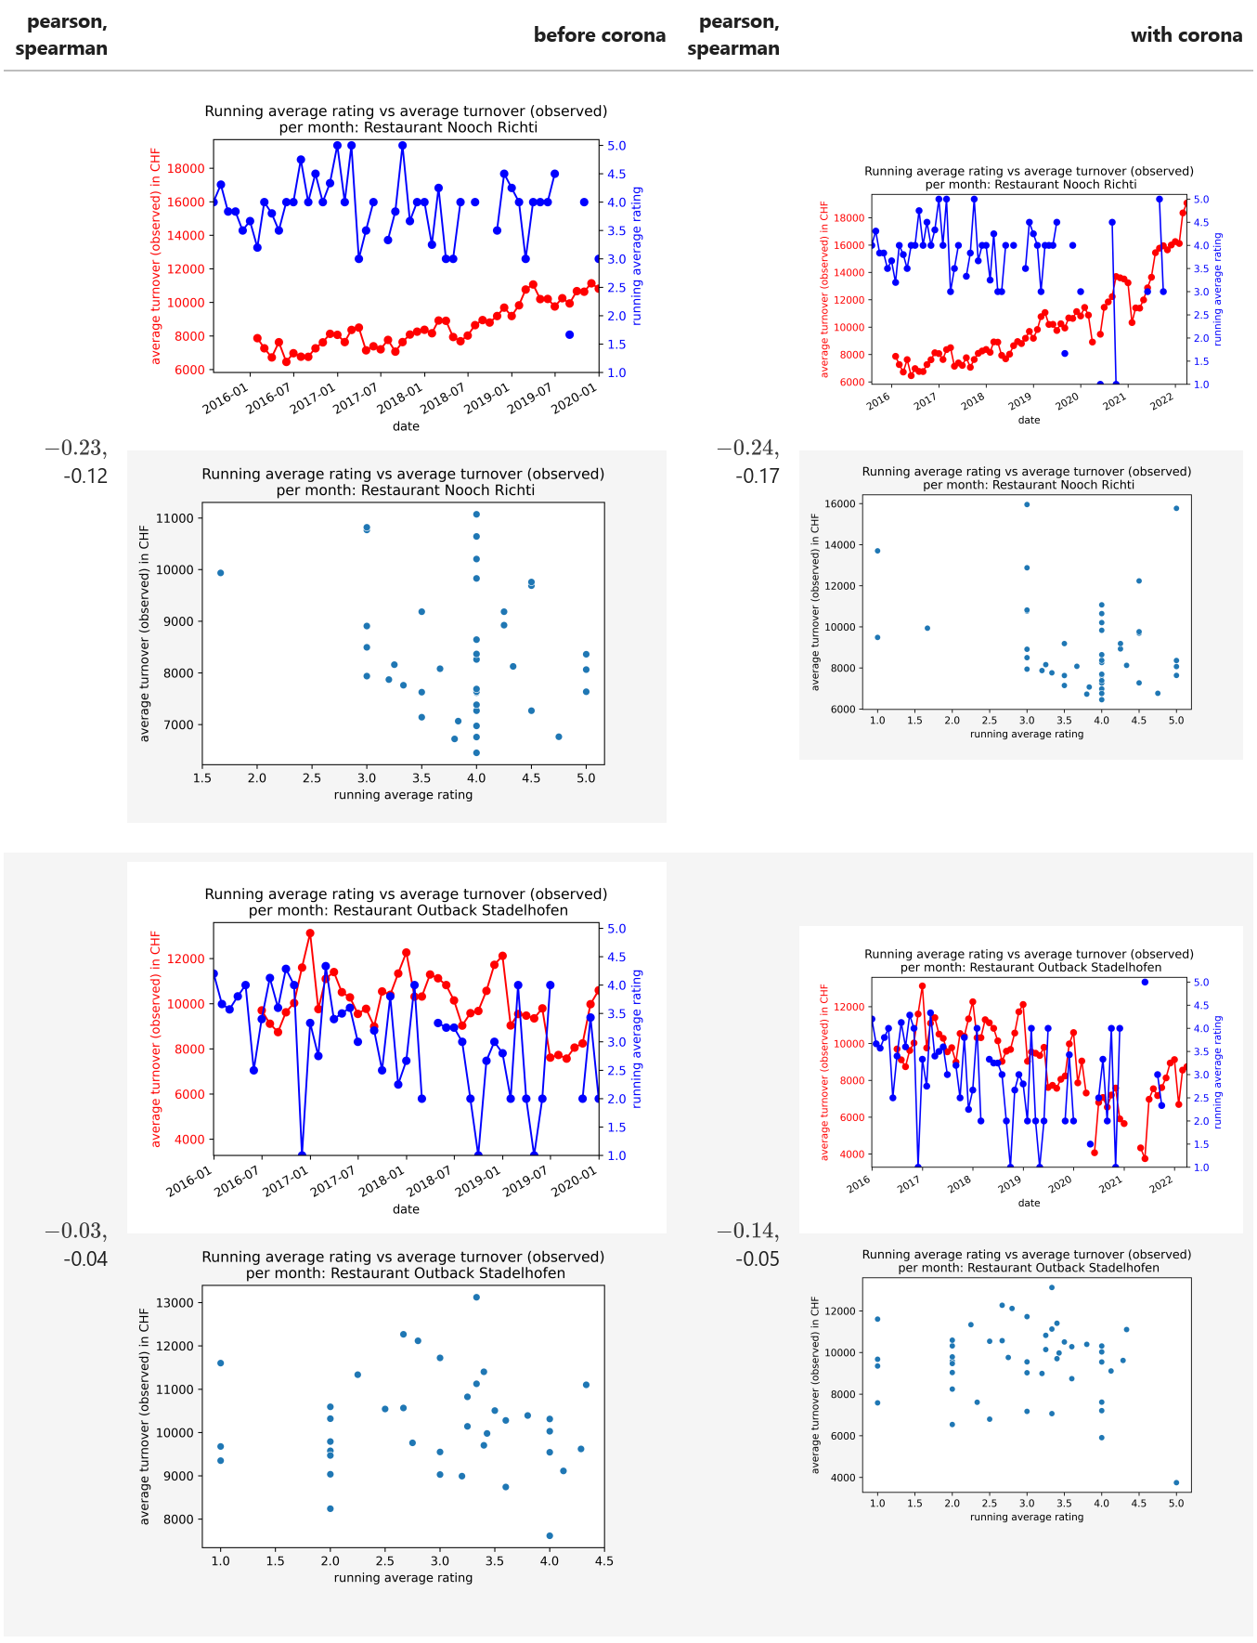

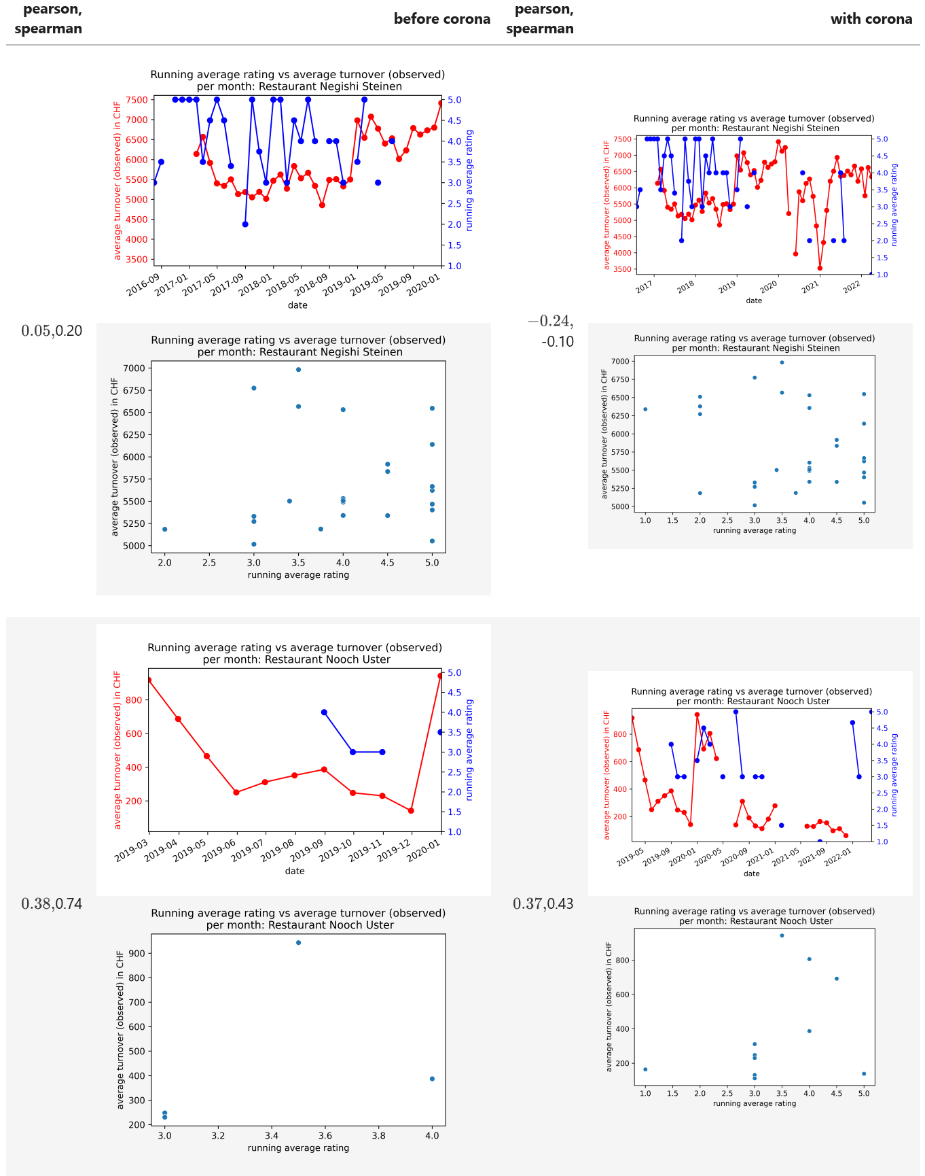

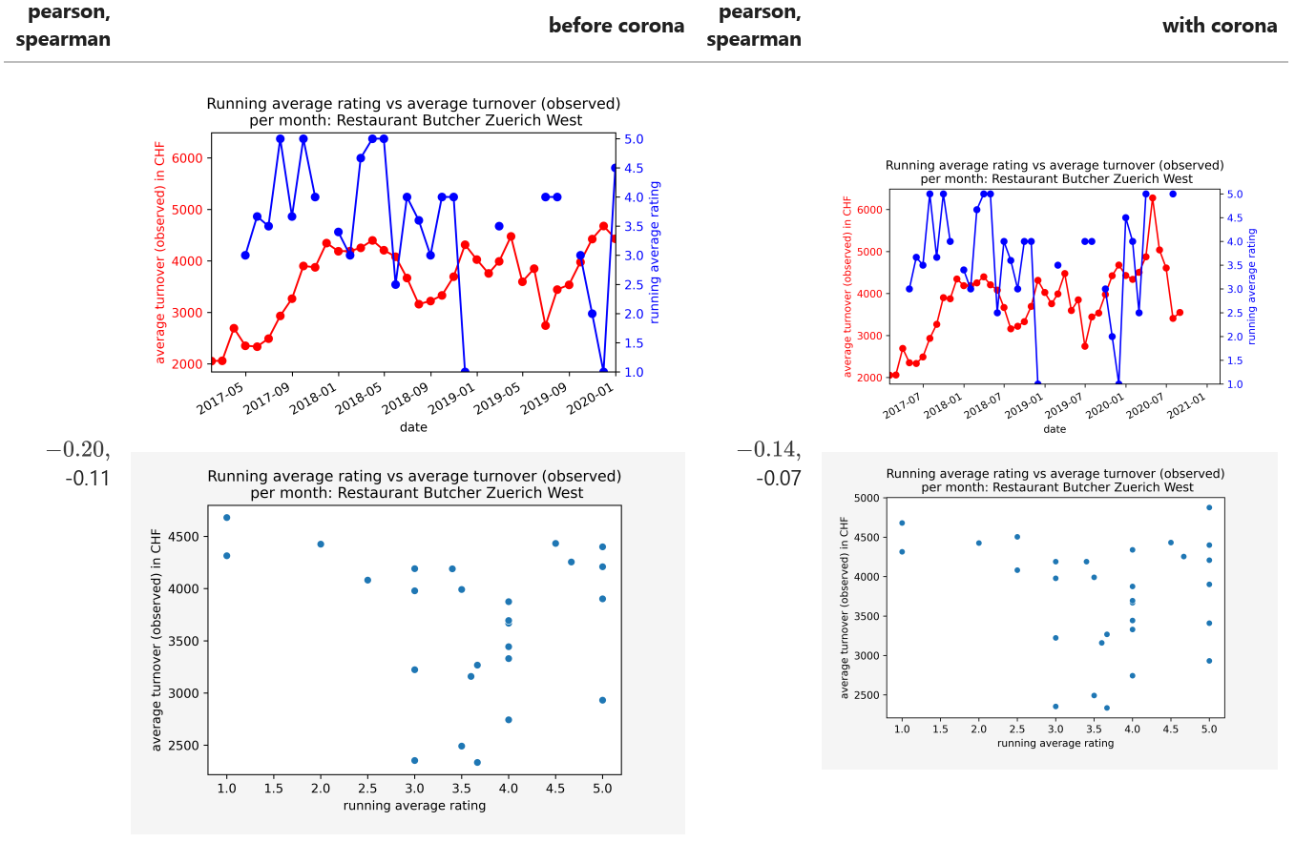

### Running average rating (observed) vs average turnover per quarter year

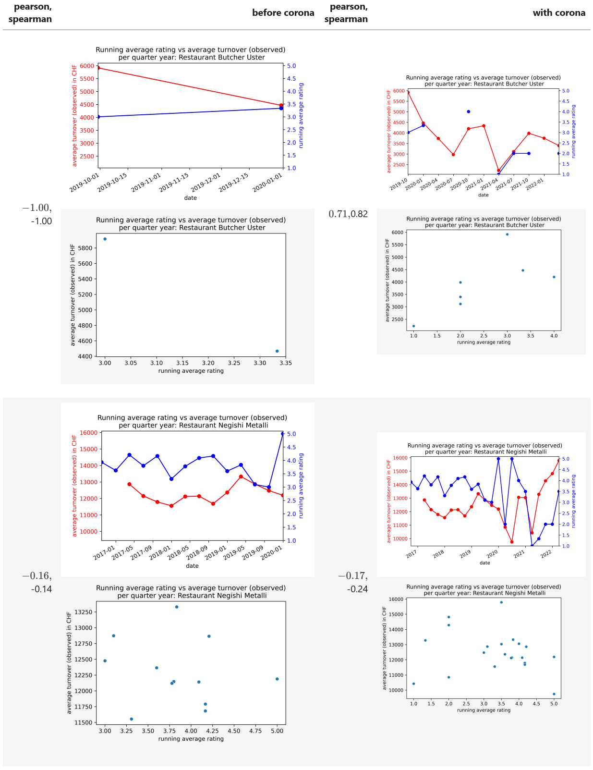

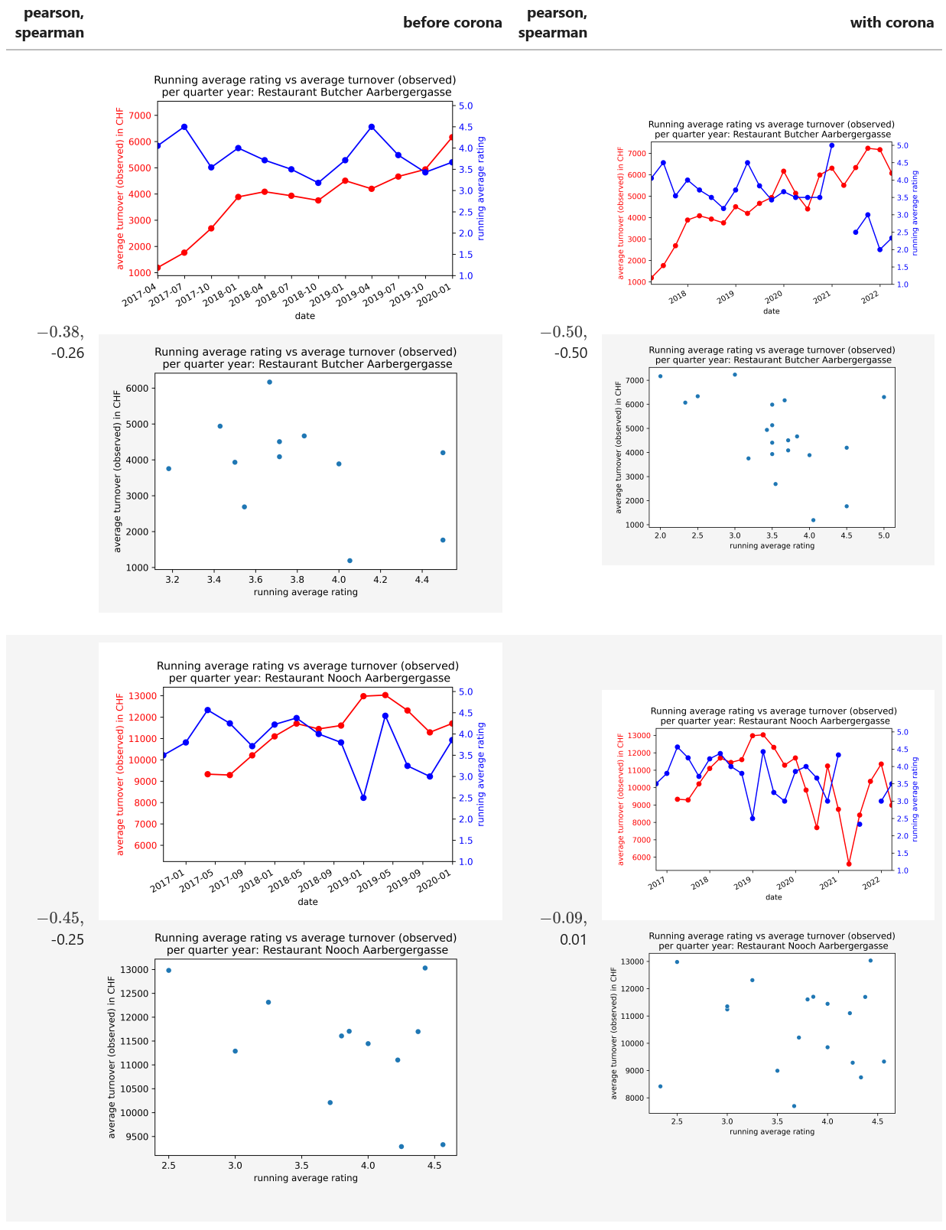

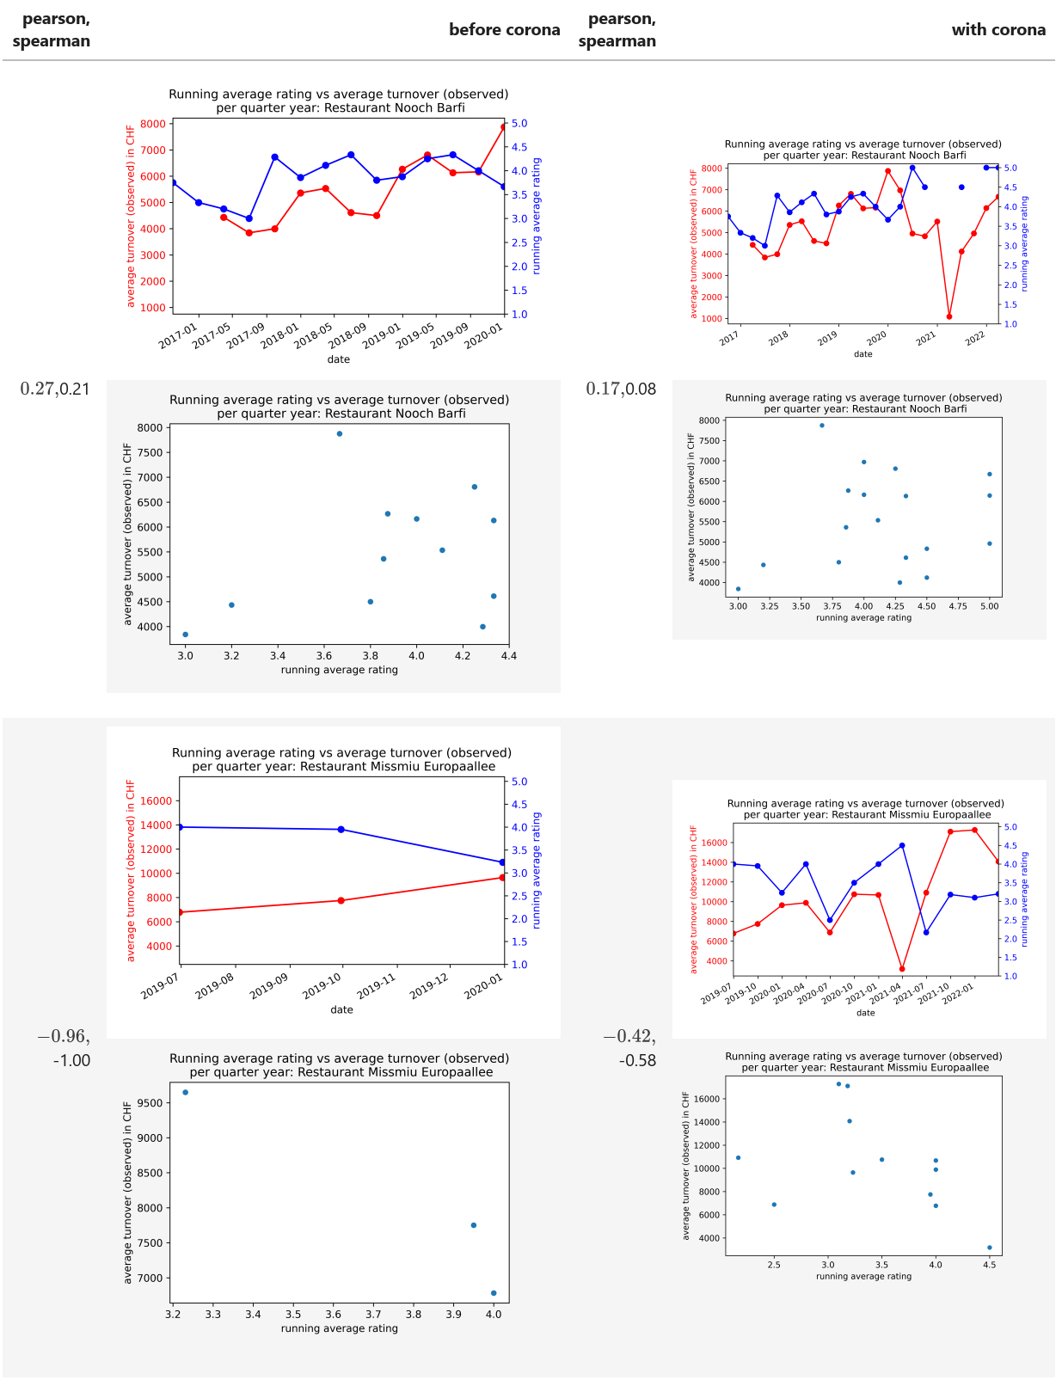

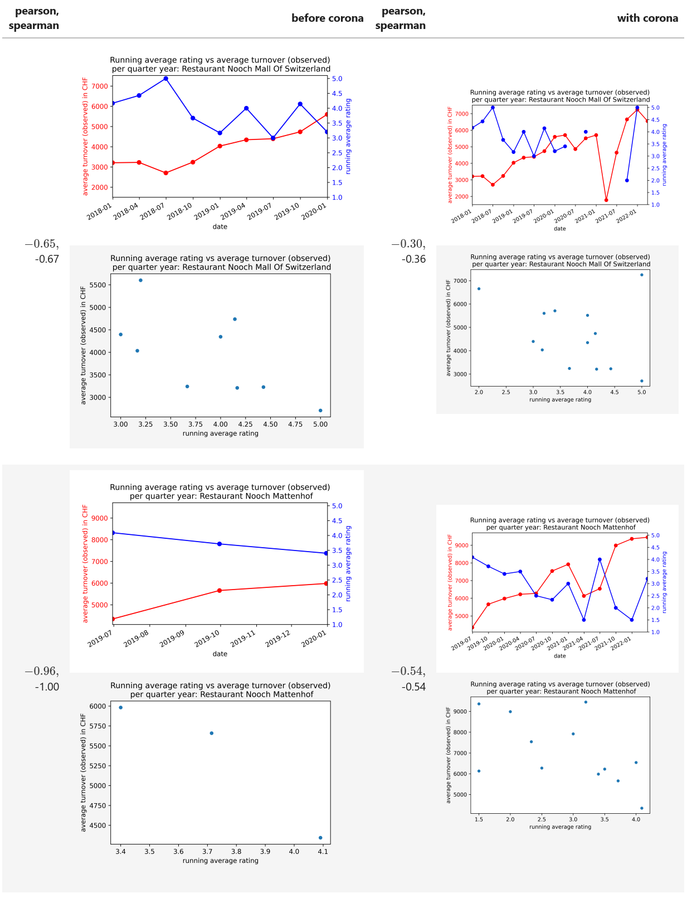

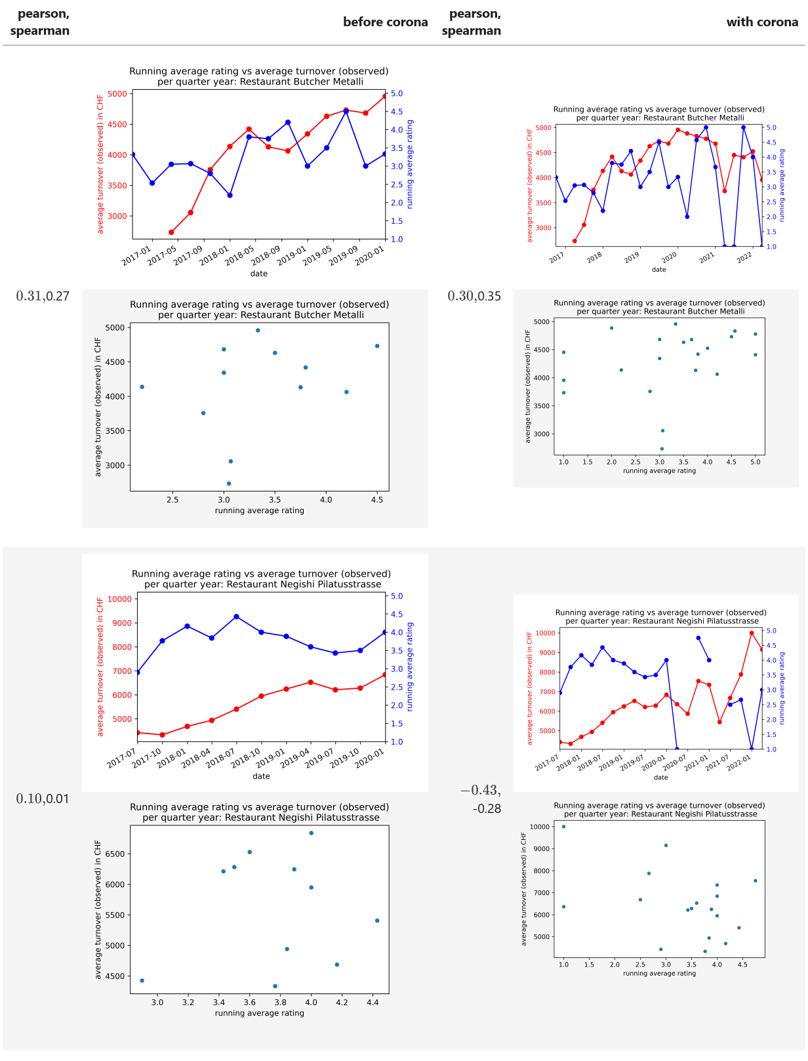

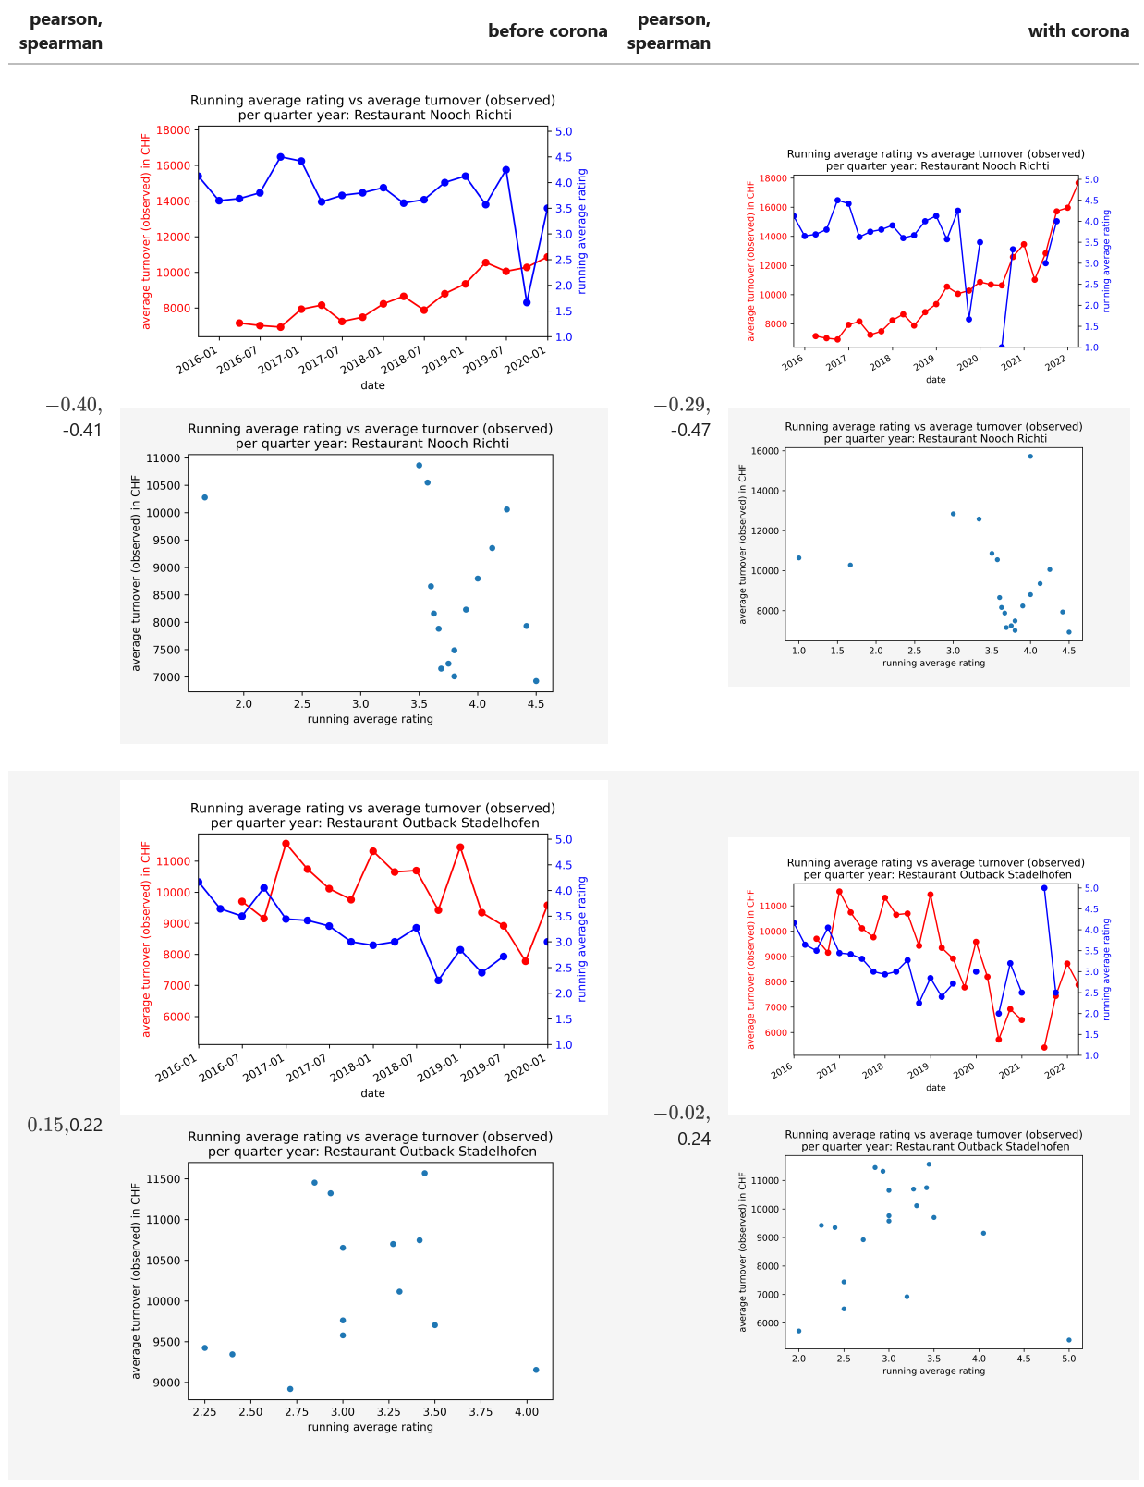

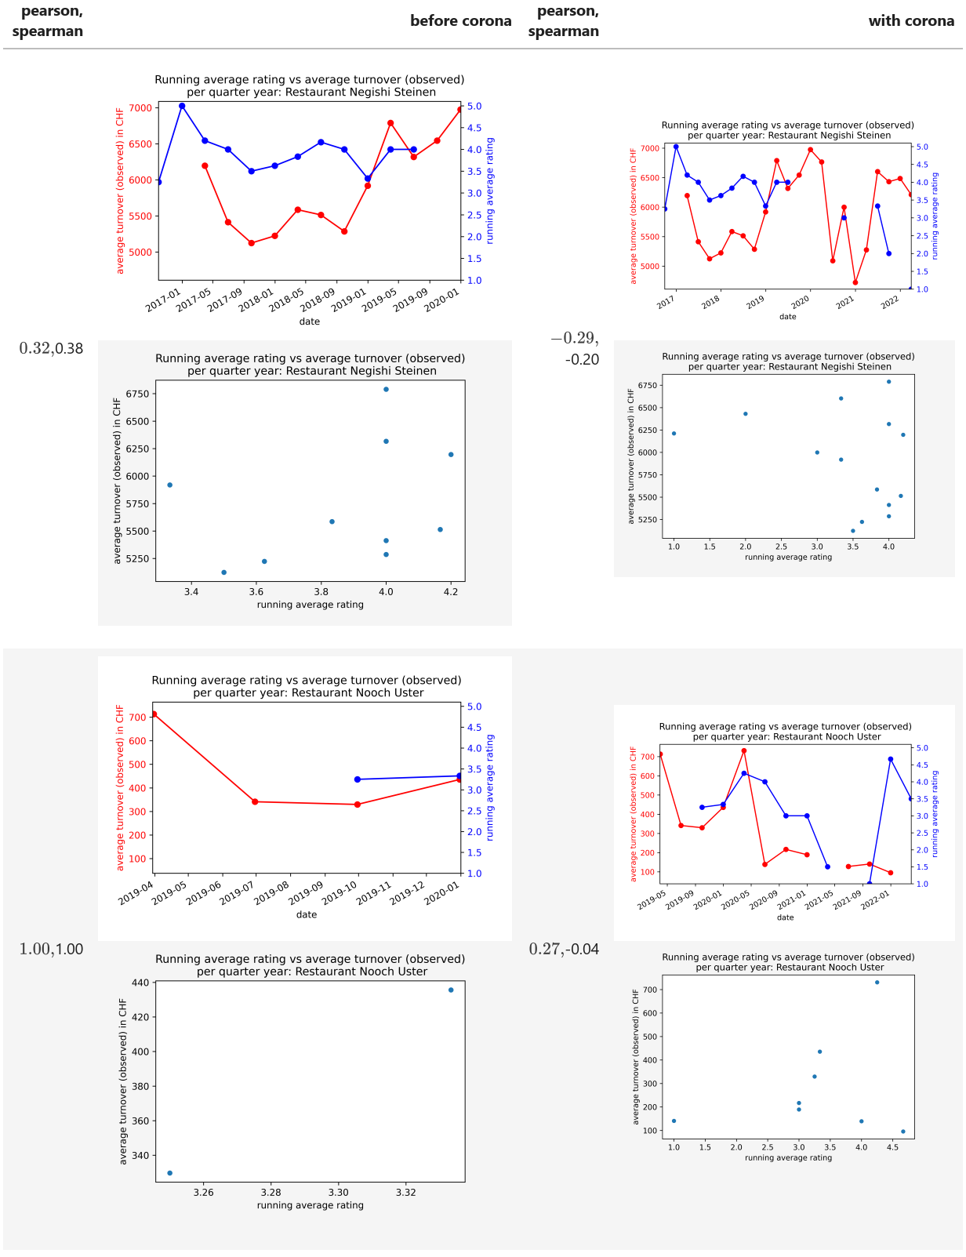

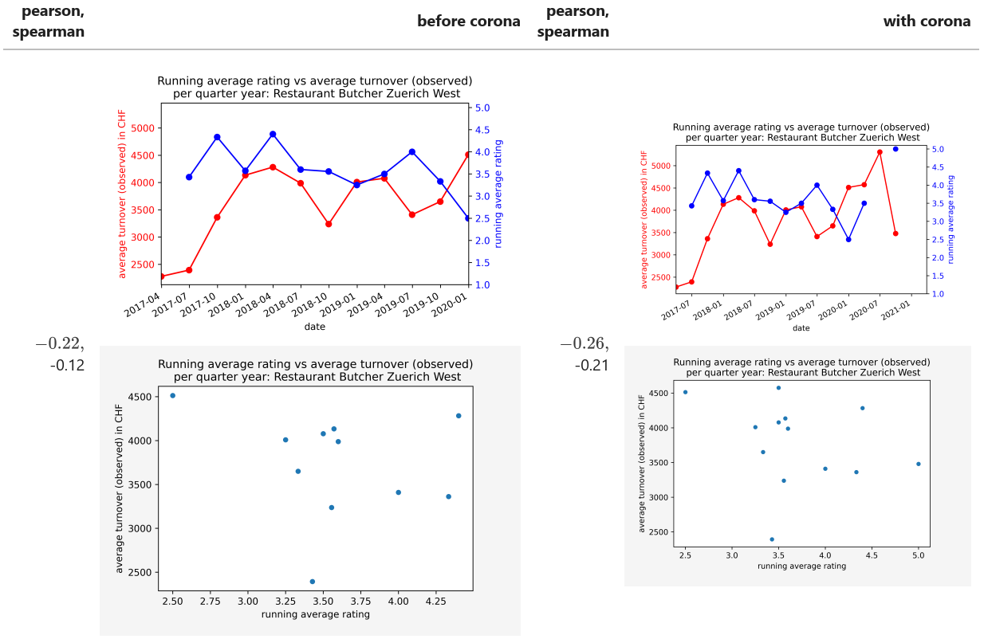

### Running average rating (residual + trend) vs average turnover per month

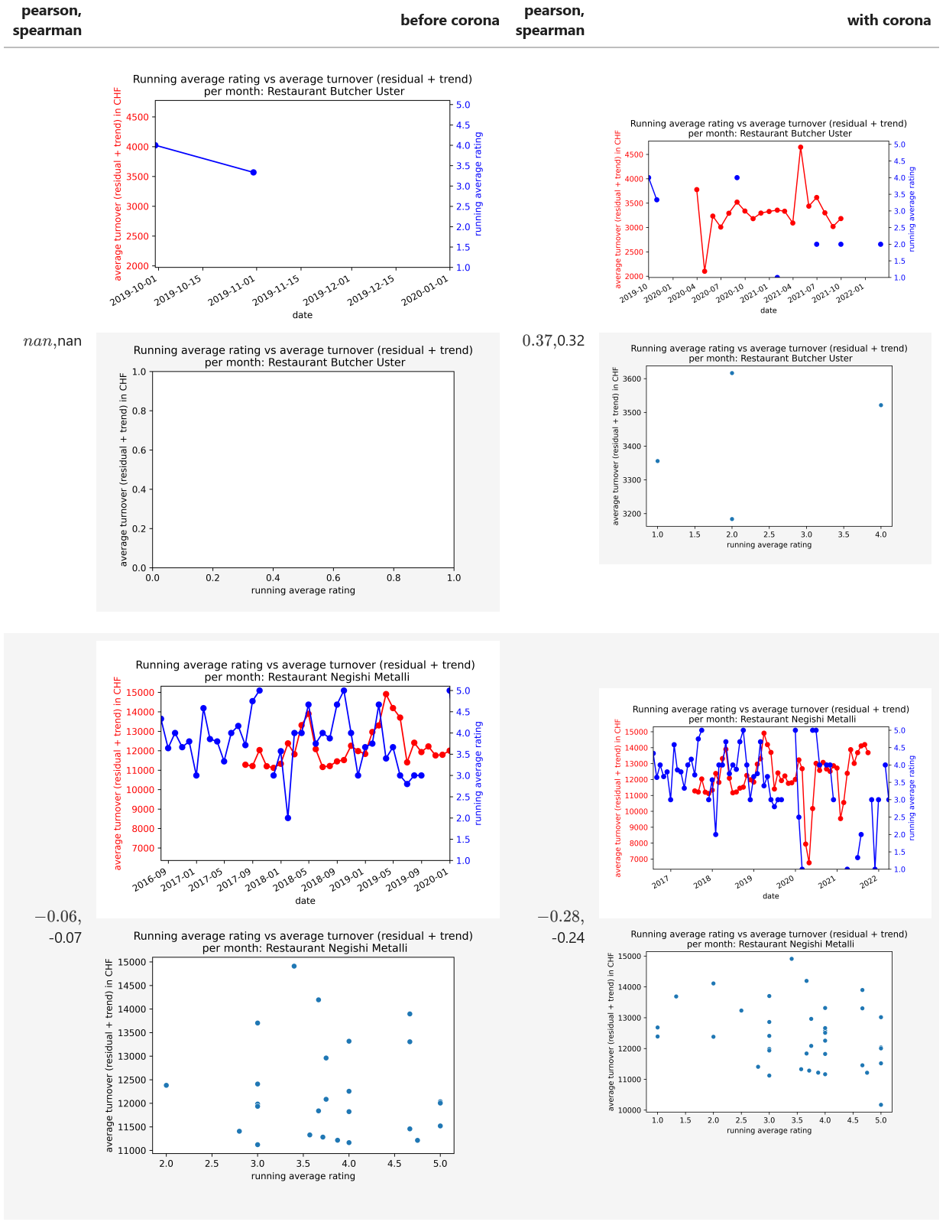

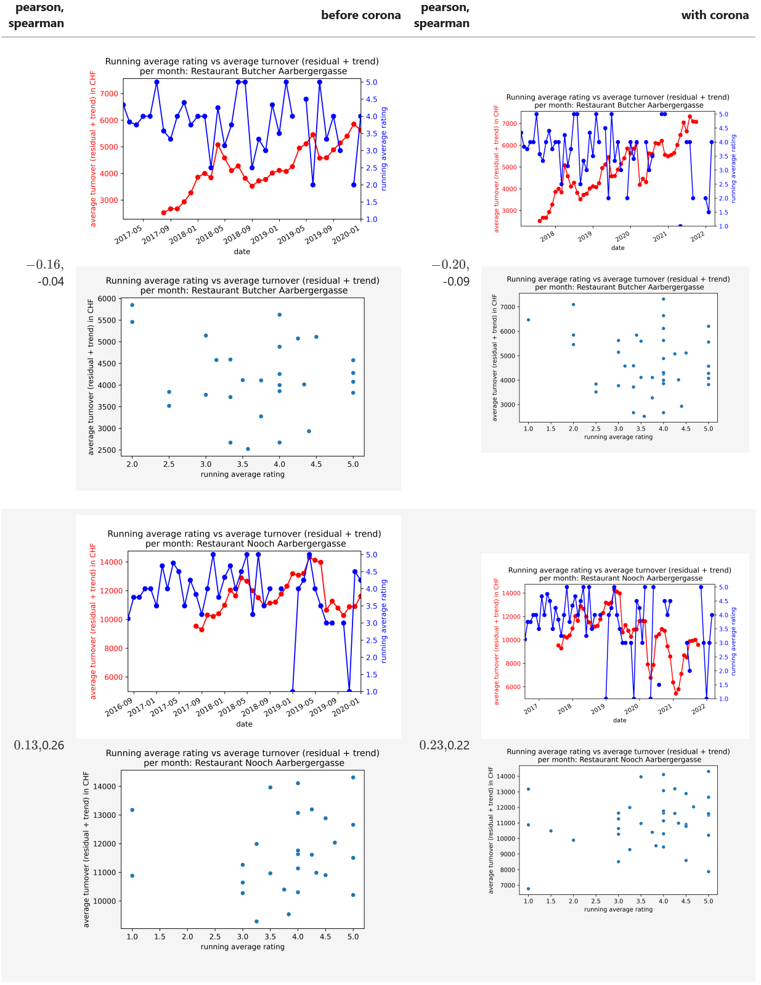

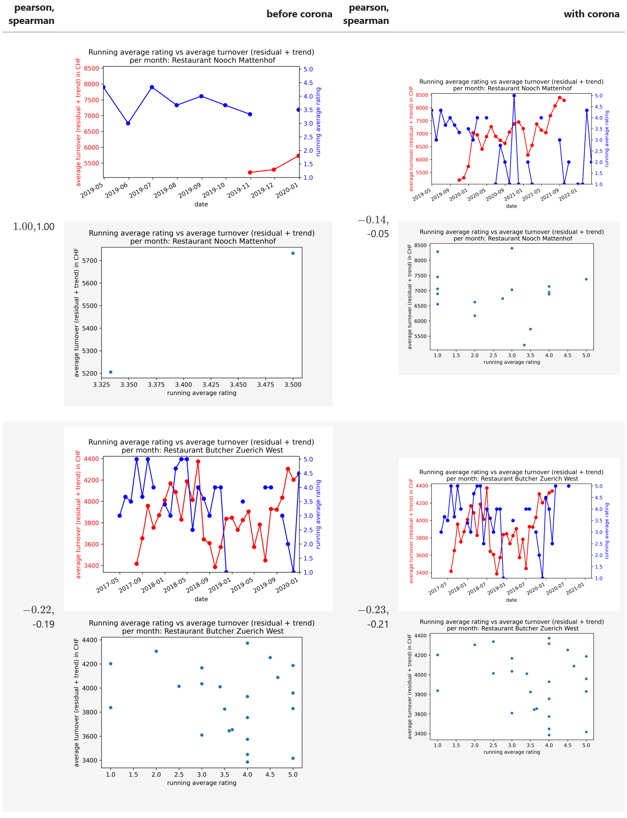

### Running average rating (residual + trend) vs average turnover per quarter year

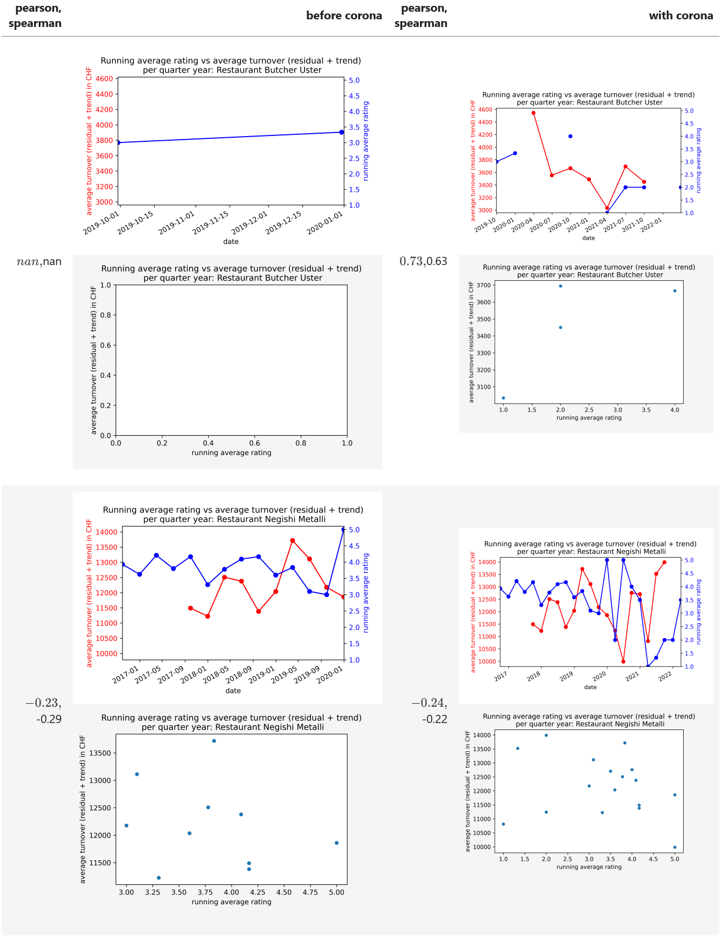

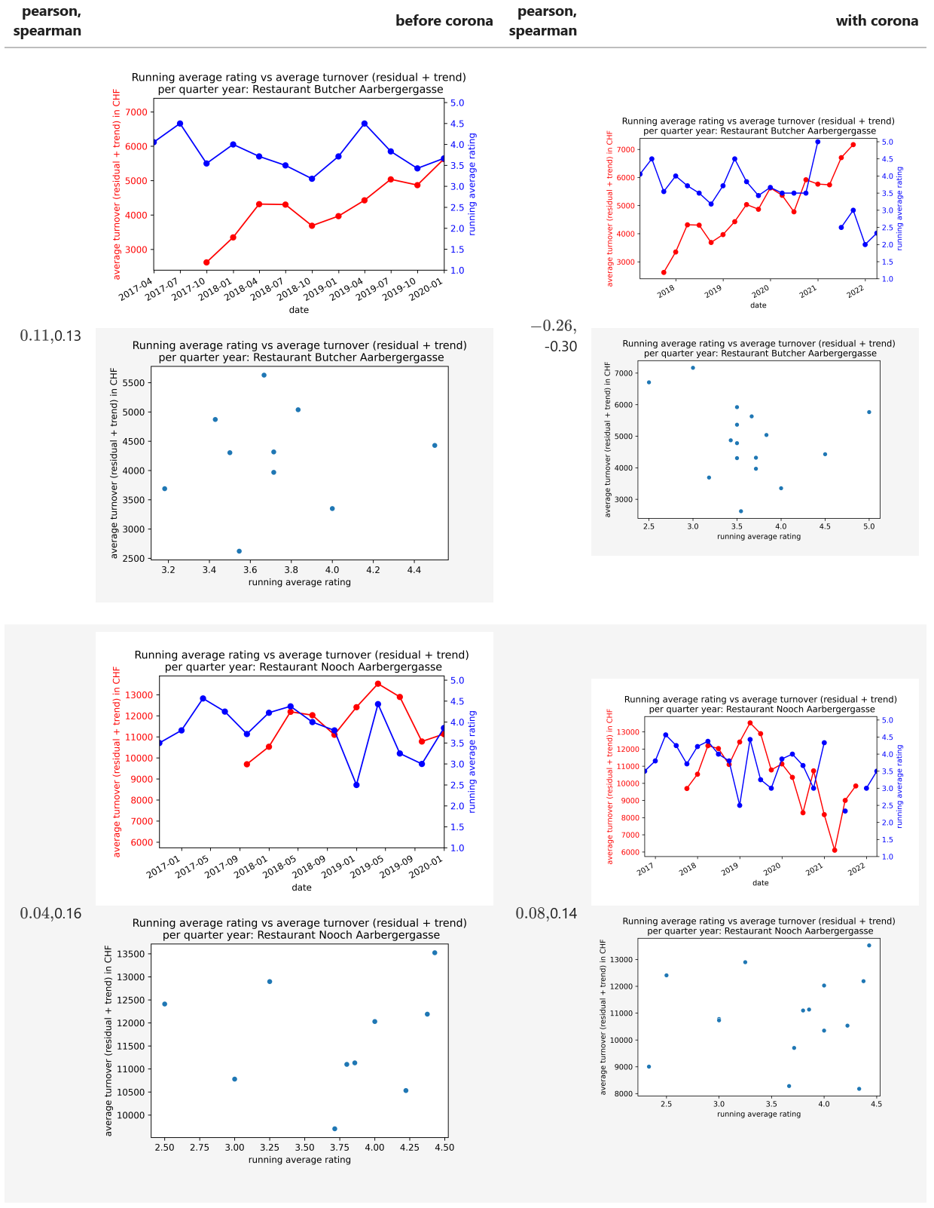

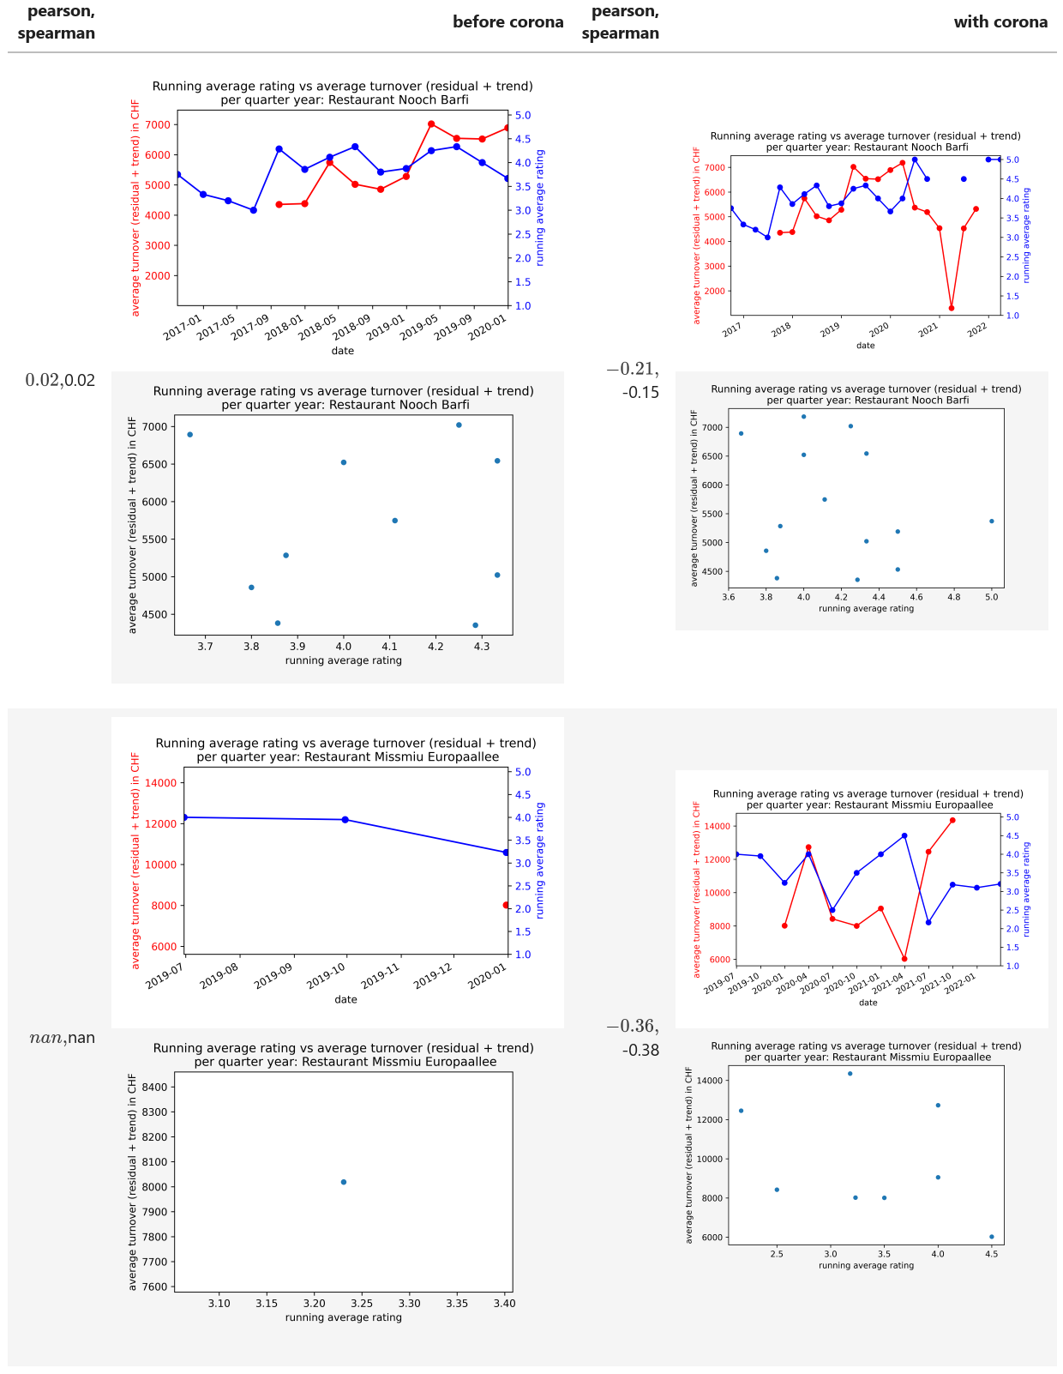

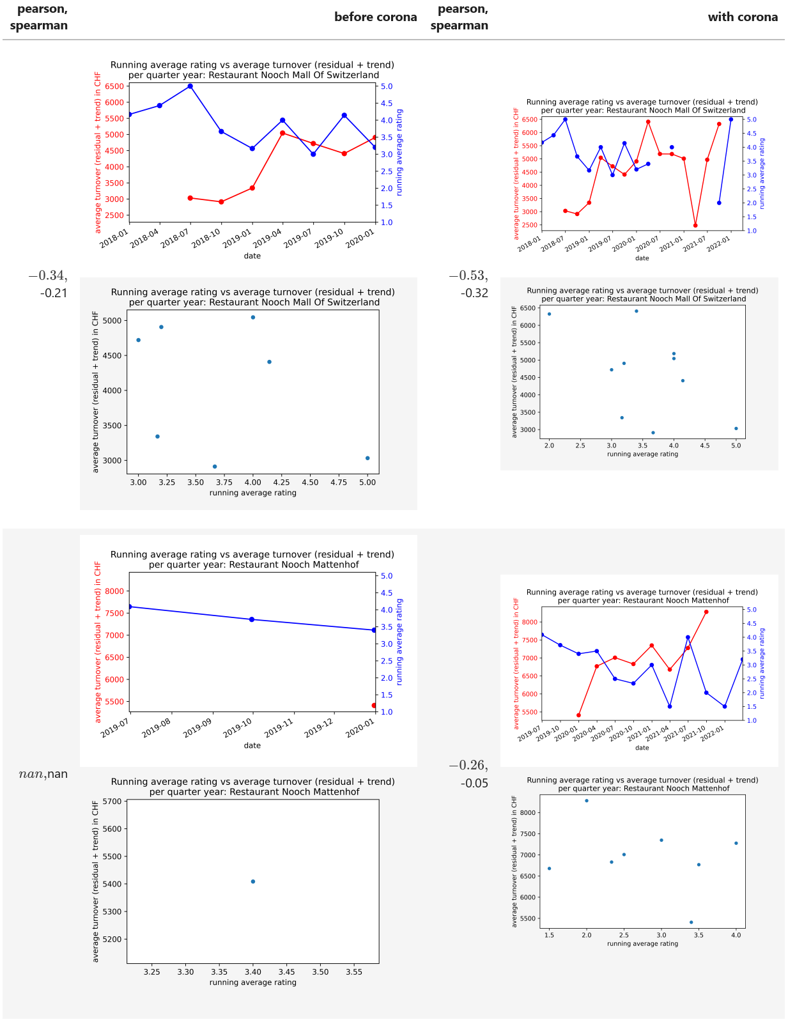

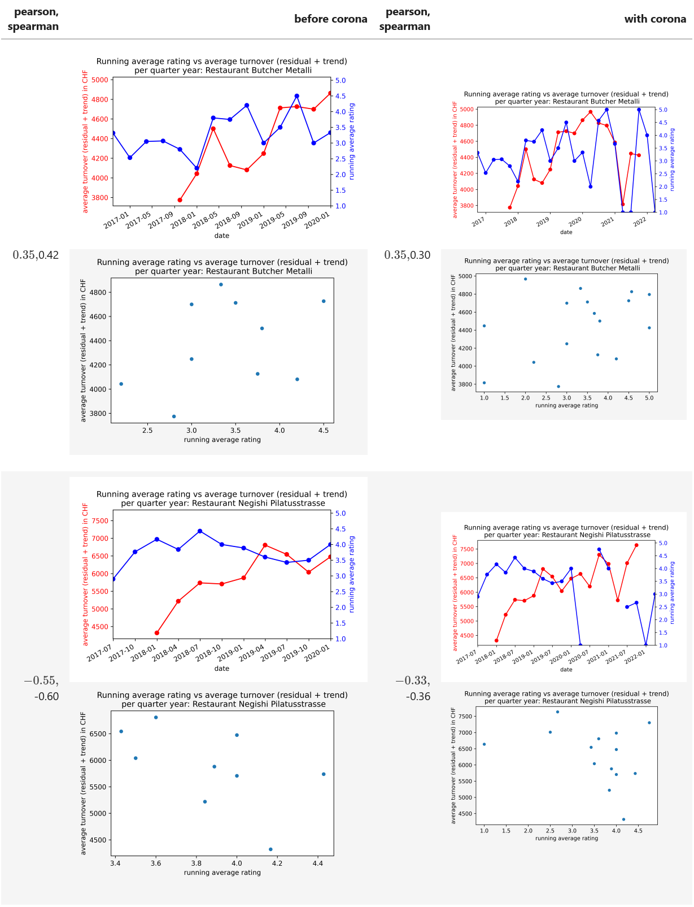

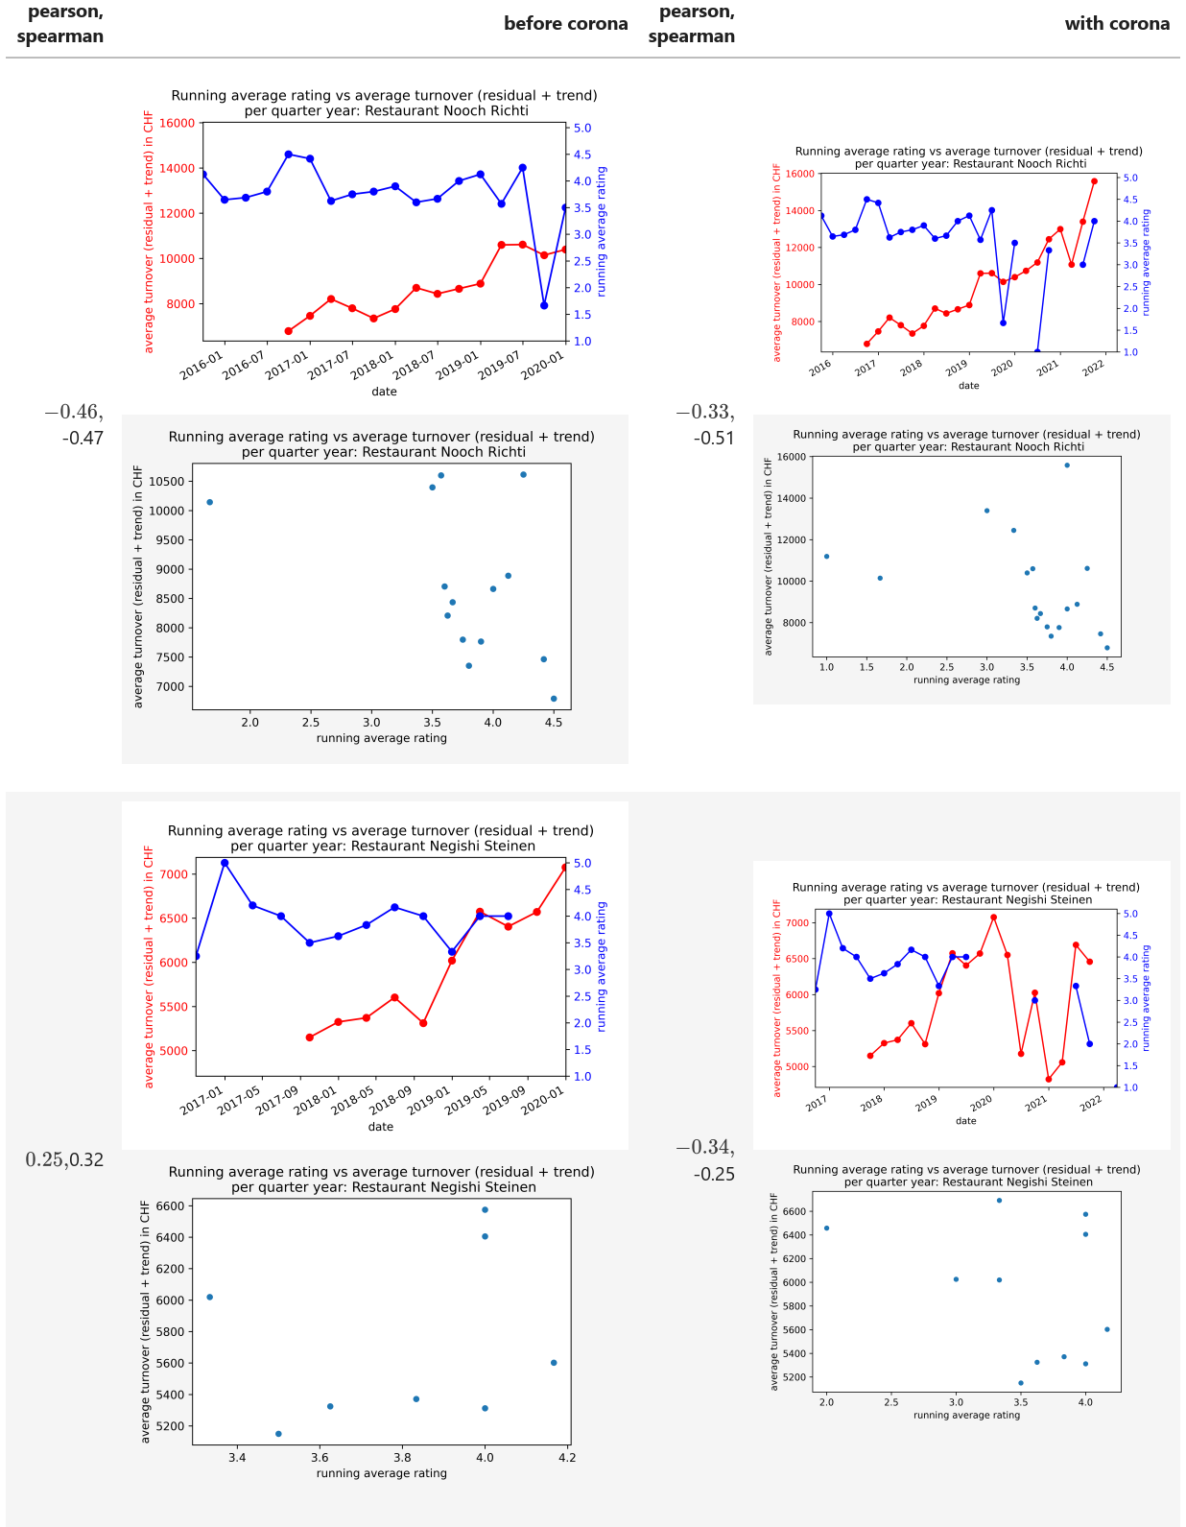

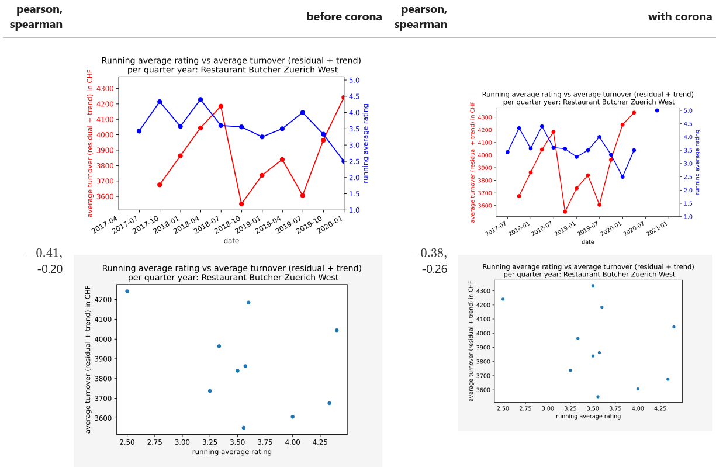

1. Industrial partner Prognolite: https://prognolite.com/site/de/
2. GitHub repository of our thesis: https://github.com/fatihsolmaz22/Bachelorarbeit_FS22
3. GitHub repository of our ScrapingTool: https://github.com/fatihsolmaz22/ScrapingTool